

**Installation Guide:**

PRO-YD-TTU07V2-LB-(All)

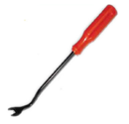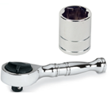Tools Needed:

* ¼” ratchet
* 10mm socket
* Panel popper

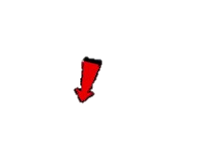

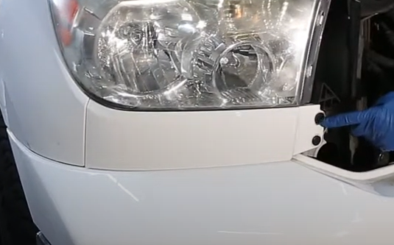

1. Remove (2x) plastic retainers using the panel popper.

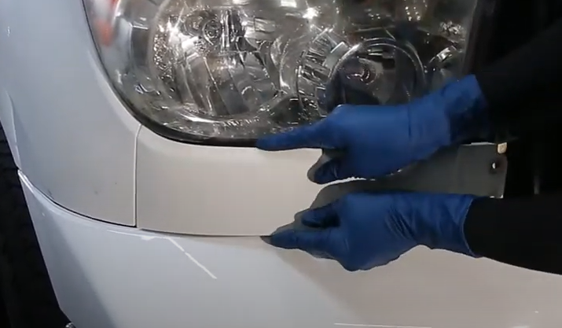

1. Unseat and remove headlight garnish.



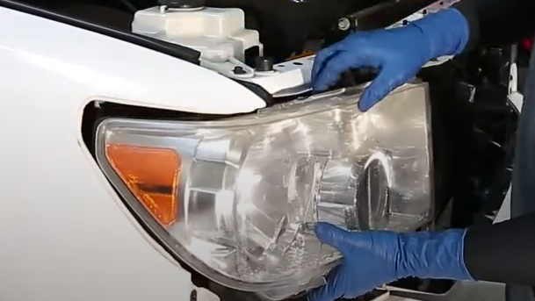

1. Unseat the headlight.

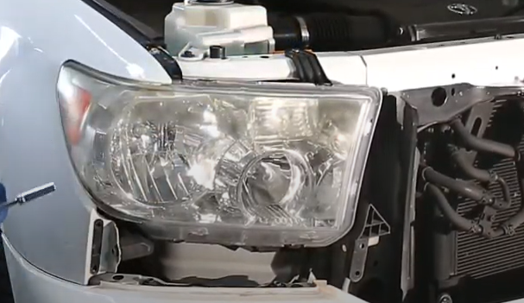

1. Remove (3x) 10mm bolts securing the headlight.



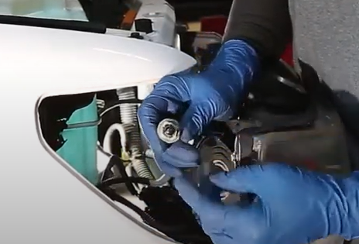

1. Remove side marker bulb from socket.

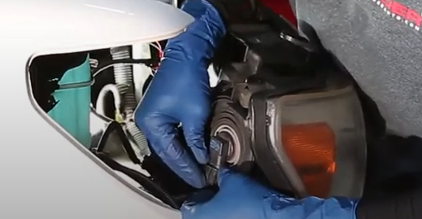

1. Disconnect low beam and high beam harness. Remove turn signal socket and side marker socket.

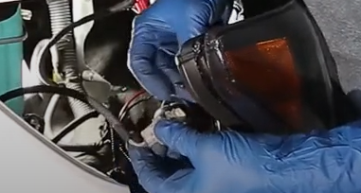

1. Install side marker socket insert. (Making sure to align Green wire on socket to Red wire on socket insert)

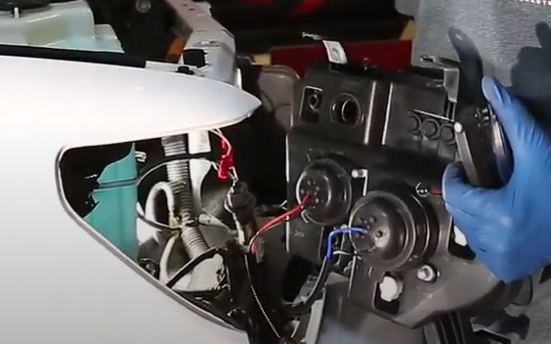

1. Connect low beam and high beam harnesses also install turn signal socket onto Spyder headlight.

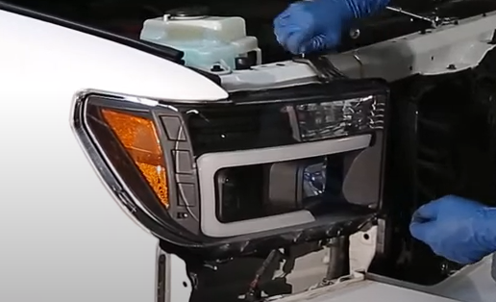

1. Install (3x) 10mm bolts securing the Spyder headlight.

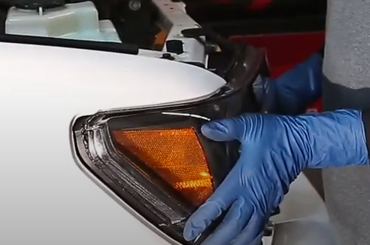

1. Seat Spyder headlight.

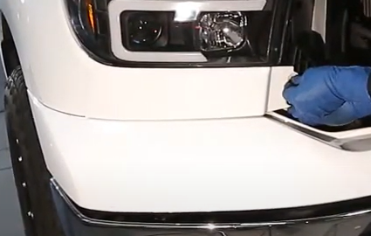

1. Install (2x) plastic retainers.

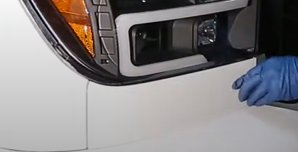

1. Seat headlight garnish.

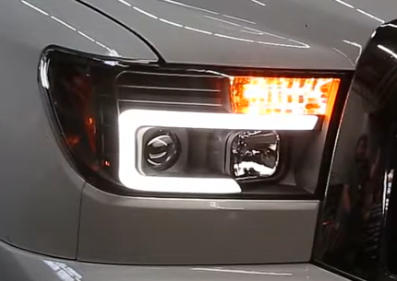

13.Turn on lights and confirm all functions are working properly. You have successfully completed the install of your new Spyder Headlights.



For further help with installation, please watch our installation video. Follow the direct link below to our YouTube channel for more information:

http://www.youtube.com/watch

**DISCLAIMER**

Spyder Auto Installation Guide is not liable for damages, injuries, and death while installing the product. This is intended to be an installation guide, to reduce installation time. We have no responsibility for improper installation. If you do not know how to install, please have a professional install it.