Installation Guide:
PRO-YD-PG605-HL-(All)

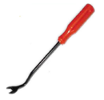
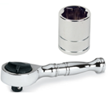
Tools Needed:
- ¼” ratchet
- 7mm socket
- Panel popper

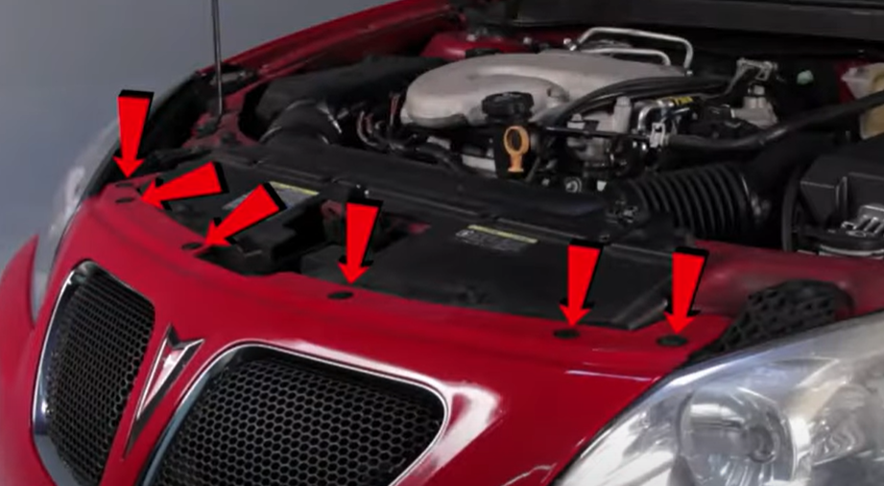
- Remove (6x) plastic retaining clips using panel popper.
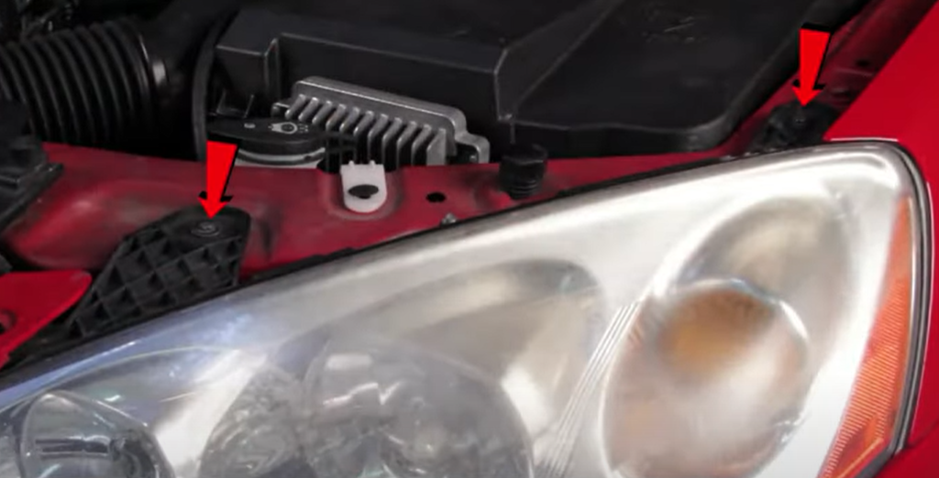
- Remove (2x) 7mm bolts.

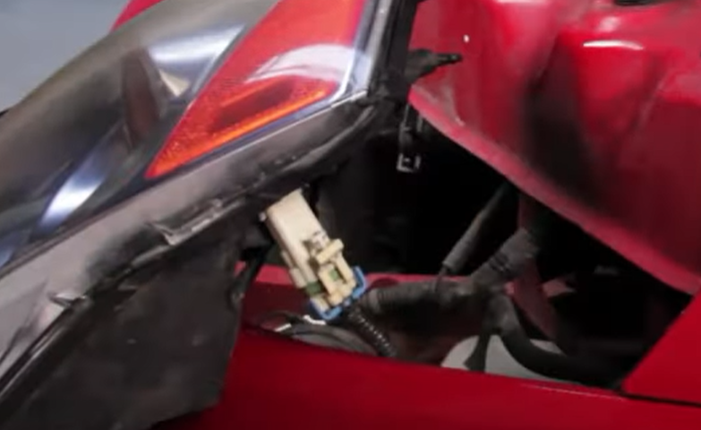
- Disconnect headlight harness.
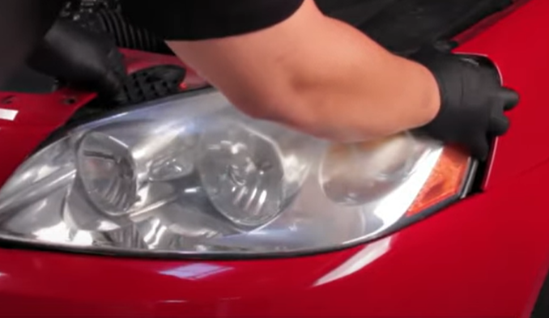
- Unseat headlight.

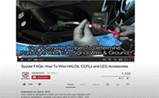
- For info on how to wire halos please refer to the Spyder FAQ playlist on the Spyder Auto YouTube channel.
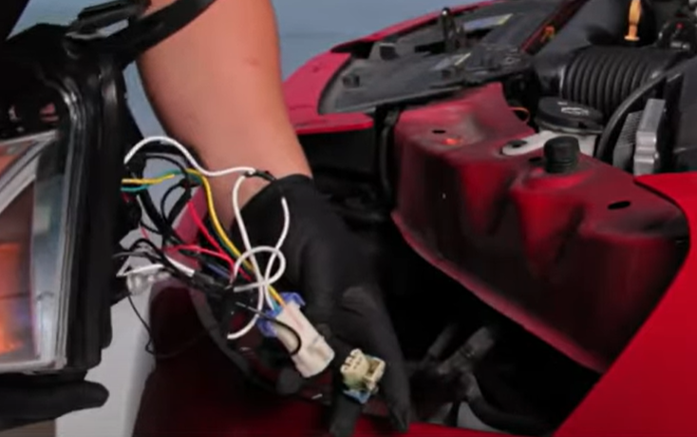
- Connect Spyder headlight harness.

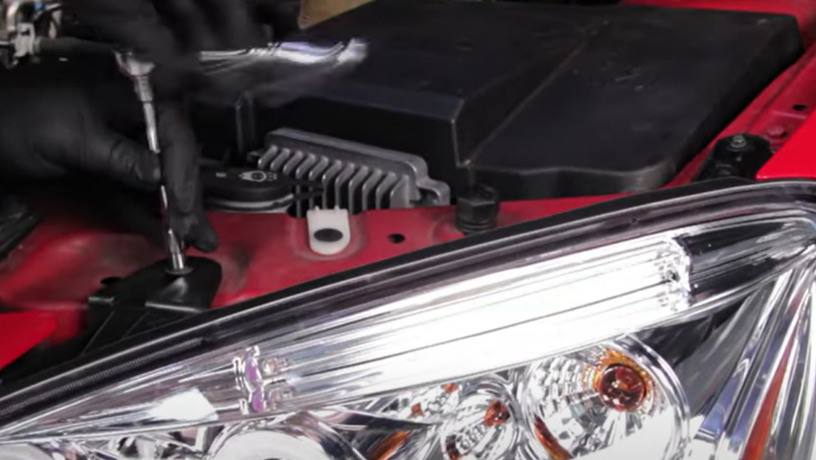
- Reinstall (2x) 7mm bolts.
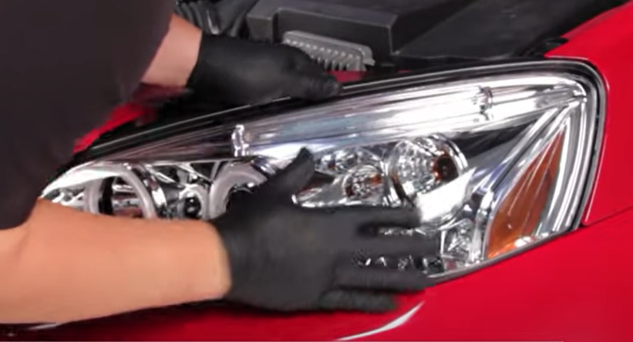
- Seat Spyder headlight.

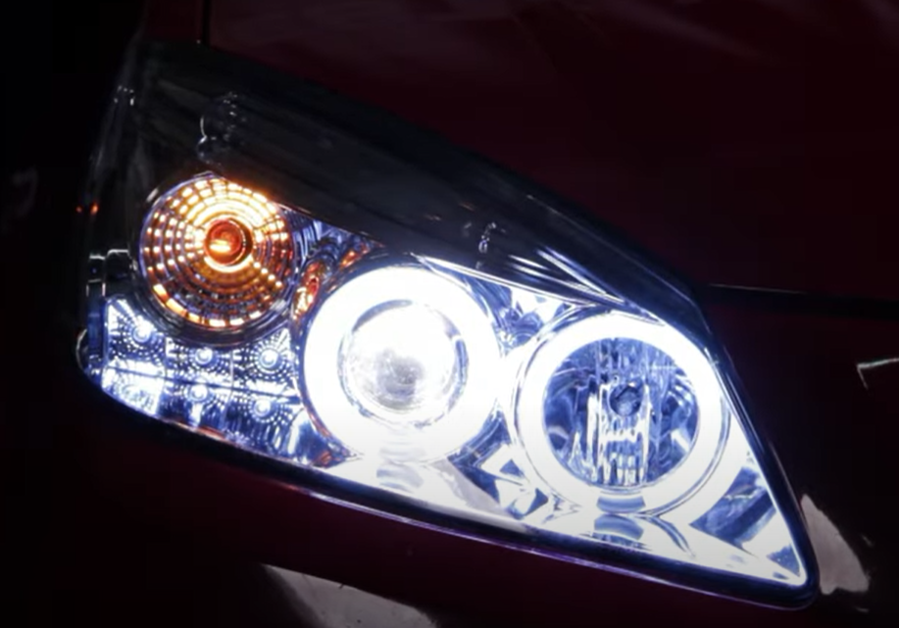
10.Turn on lights and confirm all functions are working properly. You have successfully completed the install of your new Spyder Headlights.
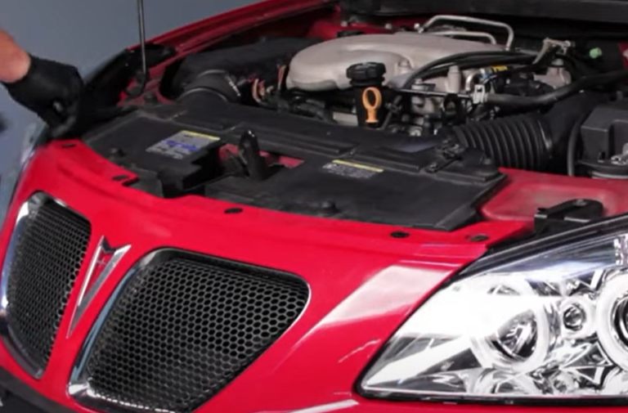
- Reinstall (6x) plastic retainer.

For further help with installation, please watch our installation video. Follow the direct link below to our YouTube channel for more information:
http://www.youtube.com/watch

DISCLAIMER
Spyder Auto Installation Guide is not liable for damages, injuries, and death while installing the product. This is intended to be an installation guide, to reduce installation time. We have no responsibility for improper installation. If you do not know how to install, please have a professional install it.

