Installation Guide:
PRO-YD-FM99-1PC-AM-(All)

Tools Needed:
- None

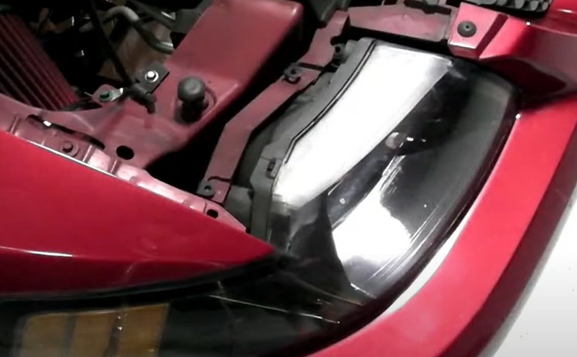
- Pull up on the (2x) headlight retaining tabs.
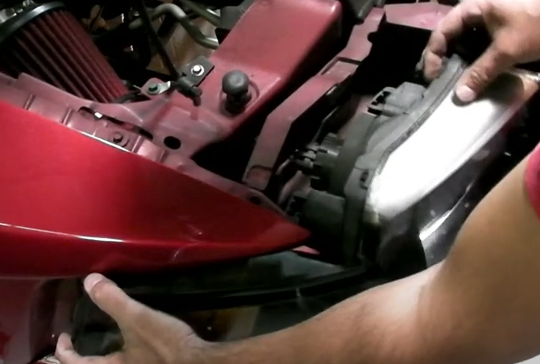
- Unseat Headlight.

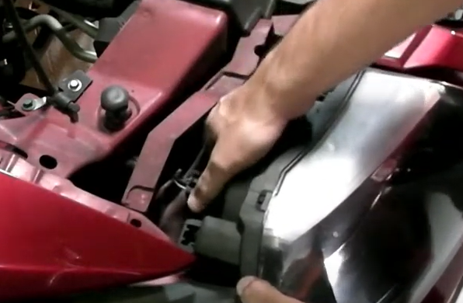
- Remove headlight and turn signal sockets.
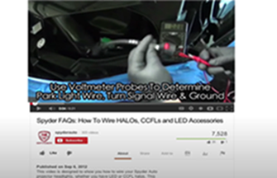
- For info on how to tap the positive turn signal please refer to the Spyder FAQ playlist on the Spyder Auto YouTube channel.

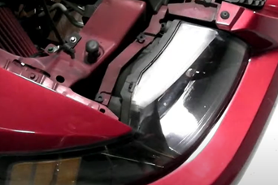
- Install (2x) headlight retaining tabs.
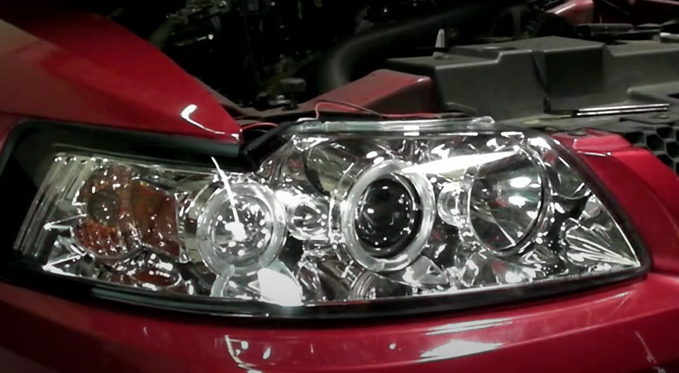
- Reinstall side marker and headlights sockets onto Spyder headlight, next seat Spyder headlight.

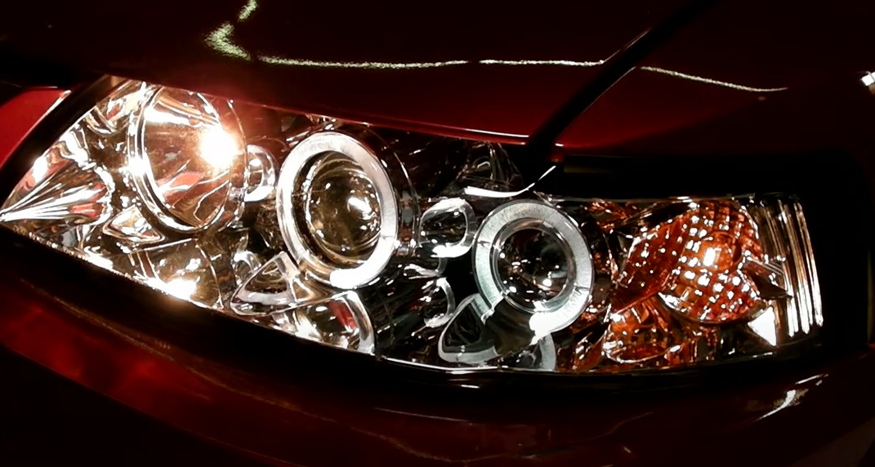
7. Turn on lights and confirm all functions are working properly. You have successfully completed the install of your new Spyder Headlights.

For further help with installation, please watch our installation video. Follow the direct link below to our YouTube channel for more information:
http://www.youtube.com/watch

DISCLAIMER
Spyder Auto Installation Guide is not liable for damages, injuries, and death while installing the product. This is intended to be an installation guide, to reduce installation time. We have no responsibility for improper installation. If you do not know how to install, please have a professional install it.

