

**Installation Guide:**

PRO-YD-FM05V2-DRL-(All)

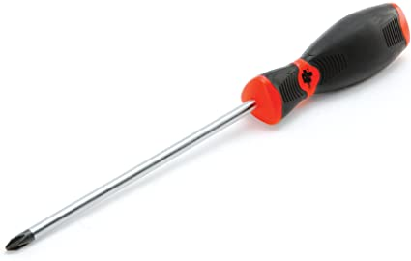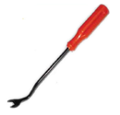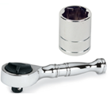Tools Needed:

* ¼” ratchet
* 10mm socket
* Panel popper
* Phillips screwdriver

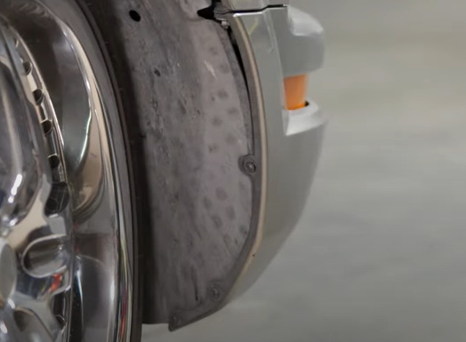

1. Remove (3x) phillips screws securing the fender liner.

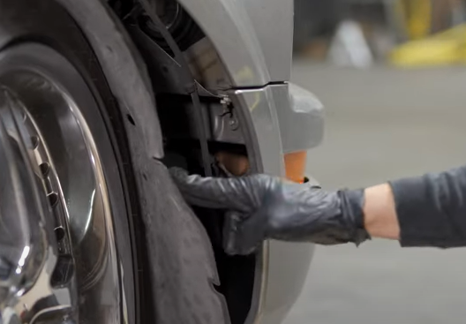

1. Pull back fender liner and remove (2x) 10mm bolts securing each corner of the bumper fascia.

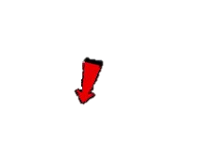







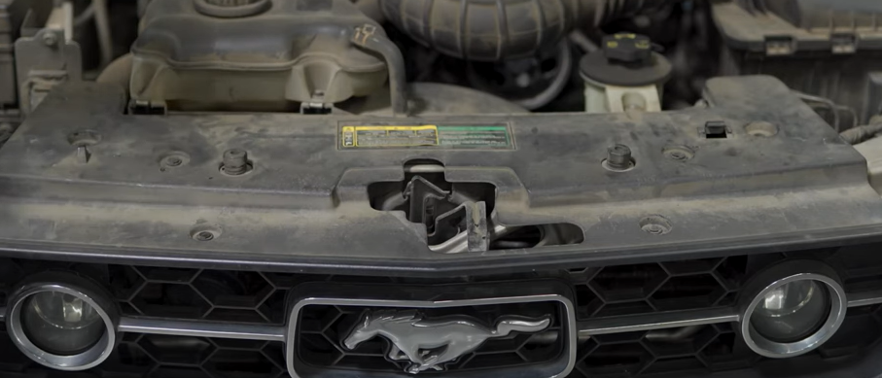

1. Remove (6x) plastic retainers securing the radiator shroud.

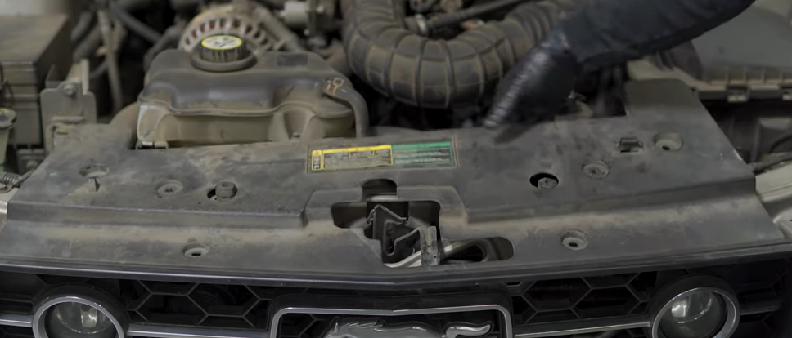

1. Remove radiator shroud.





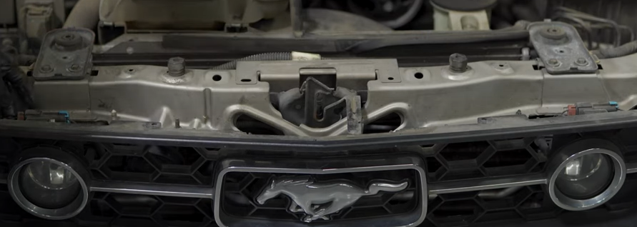

1. Disconnect (2x) grill lights.

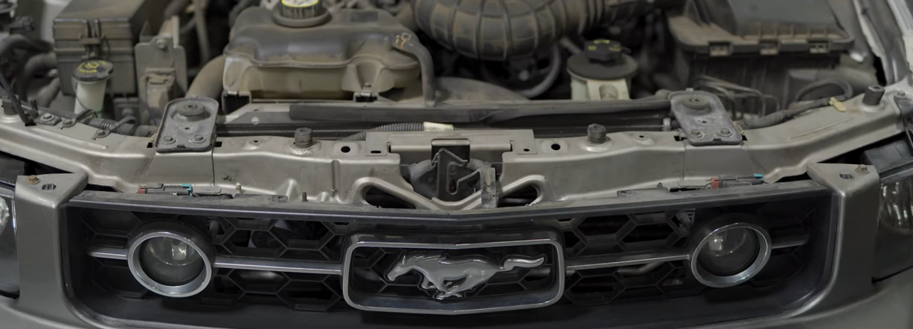

1. Remove (2x) 10mm bolts securing the bumper fascia.





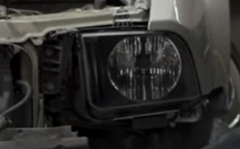

1. Remove (3x) 10mm bolts securing the headlight.

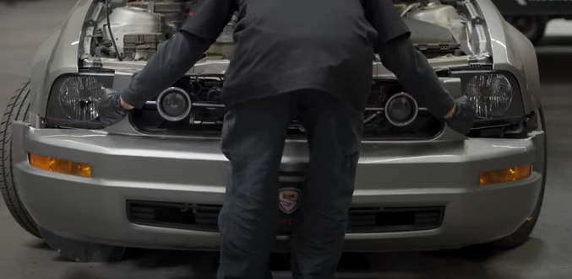

1. Unseat bumper fascia and set aside.



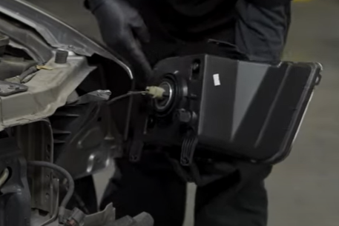

1. Disconnect headlight harness.

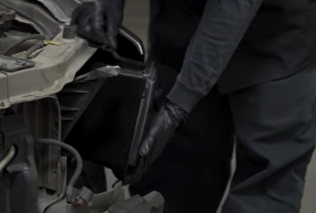

1. Unseat the headlight.

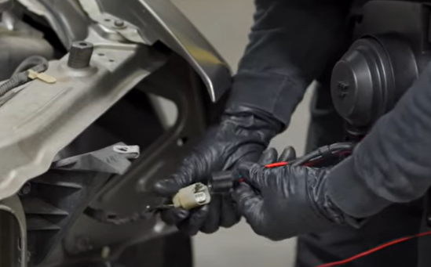

1. Connect Spyder headlight harness.

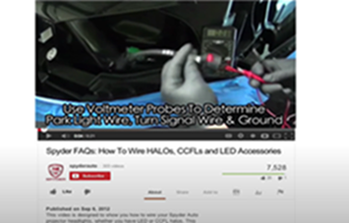

1. For info on how to tap the positive turn signal please refer to the Spyder FAQ playlist on the Spyder Auto YouTube channel.





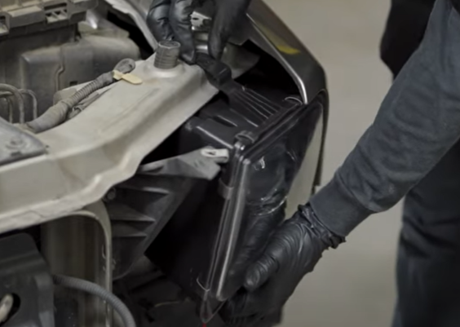

1. Seat Spyder headlight.

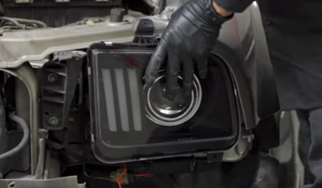

1. Reinstall (3x) 10mm bolts.



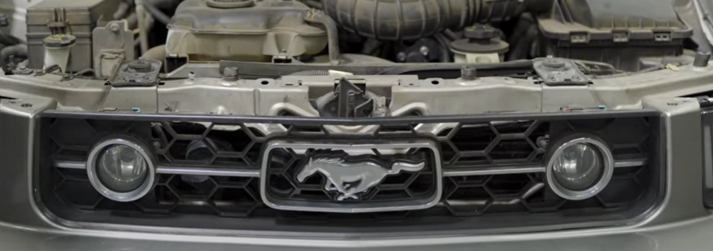

1. Reinstall (2x) grill lights harnesses and install (2x) 10mm bolts.



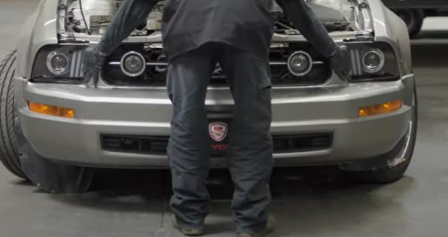

1. Reinstall front bumper fascia.

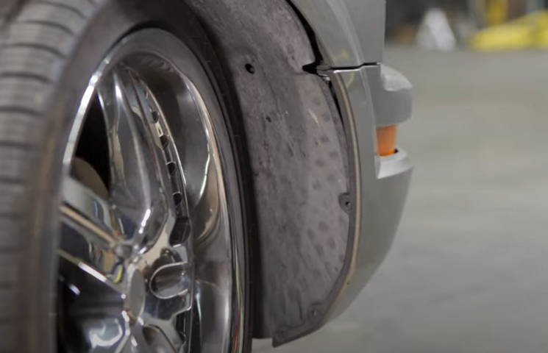

1. Seat fender liner and reinstall (3x) phillips screws.

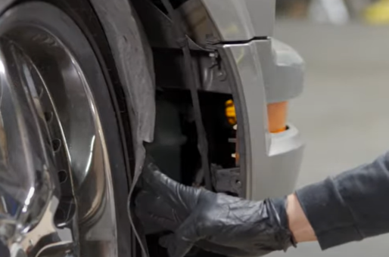

1. Reinstall (2x) 10mm bolts securing each corner of the bumper fascia.

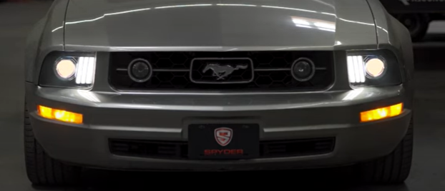

19.Turn on lights and confirm all functions are working properly. You have successfully completed the install of your new Spyder Headlights.



For further help with installation, please watch our installation video. Follow the direct link below to our YouTube channel for more information:

http://www.youtube.com/watch

**DISCLAIMER**

Spyder Auto Installation Guide is not liable for damages, injuries, and death while installing the product. This is intended to be an installation guide, to reduce installation time. We have no responsibility for improper installation. If you do not know how to install, please have a professional install it.