Installation Guide:
PRO-YD-FF15097-1P-CCFL-(All)
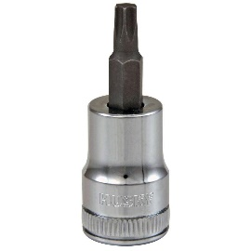
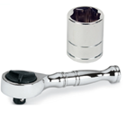
Tools Needed:
- ¼” ratchet
- T15 Torx

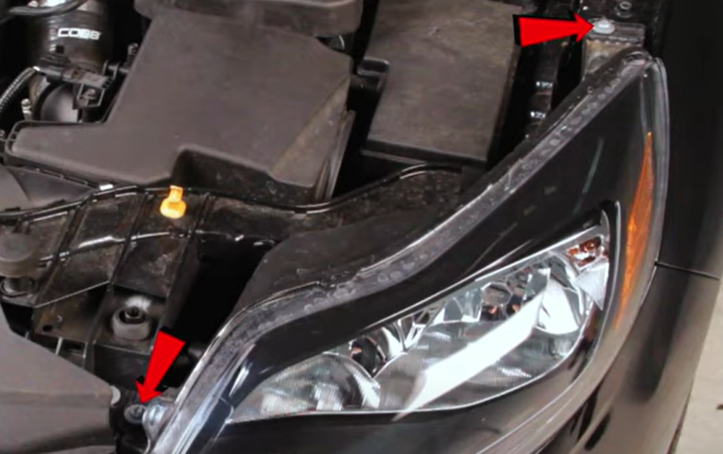
- Remove (2x) T30 torx securing the headlight.
- Unseat headlight.

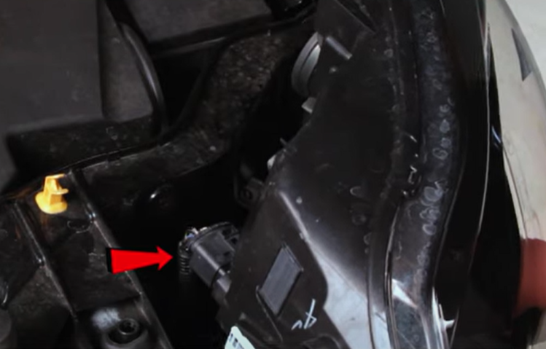
- Disconnect headlight harness.
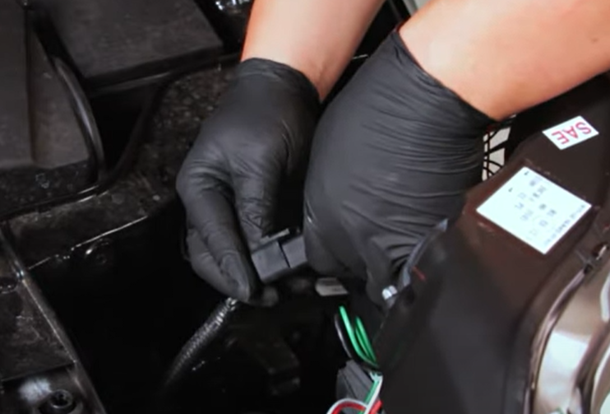
- Connect Spyder headlight harness.

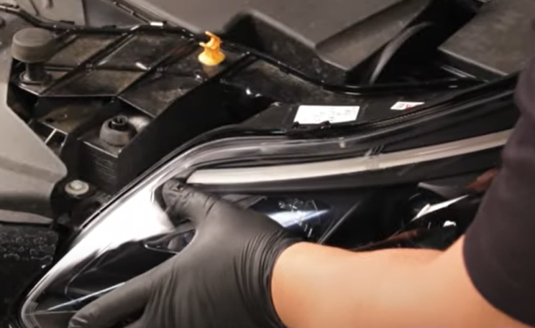
- Seat Spyder headlight.
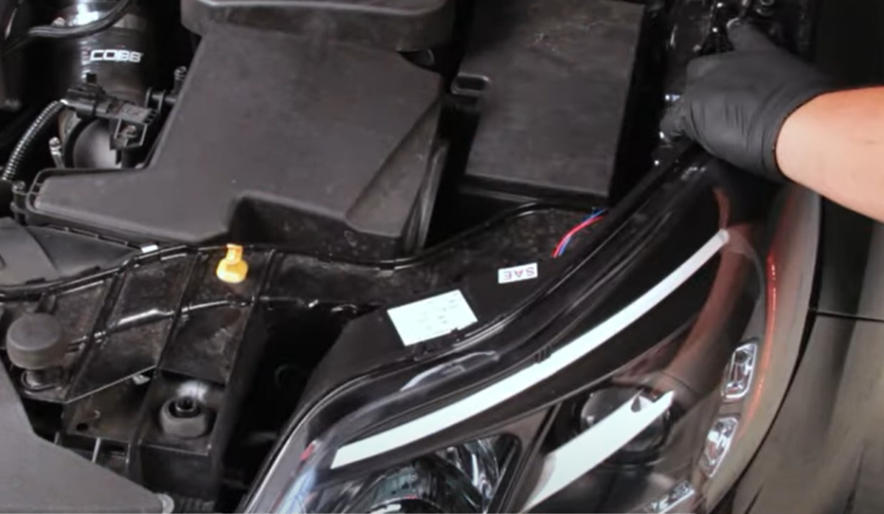
- Reinstall (2x) T30 torx securing the headlight.

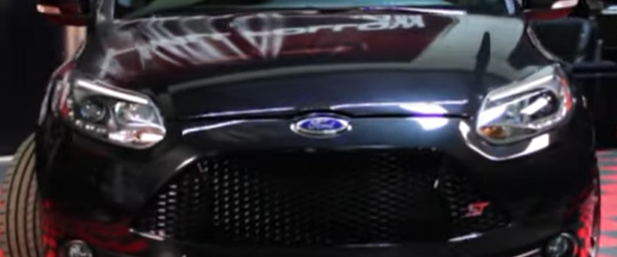
7.Turn on lights and confirm all functions are working properly. You have successfully completed the install of your new Spyder Headlights.

For further help with installation, please watch our installation video. Follow the direct link below to our YouTube channel for more information:
http://www.youtube.com/watch

DISCLAIMER
Spyder Auto Installation Guide is not liable for damages, injuries, and death while installing the product. This is intended to be an installation guide, to reduce installation time. We have no responsibility for improper installation. If you do not know how to install, please have a professional install it.

