Installation Guide:
PRO-YD-FF15097-1P-AM-(All)

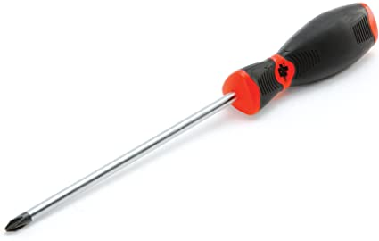
Tools Needed:
- Flathead screw driver

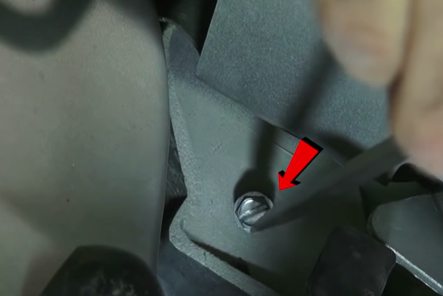
- Remove (1x) flathead crew securing the corner light.
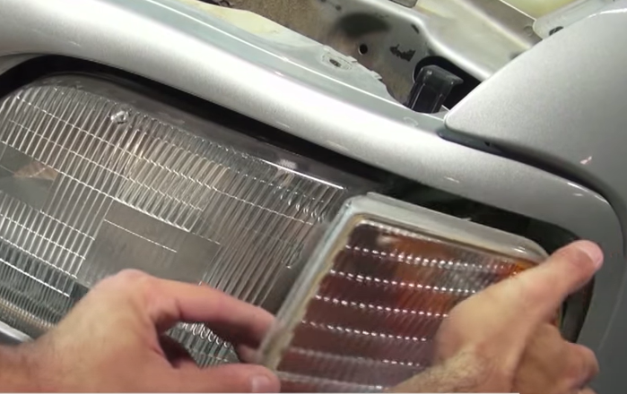
- Unseat corner light and remove turn signal socket.

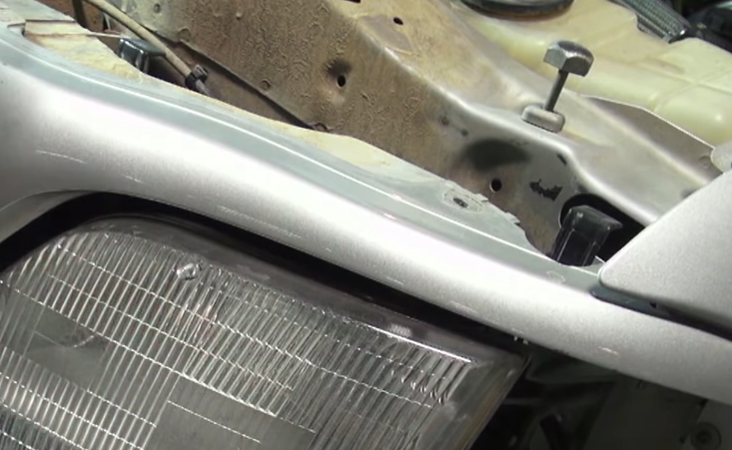
- Pull up on headlight retainer tabs to release headlight.
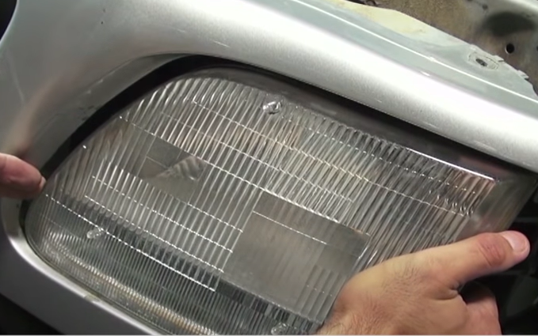
- Unseat the headlight.

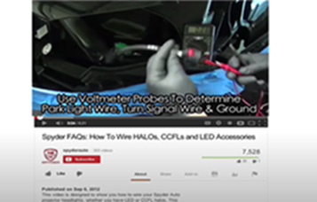
- For info on how to tap the positive turn signal please refer to the Spyder FAQ playlist on the Spyder Auto YouTube channel.

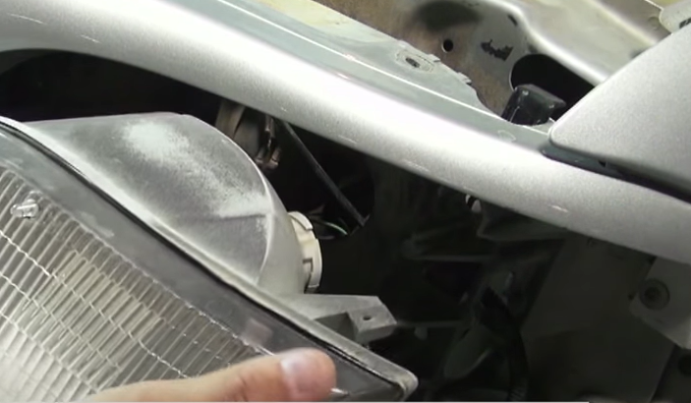
- Disconnect headlight harness.

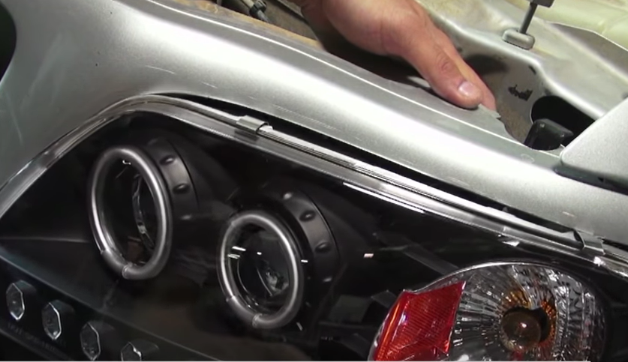
- Seat Spyder headlight.
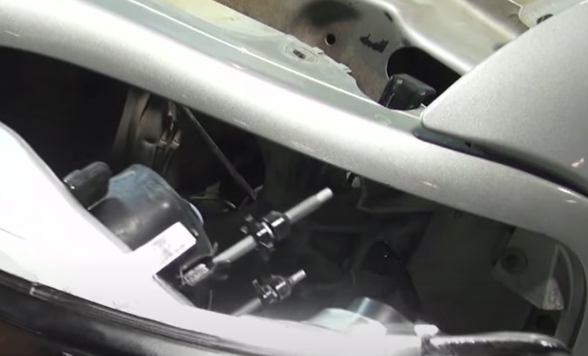
- Connect the headlight harness and install turn signal socket to Spyder headlight.

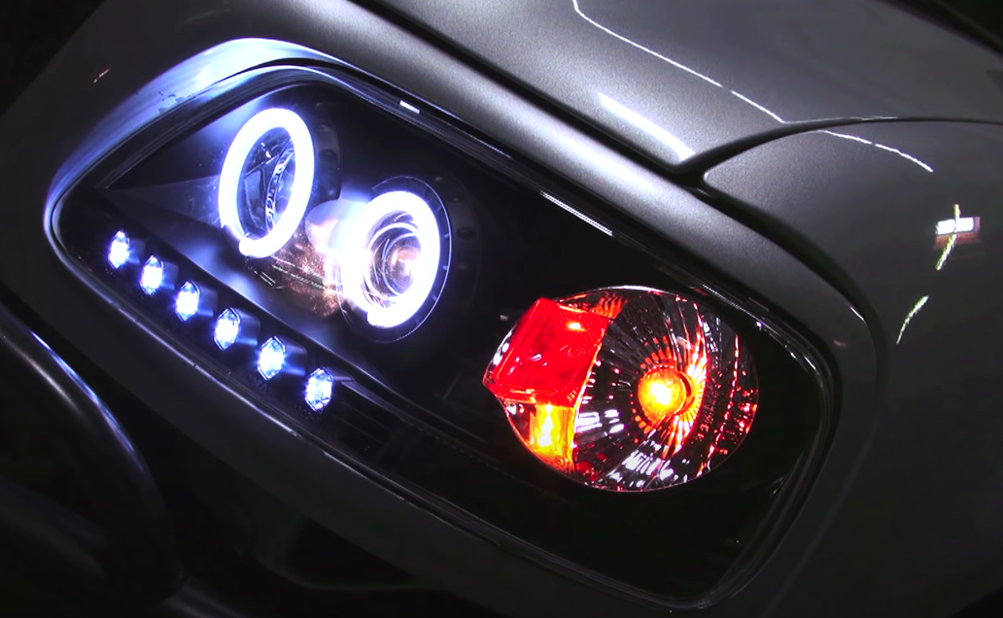
10.Turn on lights and confirm all functions are working properly. You have successfully completed the install of your new Spyder Headlights.
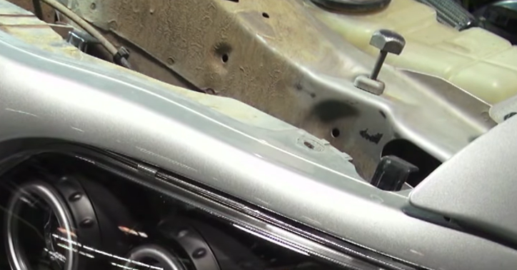
- Push down on retainer tabs to secure Spyder headlight.

For further help with installation, please watch our installation video. Follow the direct link below to our YouTube channel for more information:
http://www.youtube.com/watch

DISCLAIMER
Spyder Auto Installation Guide is not liable for damages, injuries, and death while installing the product. This is intended to be an installation guide, to reduce installation time. We have no responsibility for improper installation. If you do not know how to install, please have a professional install it.

