

**Installation Guide:**

PRO-YD-FF15009-SBLB-(All)

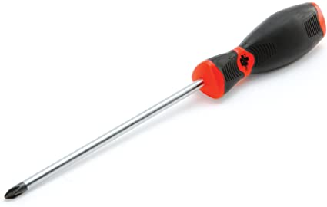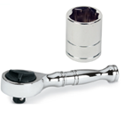Tools Needed:

* ¼” ratchet
* 10mm socket
* Phillips screw driver

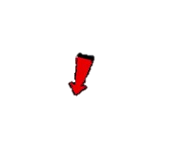

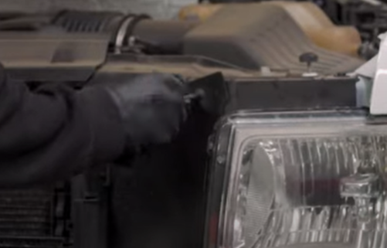

1. Remove (1x) phillips crew retainer.

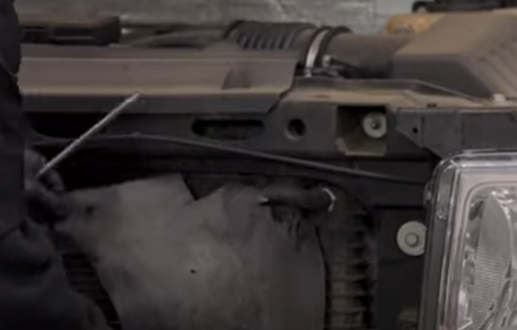

1. Pull back weather strip.



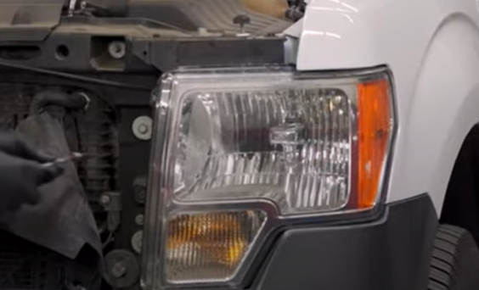

1. Remove (3x) 10mm bolts.

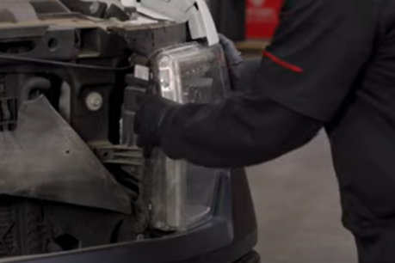

1. Unseat the headlight.





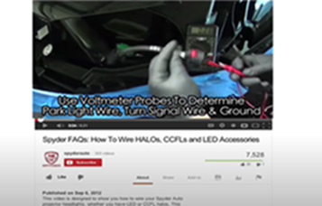

1. For info on how to tap the positive turn signal please refer to the Spyder FAQ playlist on the Spyder Auto YouTube channel.

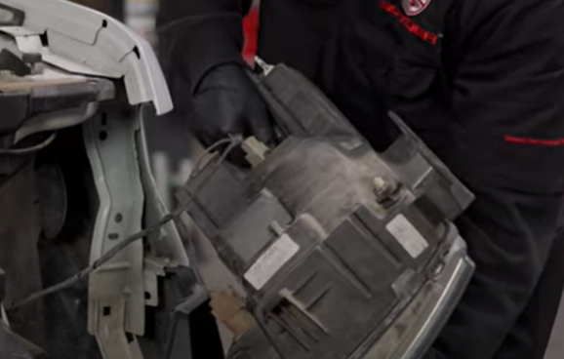

1. Disconnect headlight harness and turn signal, remove side marker socket.



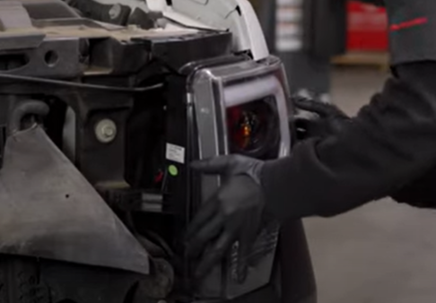

1. Seat Spyder headlight.

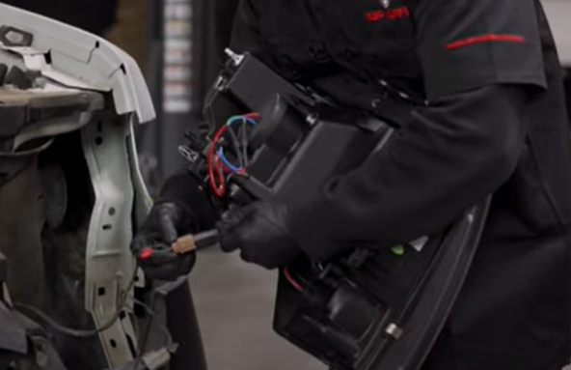

1. Connect the headlight harness and turn signal, install side marker socket.



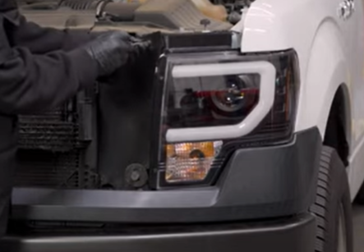

1. Reseat weather strip and install retainer.

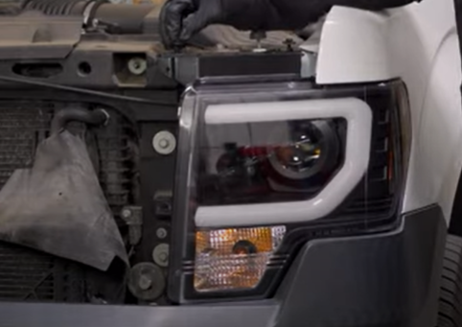

1. Reinstall (3x) 10mm bolts.

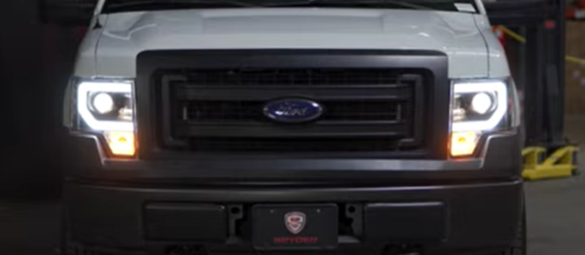

11.Turn on lights and confirm all functions are working properly. You have successfully completed the install of your new Spyder Headlights.



For further help with installation, please watch our installation video. Follow the direct link below to our YouTube channel for more information:

http://www.youtube.com/watch

**DISCLAIMER**

Spyder Auto Installation Guide is not liable for damages, injuries, and death while installing the product. This is intended to be an installation guide, to reduce installation time. We have no responsibility for improper installation. If you do not know how to install, please have a professional install it.