

**Installation Guide:**

PRO-YD-FF15004V2-LB-(All)

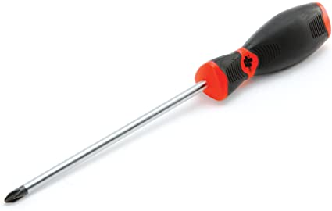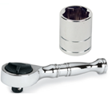Tools Needed:

* ¼” ratchet
* 10mm socket
* Phillips screw driver

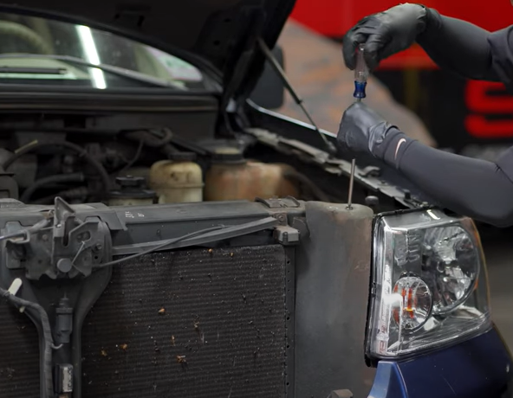

1. Remove (1x) phillips crew retainer.

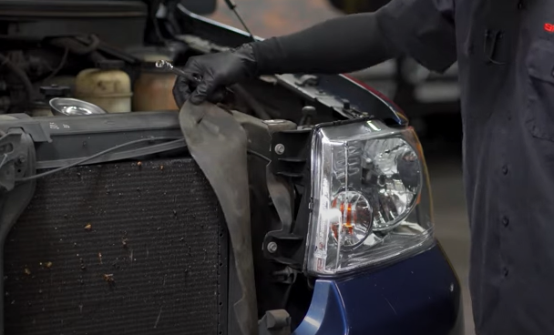

1. Pull back weather strip.

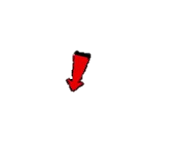



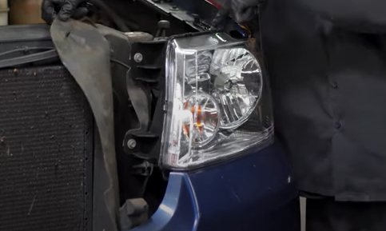

1. Remove (3x) 10mm bolts.

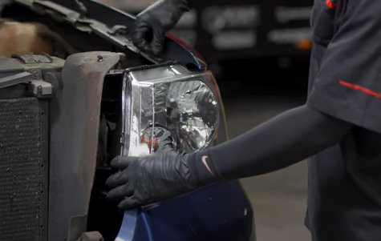

1. Carefully lift up on top bracket and unseat the headlight.



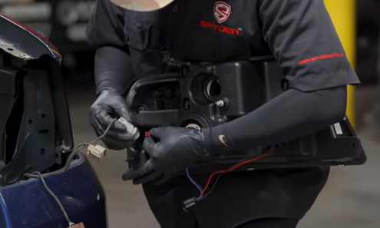

1. Remove side marker bulb and insert Spyder socket insert. (Make sure to align black wire of socket to black wire of socket insert).

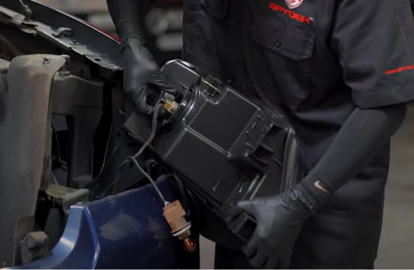

1. Remove turn signal and side marker socket. Disconnect headlight harness.

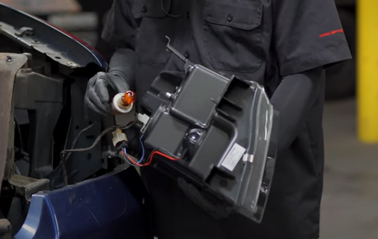

1. Install turn signal socket onto Spyder headlight (Make sure to never touch bulbs with bare hands).

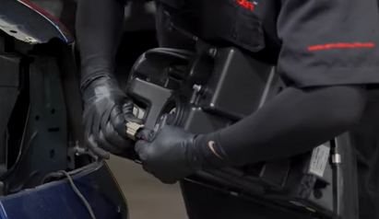

1. Connect Spyder headlight harness.



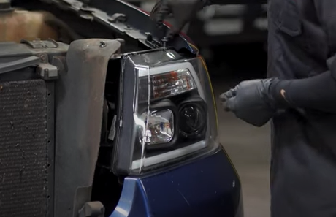

1. Reinstall (3x) 10mm bolts.

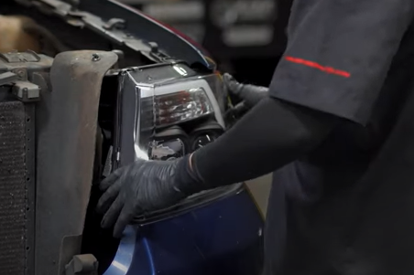

1. Seat Spyder headlight.





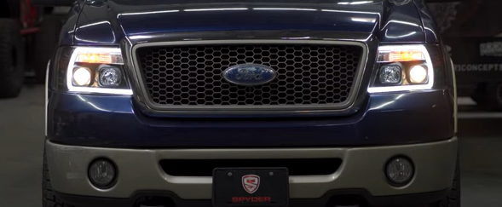

12.Turn on lights and confirm all functions are working properly. You have successfully completed the install of your new Spyder Headlights.

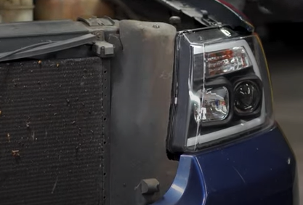

1. Reseat weather strip and install retainer.



For further help with installation, please watch our installation video. Follow the direct link below to our YouTube channel for more information:

http://www.youtube.com/watch

**DISCLAIMER**

Spyder Auto Installation Guide is not liable for damages, injuries, and death while installing the product. This is intended to be an installation guide, to reduce installation time. We have no responsibility for improper installation. If you do not know how to install, please have a professional install it.