Installation Guide:
PRO-YD-FF15-LBSEQ-(All)

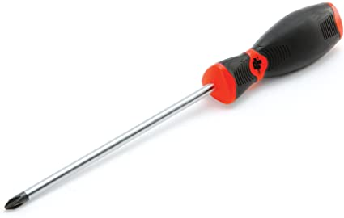
Tools Needed:
- T30 Torx

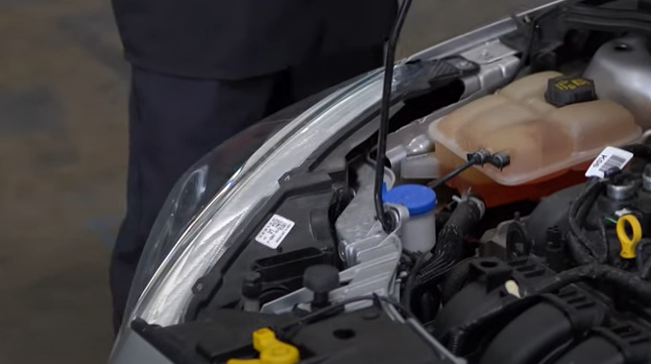
- Remove (2x) T30 torx securing the headlight.
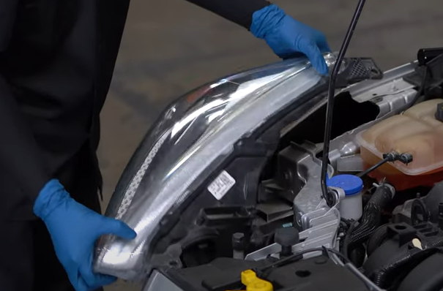
- Unseat the headlight.

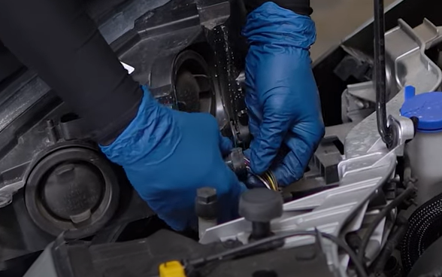
- Disconnect headlight harness.
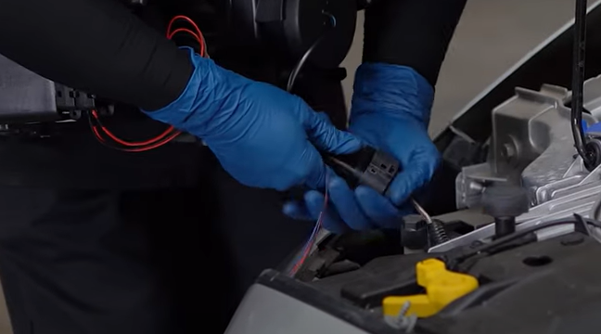
- Connect Spyder headlight harness (Note that halogen models will not require use of the extra wire).

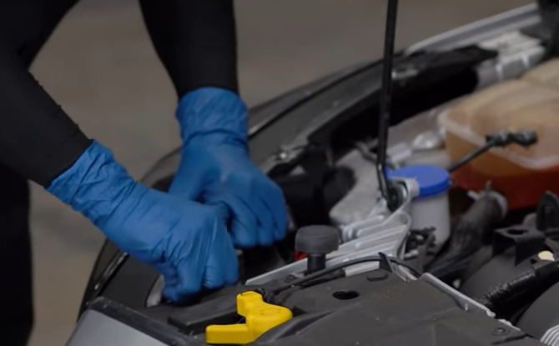
- Reinstall (2x) T30 torx screws.
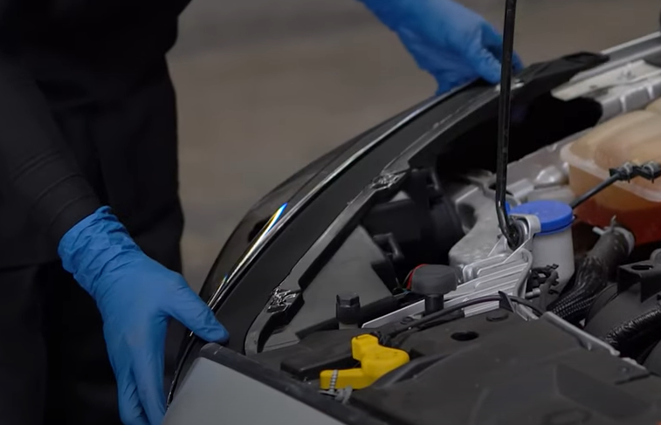
- Seat Spyder headlight.

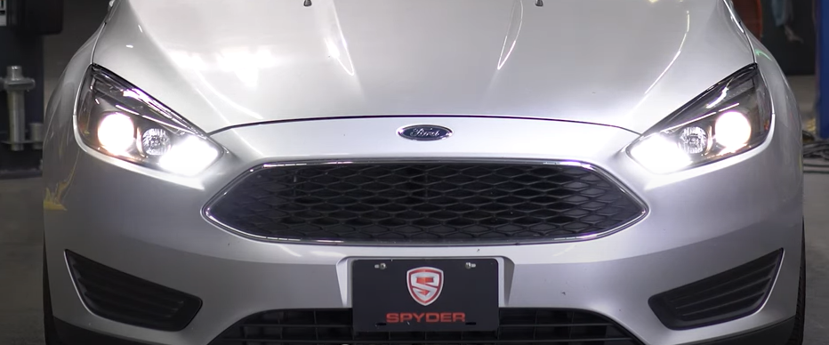
7. Turn on lights and confirm all functions are working properly. You have successfully completed the install of your new Spyder Headlights.

For further help with installation, please watch our installation video. Follow the direct link below to our YouTube channel for more information:
http://www.youtube.com/watch

DISCLAIMER
Spyder Auto Installation Guide is not liable for damages, injuries, and death while installing the product. This is intended to be an installation guide, to reduce installation time. We have no responsibility for improper installation. If you do not know how to install, please have a professional install it.

