Installation Guide:
PRO-YD-FE07-LTDRL-(All)

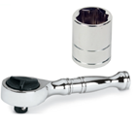
Tools Needed:
- ¼” ratchet
- 10mm socket

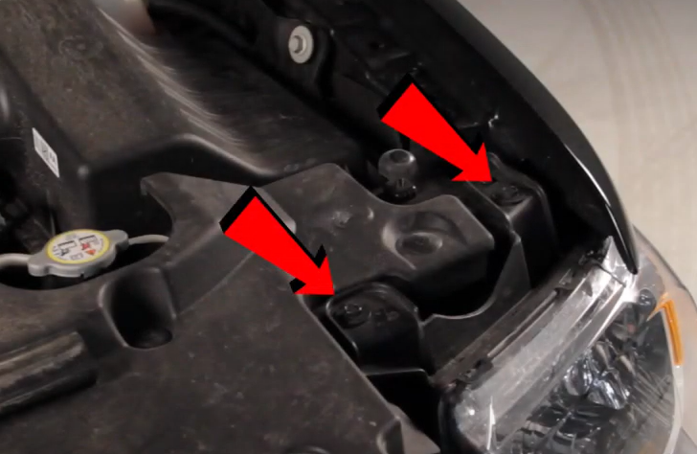
- Remove (2x) 10mm screws securing the headlight.
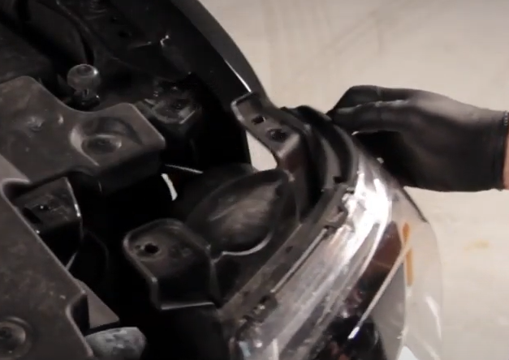
- Unseat the headlight.

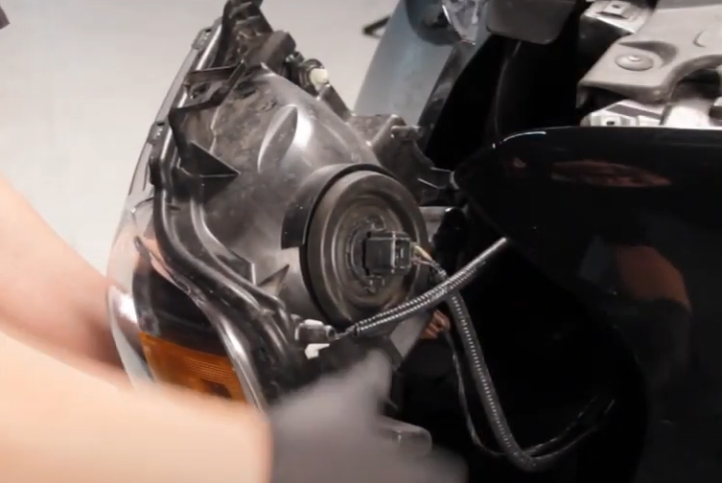
- Disconnect Low/high beam harness along with side marker and turn signal harness.
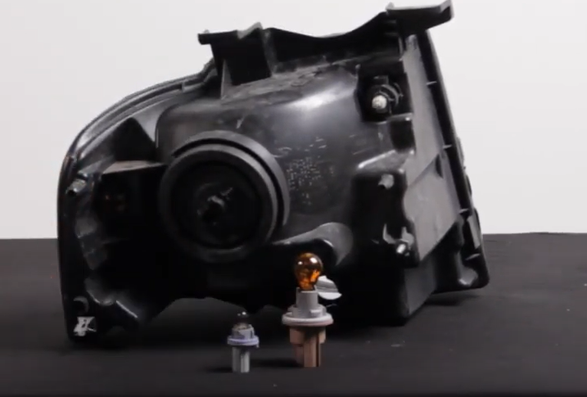
- Remove turn signal and side marker sockets from OEM headlight (Make sure to never touch bulbs with bare hands).

- Install turn signal bulb onto Spyder headlight.

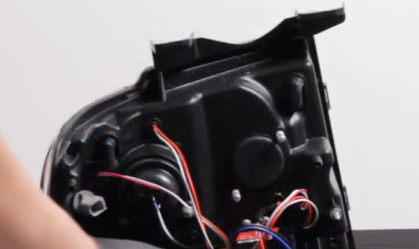
- Install side marker socket onto Spyder headlight.

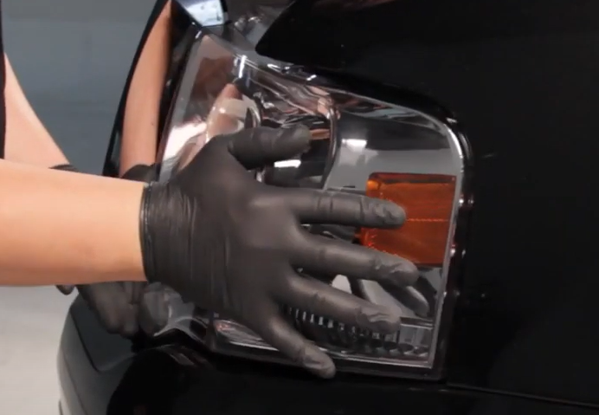
- Seat Spyder headlight.
- Connect (3x) headlight harnesses onto Spyder headlight.

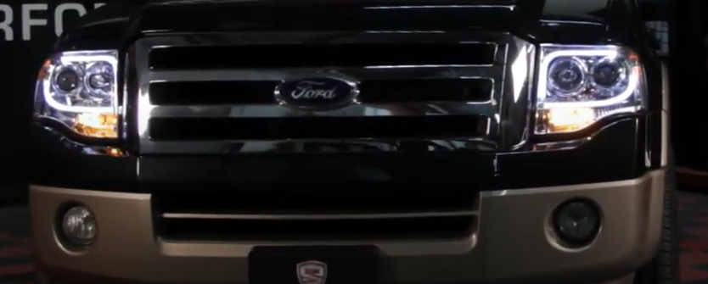
10.Turn on lights and confirm all functions are working properly. You have successfully completed the install of your new Spyder Headlights.
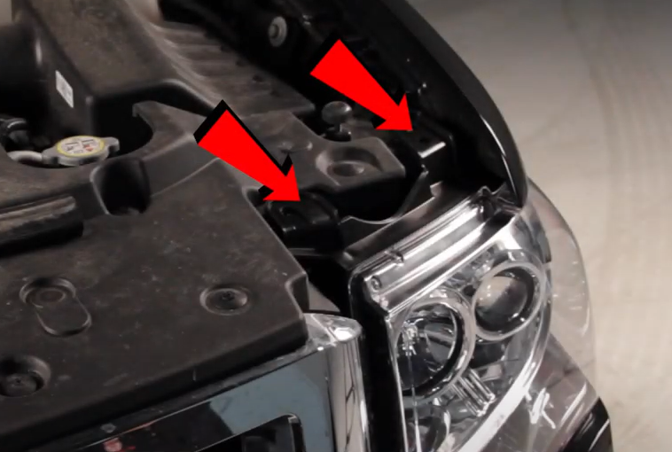
- Reinstall (2x) 10mm screws securing the headlight.

For further help with installation, please watch our installation video. Follow the direct link below to our YouTube channel for more information:
http://www.youtube.com/watch

DISCLAIMER
Spyder Auto Installation Guide is not liable for damages, injuries, and death while installing the product. This is intended to be an installation guide, to reduce installation time. We have no responsibility for improper installation. If you do not know how to install, please have a professional install it.

