

**Installation Guide:**

PRO-YD-DR09-LBDRL-(All)

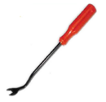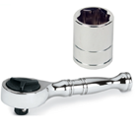Tools Needed:

* ¼” ratchet
* 7mm socket
* Panel popper

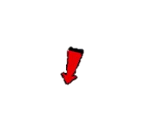



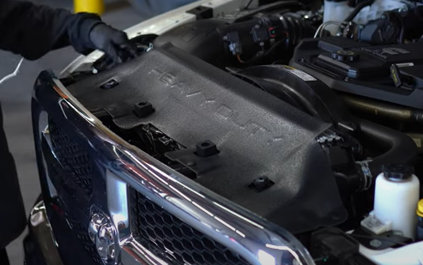

1. Remove (4x) plastic retainers using panel popper that secure the radiator shroud.

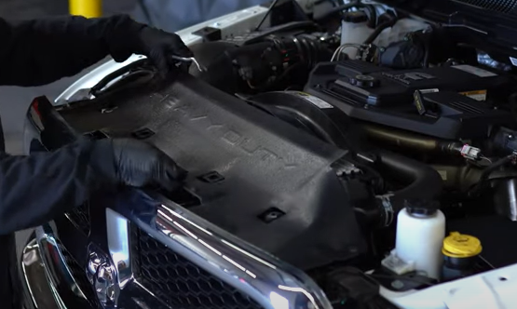

1. Remove shroud.







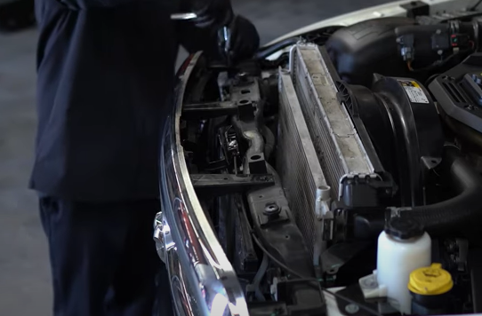

1. Remove (4x) 10mm bolts securing the grill.

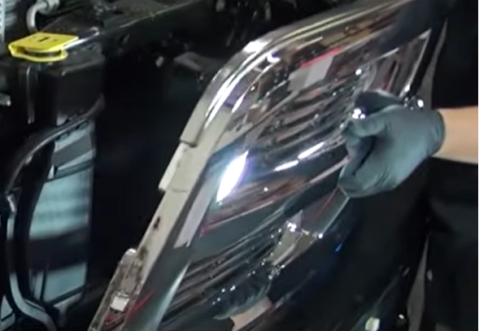

1. Remove grill and set it aside.





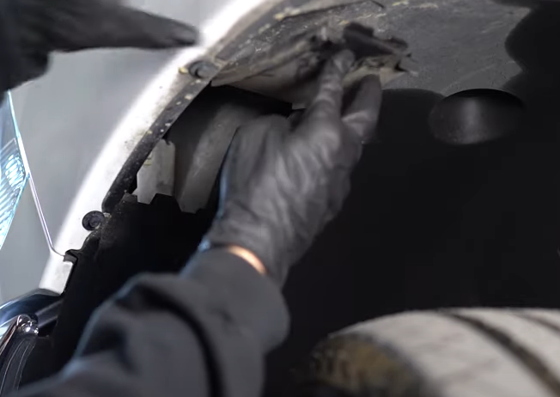

1. Open access panel from inside the fender well and to access retainer tab.

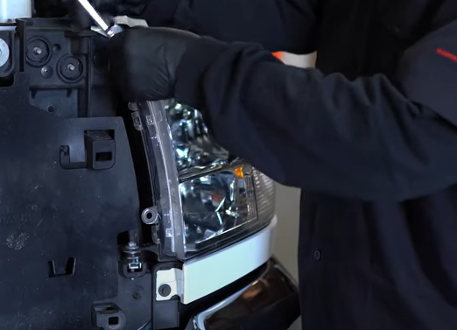

1. Remove (2x) 10mm bolts securing the headlight.



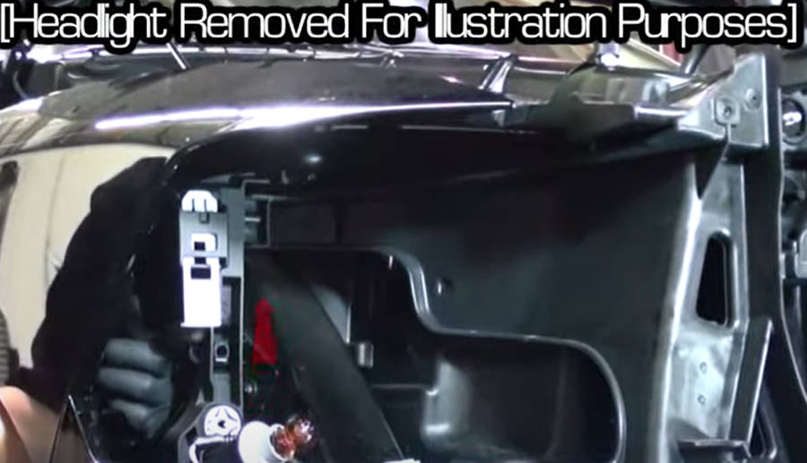

1. From access panel push up on retainer tab to release headlight.

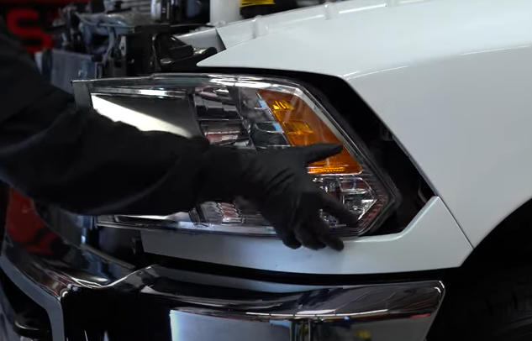

1. Unseat headlight.





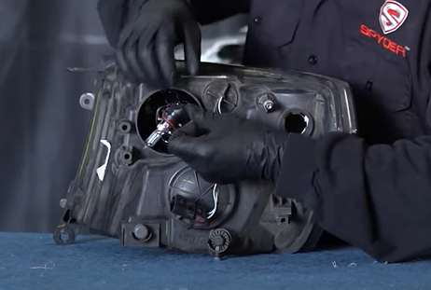

10. Remove high beam bulb from OEM headlight and install into Spyder headlight (Never touch bulbs with bare hands).

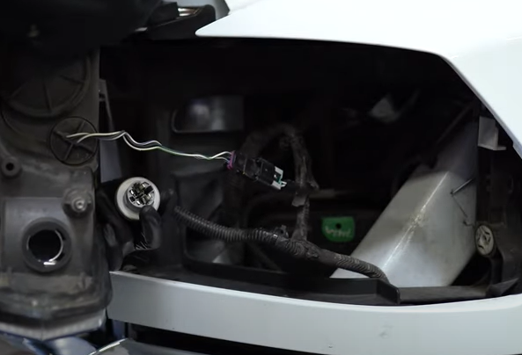

1. Remove turn signal socket and remove bulb. Next disconnect headlight harness.



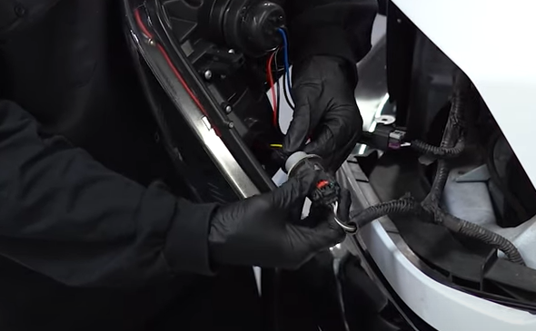

1. Install brake socket insert. (Align black wire from socket to black wire of socket insert). Install bulb socket onto Spyder headlight

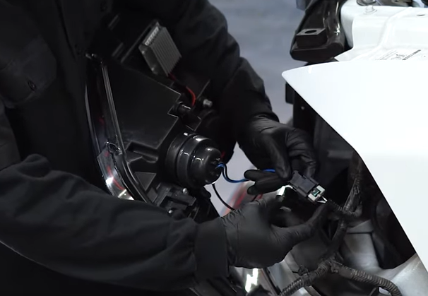

1. Connect Spyder headlight harness.

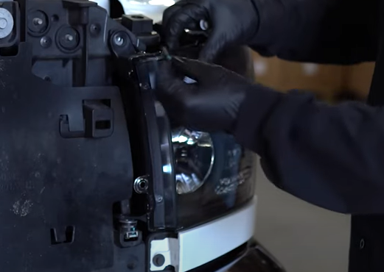

1. Reinstall (2x) 10mm bolts securing the Spyder headlight.

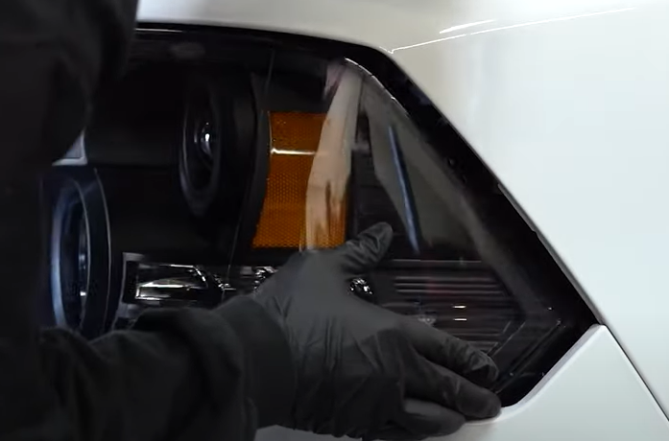

1. Seat Spyder headlight.

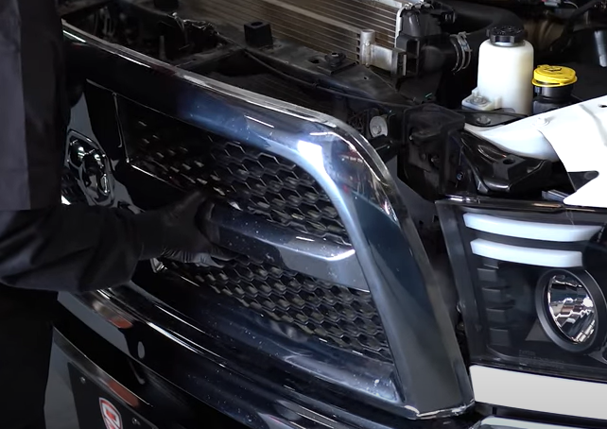

1. Seat grill and reinstall (4x) 10mm bolts.

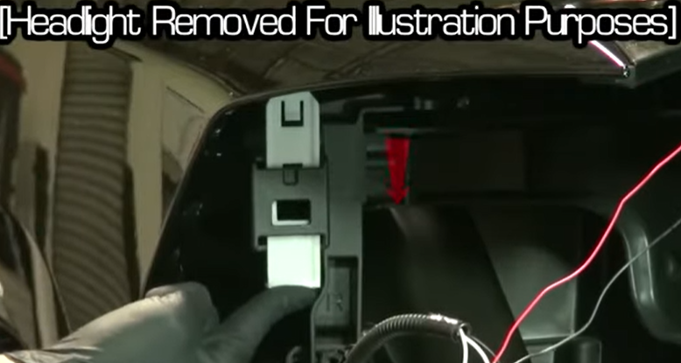

1. Lock retainer slider threw the access panel behind the headlight. Close access panel when done.

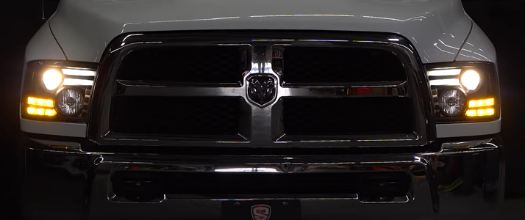

18.Turn on lights and confirm all functions are working properly. You have successfully completed the install of your new Spyder Headlights.

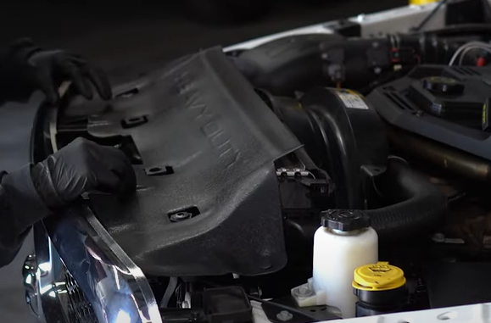

1. Replace radiator shroud and install (4x) plastic retaining clips.



For further help with installation, please watch our installation video. Follow the direct link below to our YouTube channel for more information:

http://www.youtube.com/watch

**DISCLAIMER**

Spyder Auto Installation Guide is not liable for damages, injuries, and death while installing the product. This is intended to be an installation guide, to reduce installation time. We have no responsibility for improper installation. If you do not know how to install, please have a professional install it.