

**Installation Guide:**

PRO-YD-DR06V2-LB-(All)

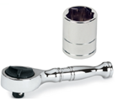Tools Needed:

* ¼” ratchet
* 10mm socket

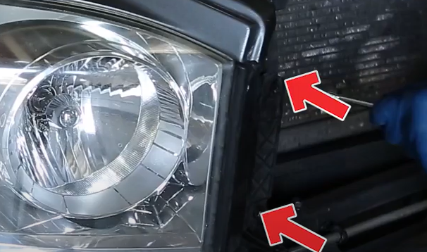

1. Remove (2x) 10mm bolts securing the headlight.

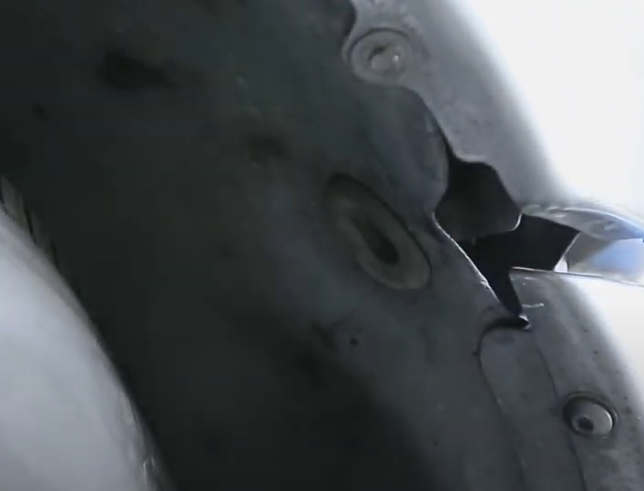

1. Inside the fender well remove plastic plug to gain access to (1x) 10mm nuts securing the headlight.

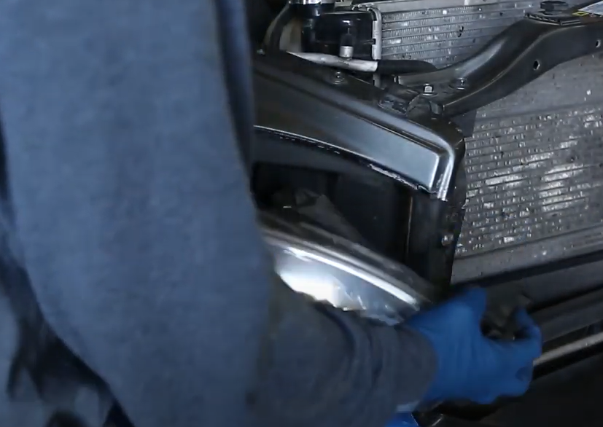

1. Unseat headlight.

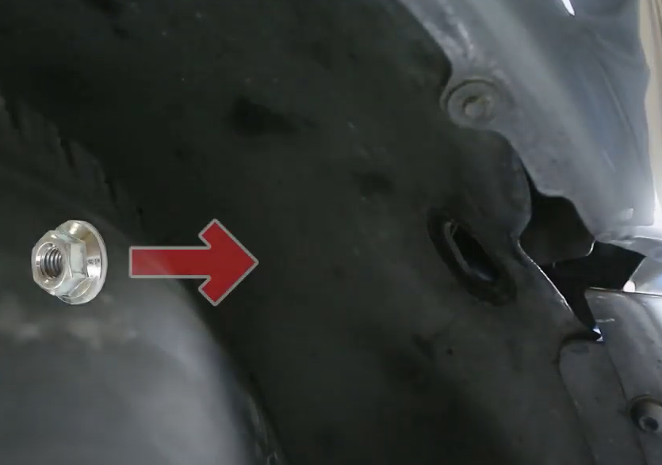

1. Remove (1x) 10mm nut.

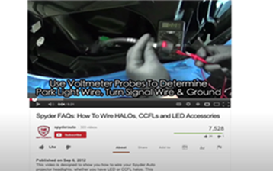

1. For info on how to wire halos please refer to the Spyder FAQ playlist on the Spyder Auto YouTube channel.

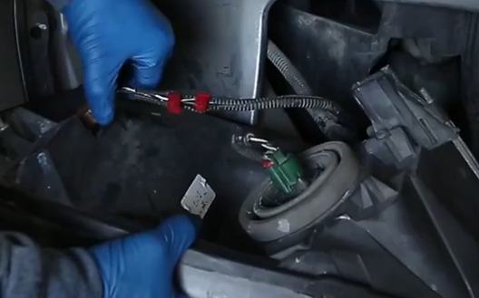

1. Remove headlight harness and turn signal socket.

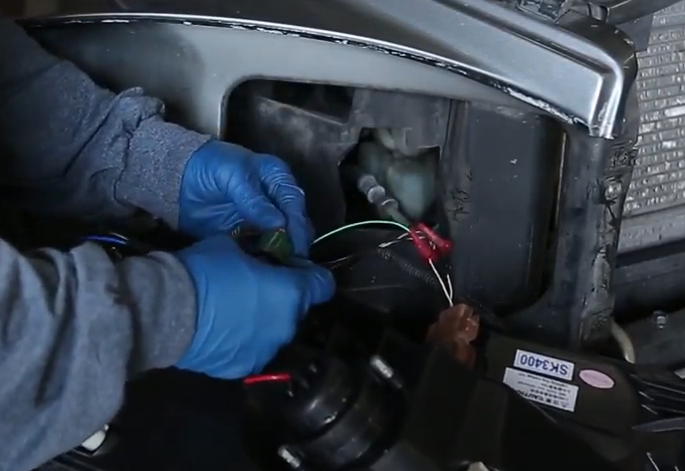

1. Connect Spyder headlight harness and install turn signal socket.

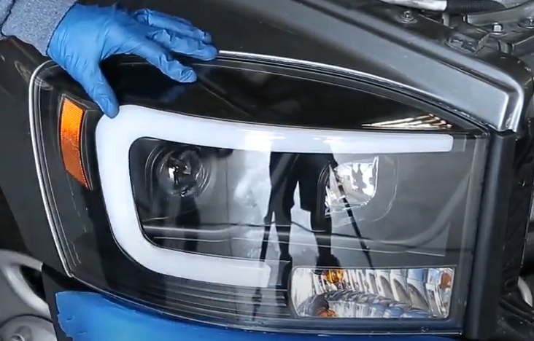

1. Seat Spyder headlight.

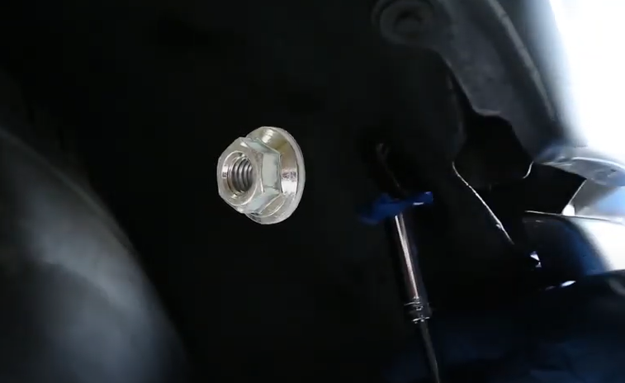

1. Reinstall (1x) 10mm behind headlight inside fender well.

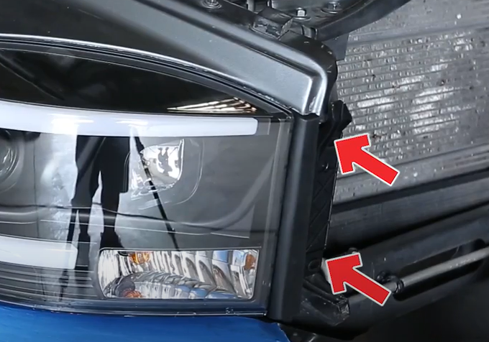

1. Reinstall (2x) 10mm bolts securing the Spyder headlight.

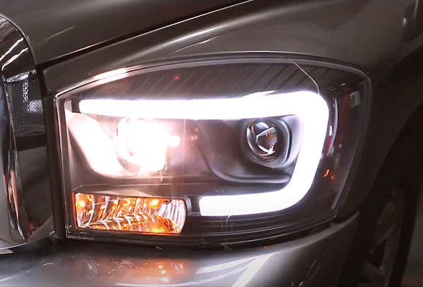

12.Turn on lights and confirm all functions are working properly. You have successfully completed the install of your new Spyder Headlights.

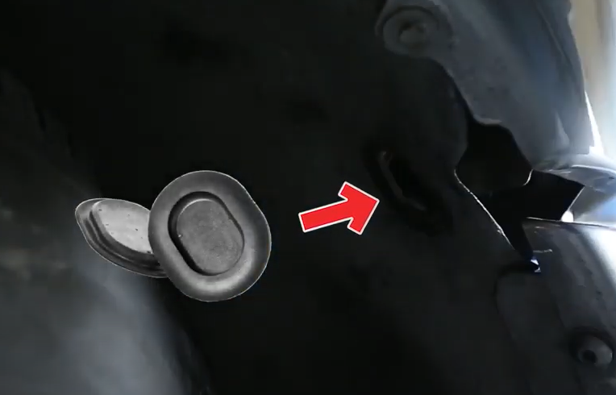

1. Reinstall fender plug.



For further help with installation, please watch our installation video. Follow the direct link below to our YouTube channel for more information:

http://www.youtube.com/watch

**DISCLAIMER**

Spyder Auto Installation Guide is not liable for damages, injuries, and death while installing the product. This is intended to be an installation guide, to reduce installation time. We have no responsibility for improper installation. If you do not know how to install, please have a professional install it.