

**Installation Guide:**

PRO-YD-DR02-CCFL-(All)

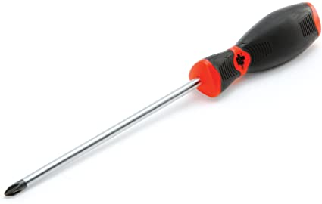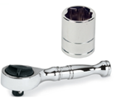Tools Needed:

* ¼” ratchet
* 10mm socket
* Phillips screw driver

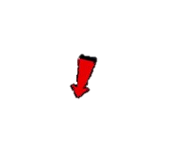

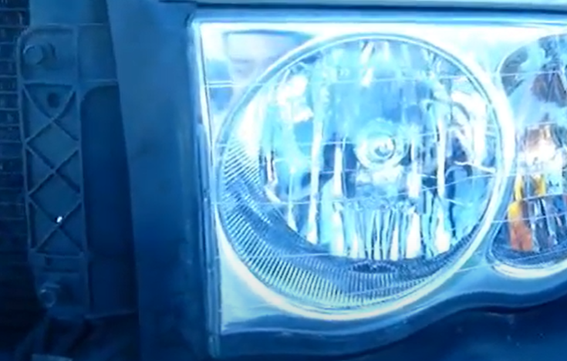

1. Remove (3x) 10mm bolts securing the headlight.

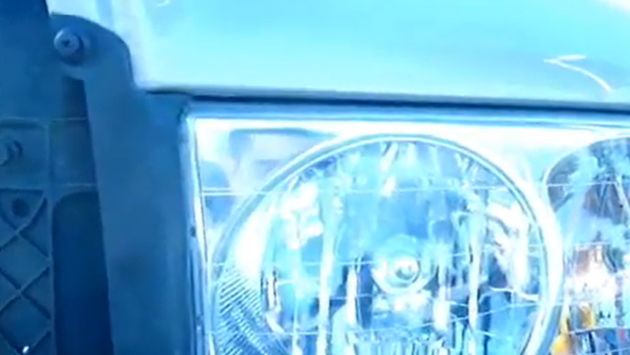

1. Remove (1x) plastic retainer using a phillips screw driver.





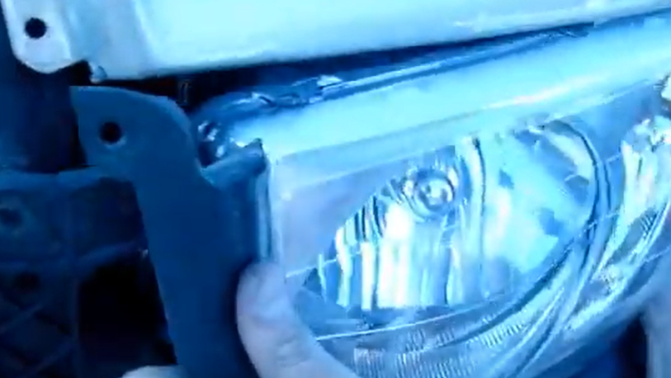

1. Unseat headlight.

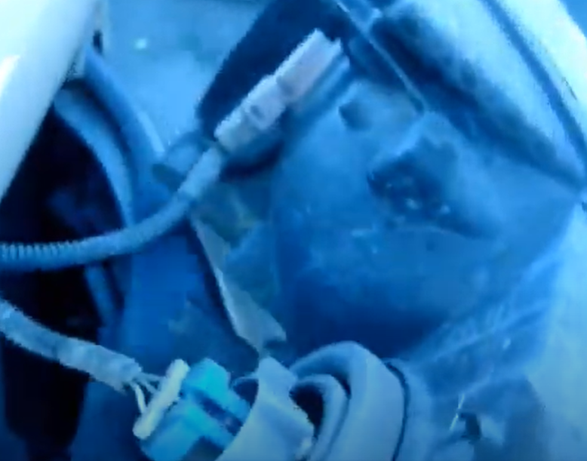

1. Remove turn signal and headlight harness.



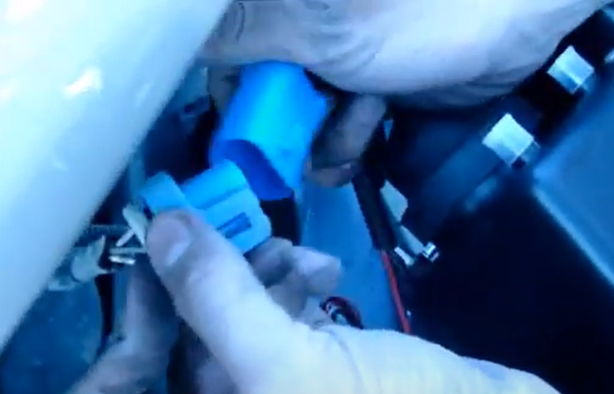

1. Connect Spyder headlight harness.

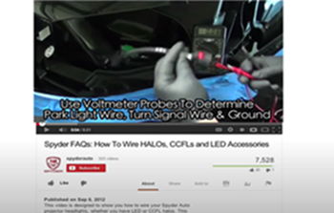

1. For info on how to wire halos please refer to the Spyder FAQ playlist on the Spyder Auto YouTube channel.

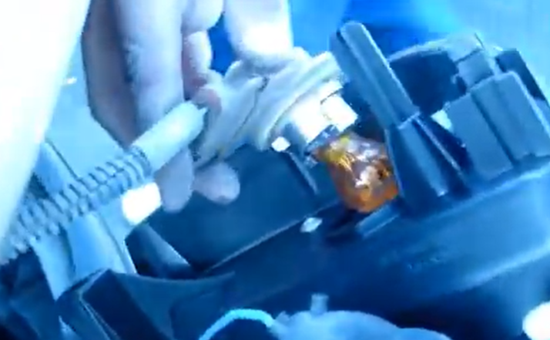

1. Install turn signal socket onto Spyder headlight (Make sure to never touch bulbs with bare hands).

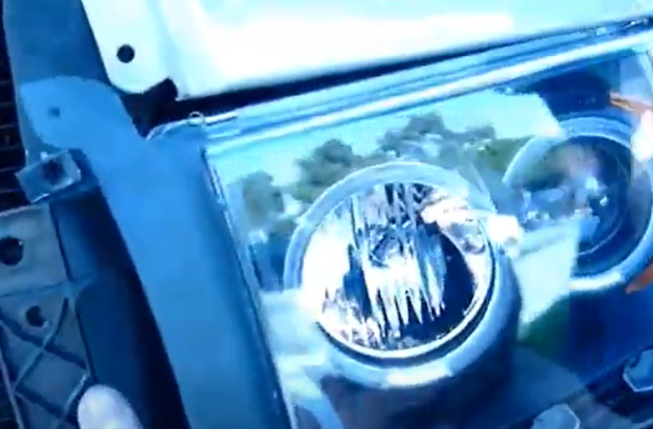

1. Seat Spyder headlight.





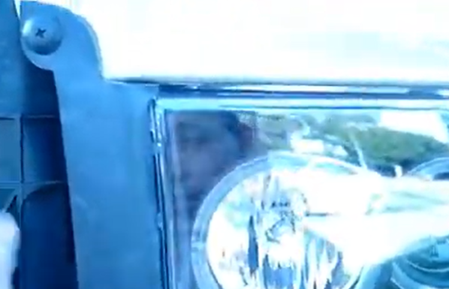

1. Reinstall (1x) plastic retaining clip.

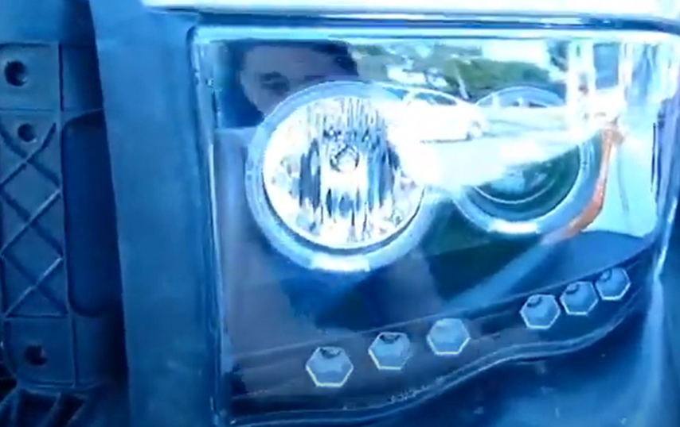

1. Reinstall (3x) 10mm bolts securing the headlight.



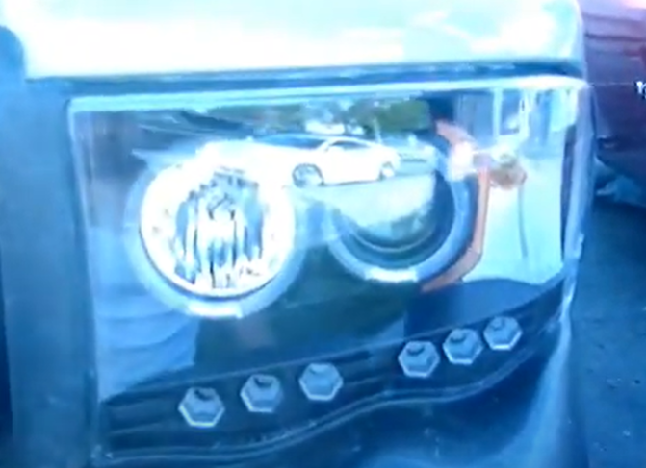

11.Turn on lights and confirm all functions are working properly. You have successfully completed the install of your new Spyder Headlights.



For further help with installation, please watch our installation video. Follow the direct link below to our YouTube channel for more information:

http://www.youtube.com/watch

**DISCLAIMER**

Spyder Auto Installation Guide is not liable for damages, injuries, and death while installing the product. This is intended to be an installation guide, to reduce installation time. We have no responsibility for improper installation. If you do not know how to install, please have a professional install it.