

**Installation Guide:**

PRO-YD-DDU04-LB-(All)

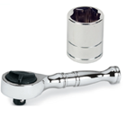Tools Needed:

* ¼” ratchet
* 10mm socket

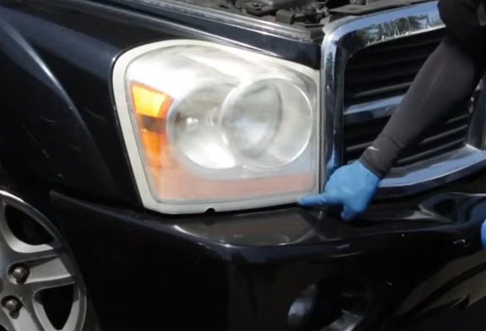

1. Remove (2x) 10mm bolts.

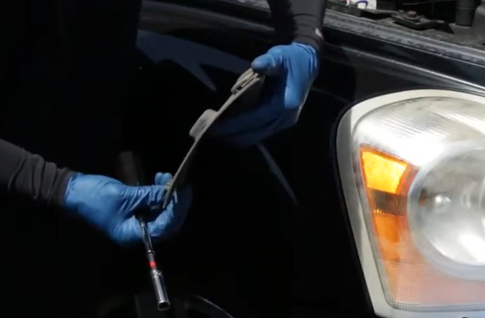

1. Remove rear headlight cover from inside the wheel well.

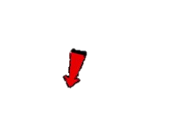



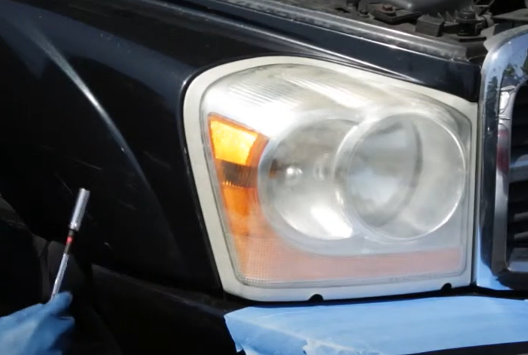

1. Remove (1x) 10mm bolt from inside the wheel well behind the headlight.

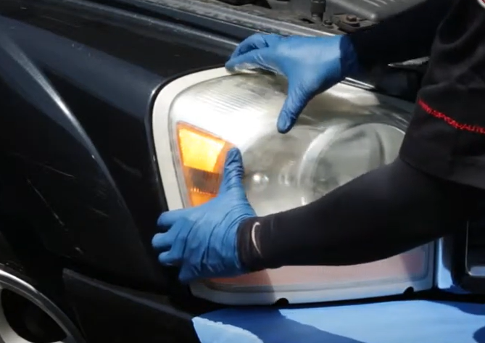

1. Unseat the headlight.

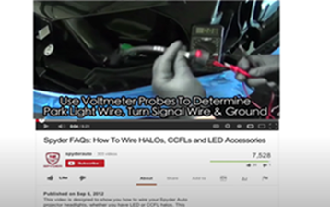

1. For info on how to wire halos please refer to the Spyder FAQ playlist on the Spyder Auto YouTube channel.



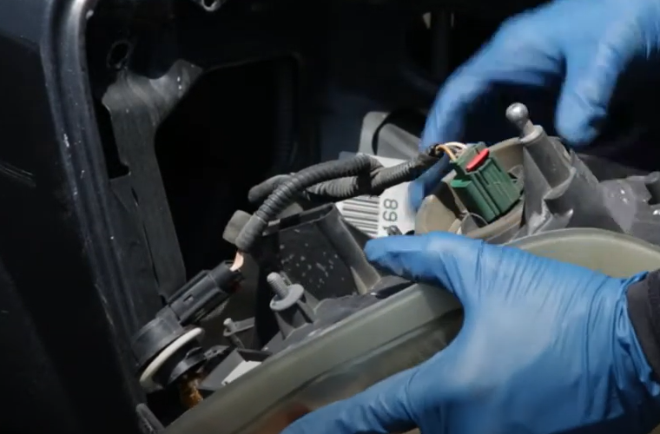

1. Remove headlight harness and unseat signal socket.



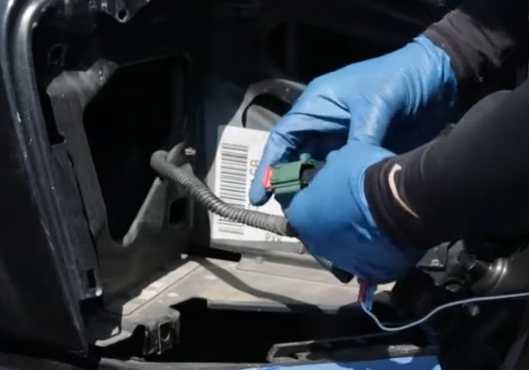

1. Connect headlight harness to Spyder headlight.

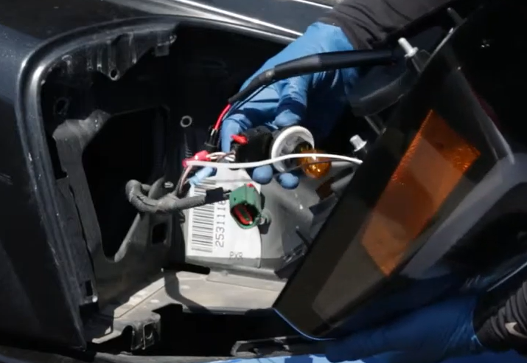

1. Install turn signal bulb socket onto Spyder headlight.





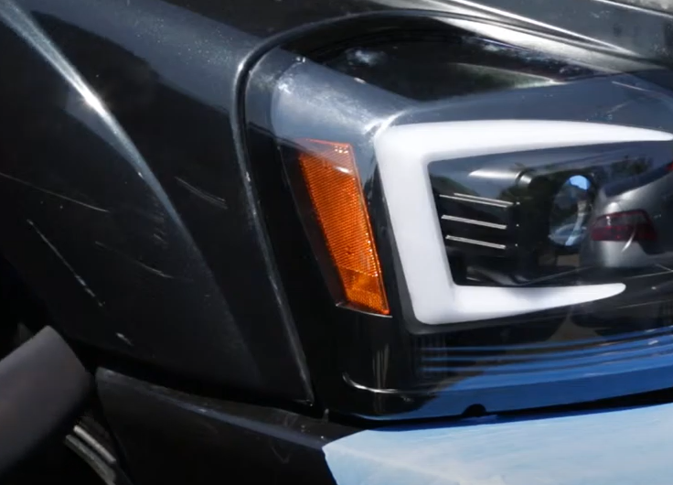

1. Reinstall (1x) 10mm bolt behind the headlight and reinstall rear headlight cover.

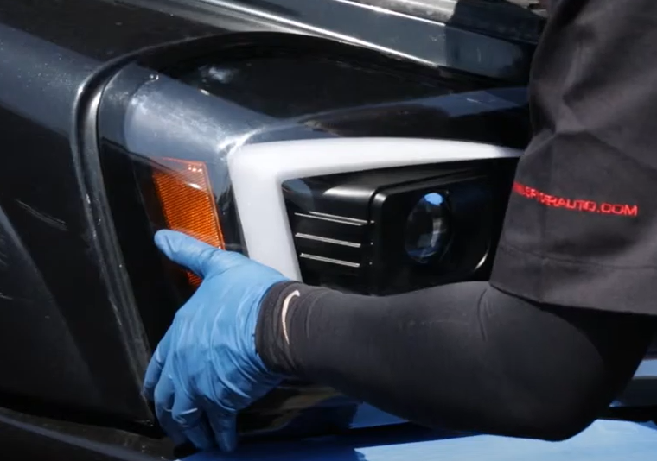

1. Seat Spyder headlight.

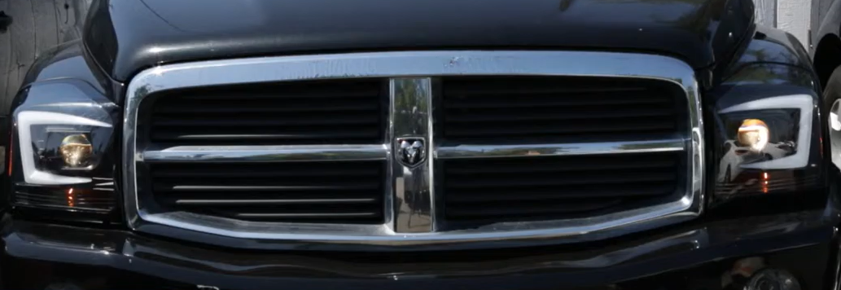

12.Turn on lights and confirm all functions are working properly. You have successfully completed the install of your new Spyder Headlights.

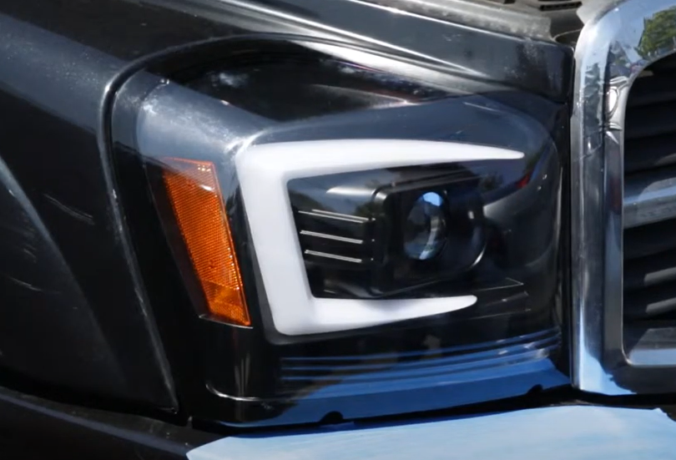

1. Reinstall (2x) 10mm bolts securing the headlight.





For further help with installation, please watch our installation video. Follow the direct link below to our YouTube channel for more information:

http://www.youtube.com/watch

**DISCLAIMER**

Spyder Auto Installation Guide is not liable for damages, injuries, and death while installing the product. This is intended to be an installation guide, to reduce installation time. We have no responsibility for improper installation. If you do not know how to install, please have a professional install it.