Installation Guide:
PRO-YD-CHIP00-CCFL-(All)

Tools Needed:
- None

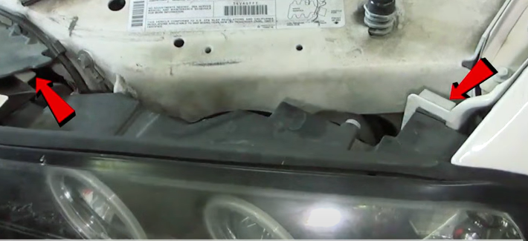
- Remove (2x) plastic pull tabs by pulling upward.
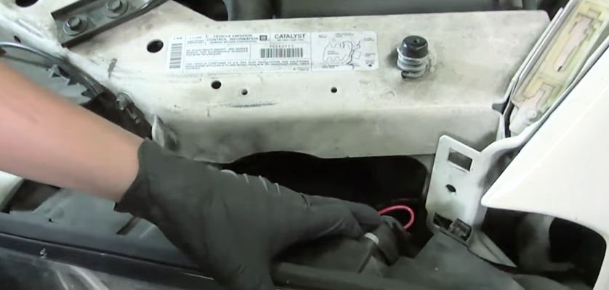
- Unseat headlight.

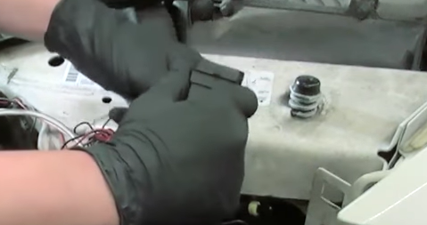
- Disconnect headlight wiring harness.
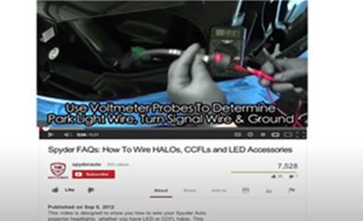
- For info on how to wire halos please refer to the Spyder FAQ playlist on the Spyder Auto YouTube channel.

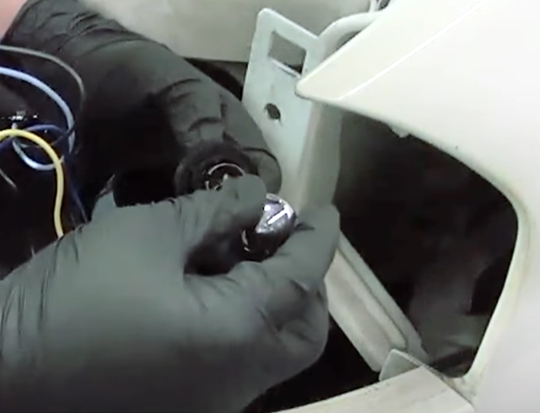
- Install corner lamp bulb onto Spyder headlight from OEM headlight (Make sure to never touch bulb with bare hands).
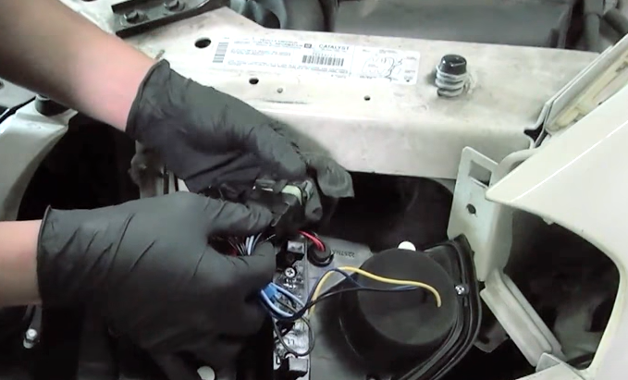
- Connect Spyder headlight harness.

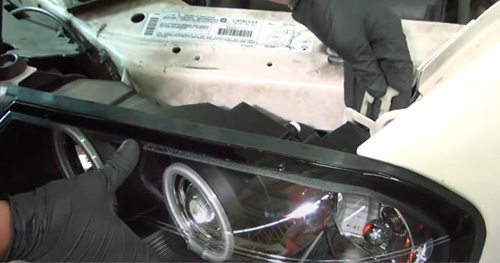
- Reinstall (2x) plastic tabs securing the headlight.
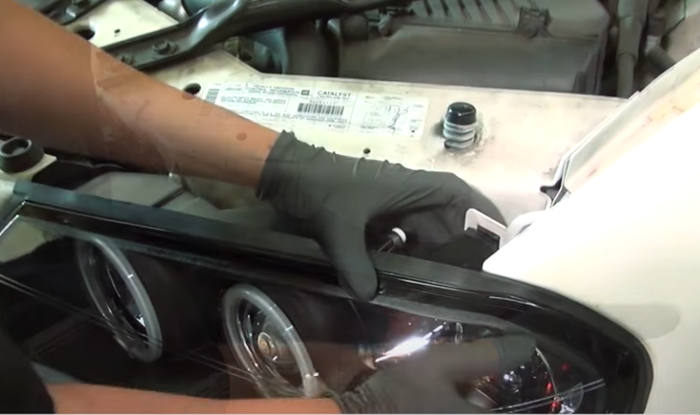
- Seat Spyder headlight.

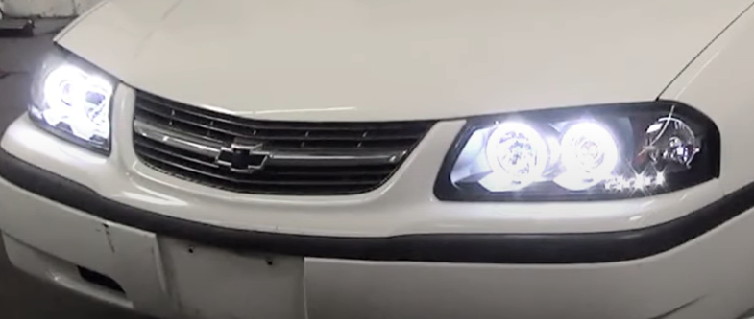
9.Turn on lights and confirm all functions are working properly. You have successfully completed the install of your new Spyder Headlights.

For further help with installation, please watch our installation video. Follow the direct link below to our YouTube channel for more information:
http://www.youtube.com/watch

DISCLAIMER
Spyder Auto Installation Guide is not liable for damages, injuries, and death while installing the product. This is intended to be an installation guide, to reduce installation time. We have no responsibility for improper installation. If you do not know how to install, please have a professional install it.

