Installation Guide:
PRO-YD-CDE00V2-LB-(All)

Tools Needed:
- None

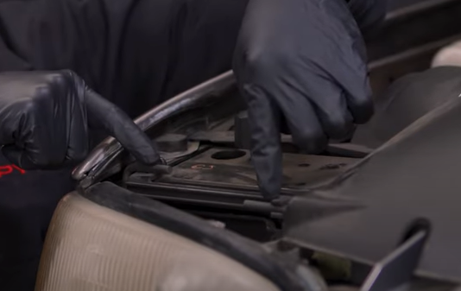
- Push the two rods show here forward and pull up to release the headlight.
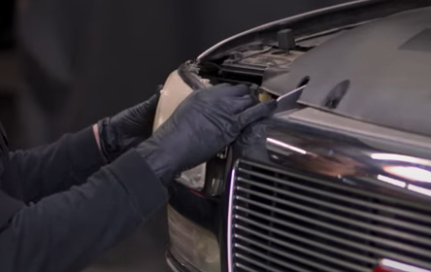
- Unseat headlight.

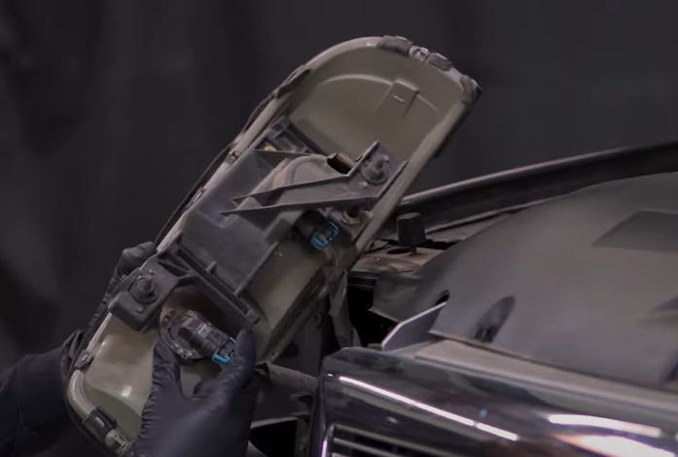
- Remove high beam bulb by turning it clock wise (Never touch bulbs with bare hands).
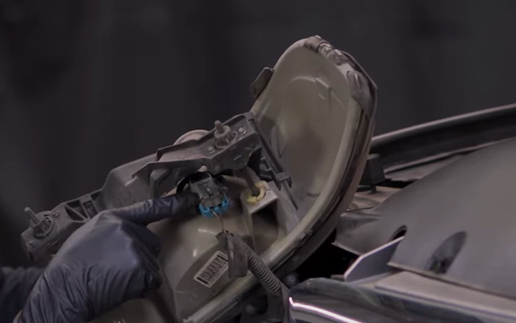
- Disconnect low beam harness.

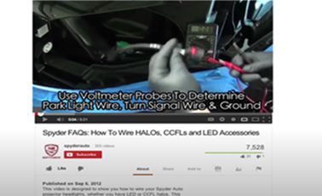
- For info on how to wire halos please refer to the Spyder FAQ playlist on the Spyder Auto YouTube channel.
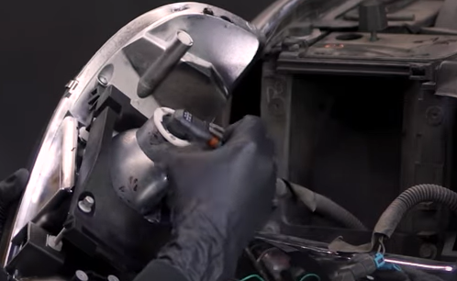
- Connect low beam harness to Spyder headlight.

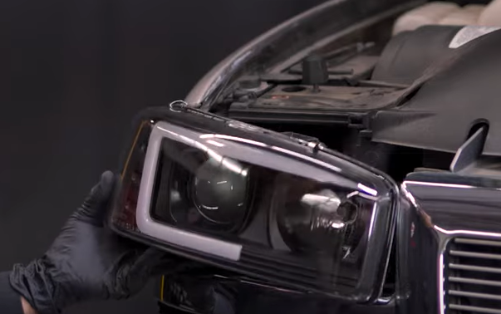
- Seat Spyder headlight.
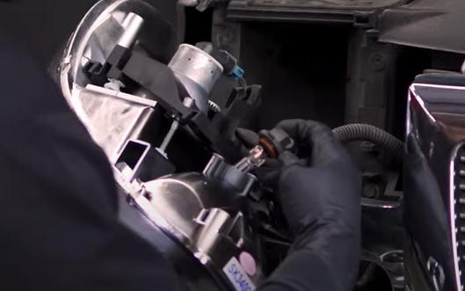
- Install high beam bulb onto Spyder headlight.

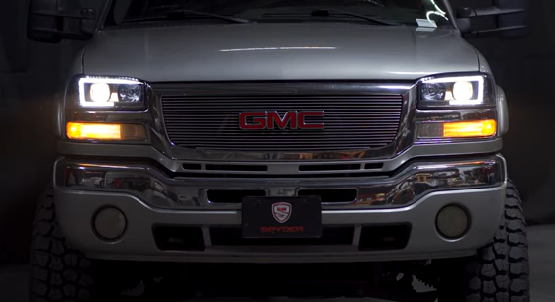
10.Turn on lights and confirm all functions are working properly. You have successfully completed the install of your new Spyder Headlights.
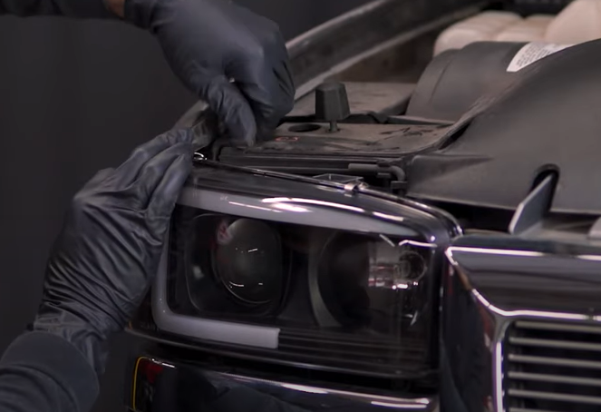
- Reinstall (2x) rods securing the headlight.

For further help with installation, please watch our installation video. Follow the direct link below to our YouTube channel for more information:
http://www.youtube.com/watch

DISCLAIMER
Spyder Auto Installation Guide is not liable for damages, injuries, and death while installing the product. This is intended to be an installation guide, to reduce installation time. We have no responsibility for improper installation. If you do not know how to install, please have a professional install it.

