

**Installation Guide:**

PRO-YD-CCOB05-CCFL-(All)

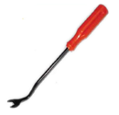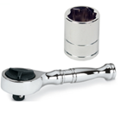Tools Needed:

* ¼” ratchet
* 10mm socket
* Panel popper

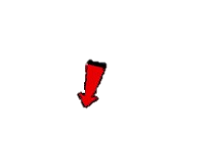





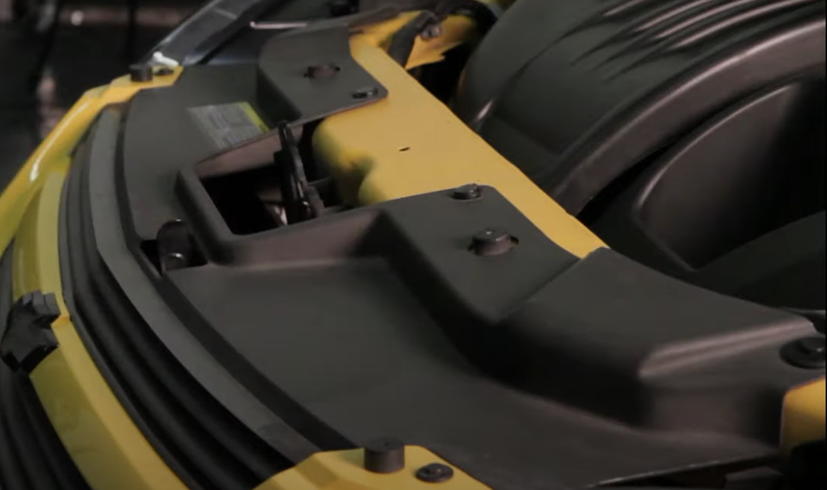

1. Remove (6x) plastic clips securing the bumper fascia.

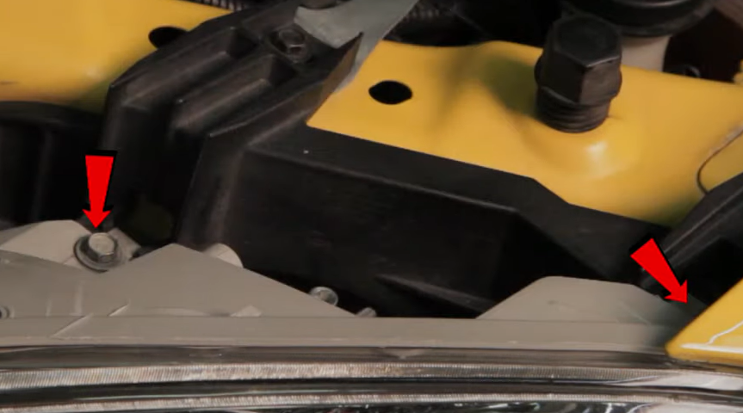

1. Remove (2x) 10mm bolts securing the headlight.





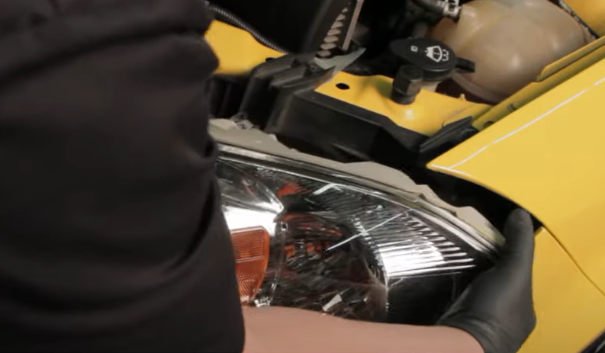

1. Unseat the headlight.

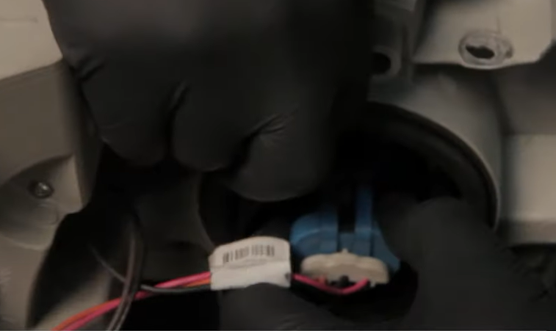

1. Disconnect headlight harness.

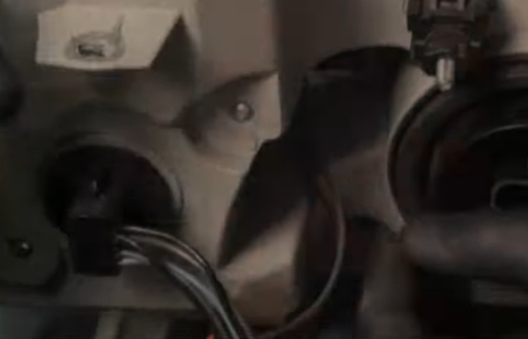

1. Remove turn signal and city light sockets.

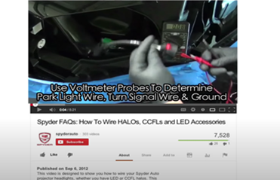

1. For info on how to wire halos please refer to the Spyder FAQ playlist on the Spyder Auto YouTube channel.





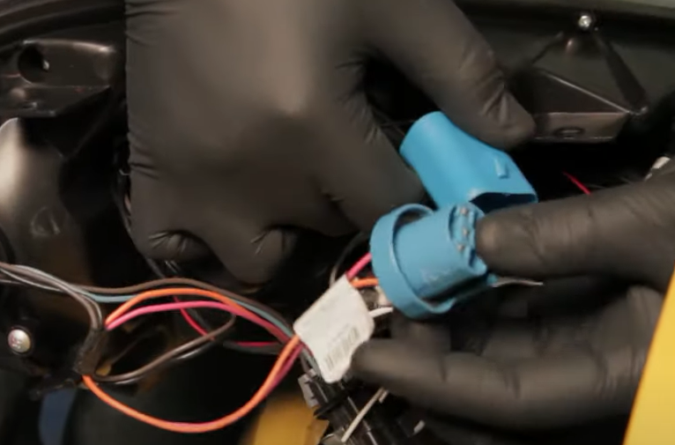

1. Connect headlight harness.

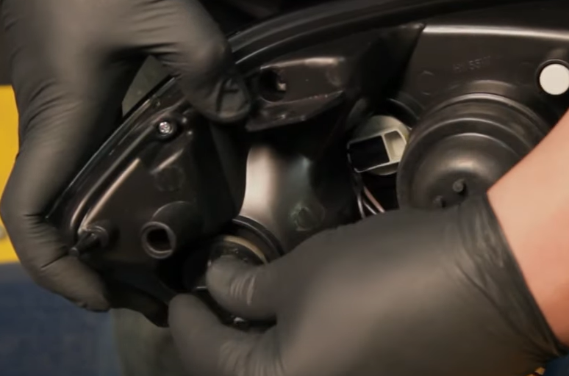

1. Install turn signal and city light sockets onto Spyder headlight.



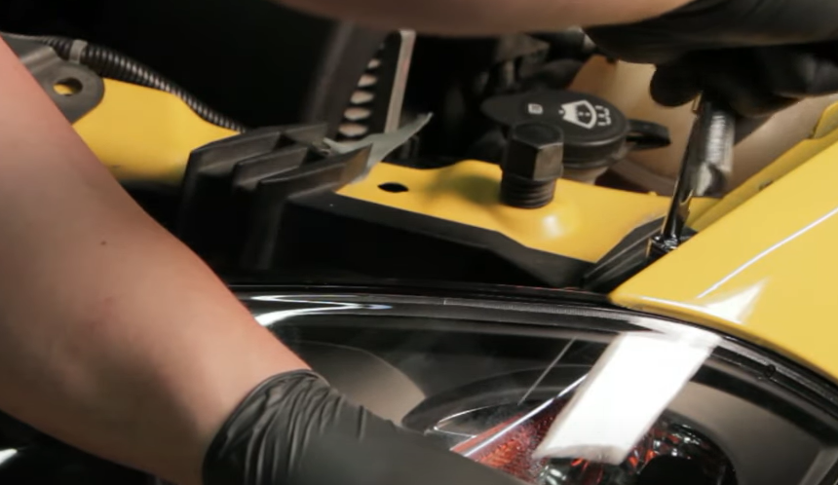

1. Reinstall (2x) 10mm bolts securing the headlight.

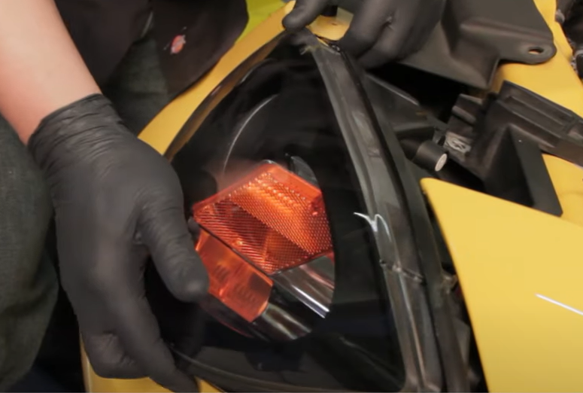

1. Seat Spyder headlight.

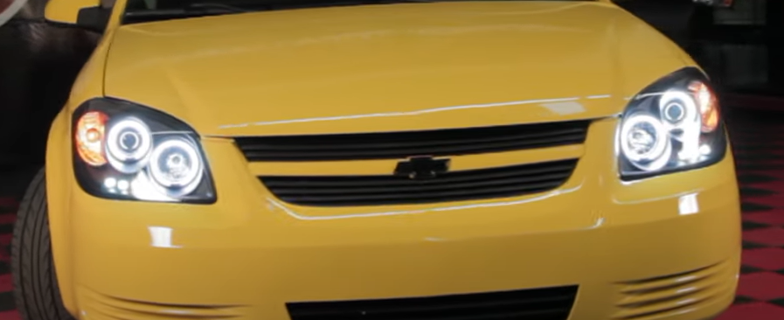

12.Turn on lights and confirm all functions are working properly. You have successfully completed the install of your new Spyder Headlights.

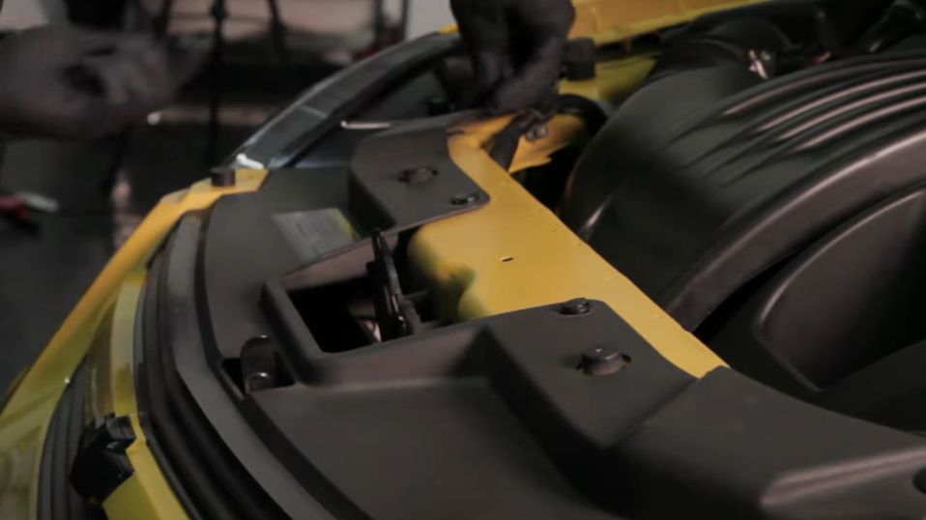

1. Reinstall (6x) plastic clips securing the front bumper fascia.



For further help with installation, please watch our installation video. Follow the direct link below to our YouTube channel for more information:

http://www.youtube.com/watch

**DISCLAIMER**

Spyder Auto Installation Guide is not liable for damages, injuries, and death while installing the product. This is intended to be an installation guide, to reduce installation time. We have no responsibility for improper installation. If you do not know how to install, please have a professional install it.