Installation Guide:
PRO-YD-CCAM98-HL-(All)

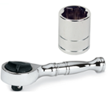
Tools Needed:
- ¼” ratchet
- 8mm and 10mm socket

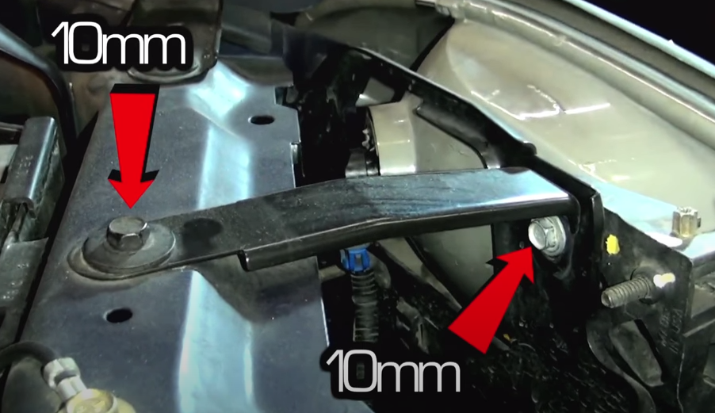
- Remove (2x) 10mm bolts securing the headlight.
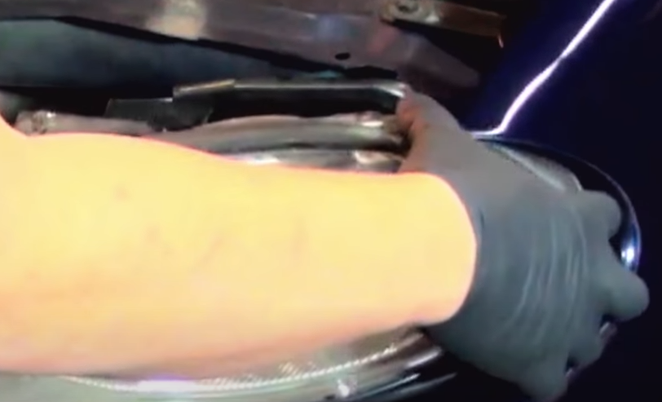
- Unseat headlight.

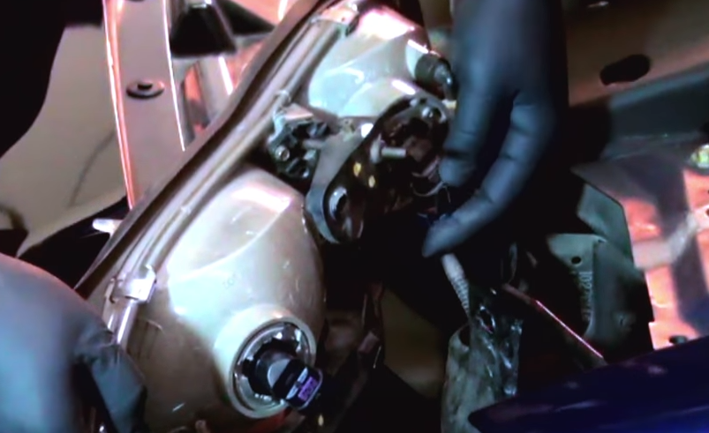
- Disconnect high and low beam harnesses.
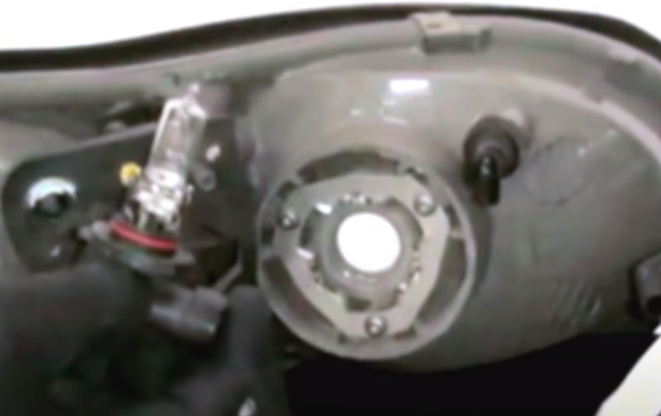
- Remove high beam bulb from OEM headlight (Never touch bulbs with bare hands).

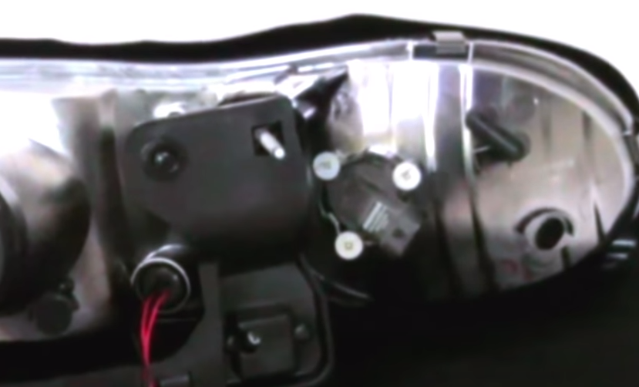
- Install high beam bulb into Spyder headlight.
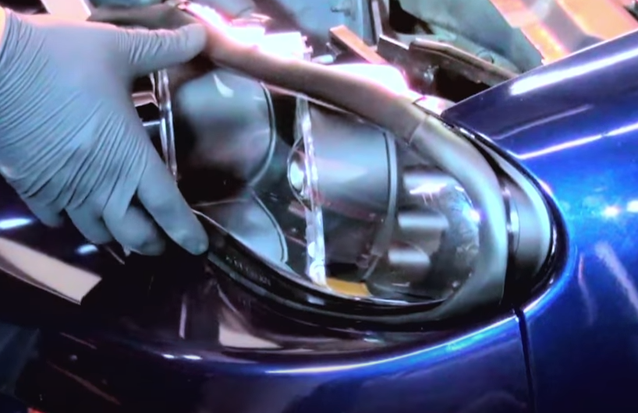
- Seat Spyder headlight.

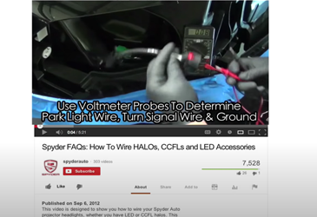
- For info on how to wire halos please refer to the Spyder FAQ playlist on the Spyder Auto YouTube channel.
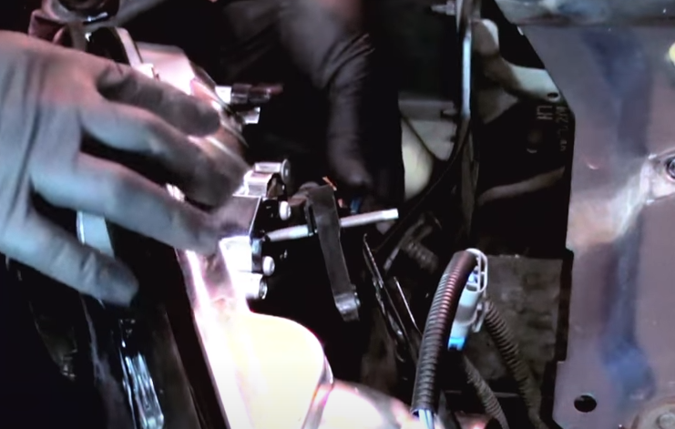
- Connect high and low beam harnesses.

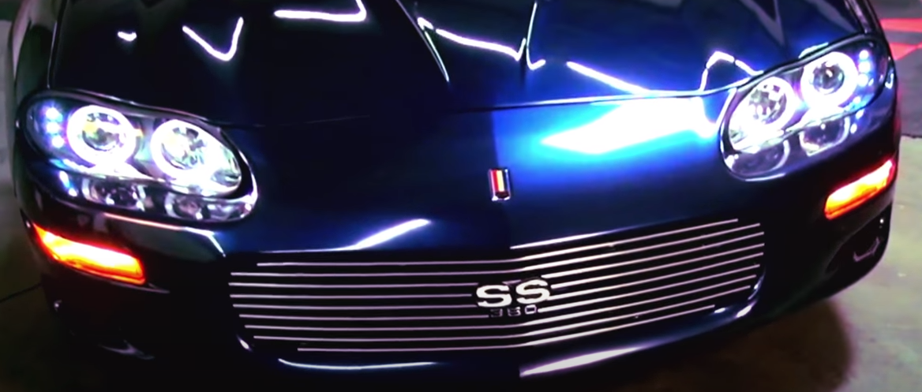
10.Turn on lights and confirm all functions are working properly. You have successfully completed the install of your new Spyder Headlights.
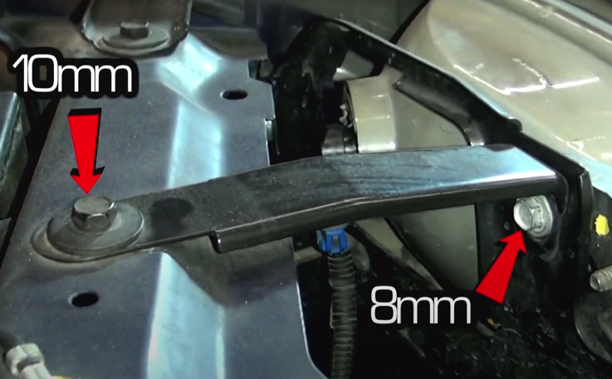
- Reinstall (1x) 10mm bolts and (1x) 8mm bolt that was included.

For further help with installation, please watch our installation video. Follow the direct link below to our YouTube channel for more information:
http://www.youtube.com/watch

DISCLAIMER
Spyder Auto Installation Guide is not liable for damages, injuries, and death while installing the product. This is intended to be an installation guide, to reduce installation time. We have no responsibility for improper installation. If you do not know how to install, please have a professional install it.

