Installation Guide:
ALT-YD-TT16-LED-(All)

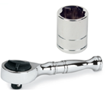
Tools Needed:
- ¼” ratchet
- 10mm socket

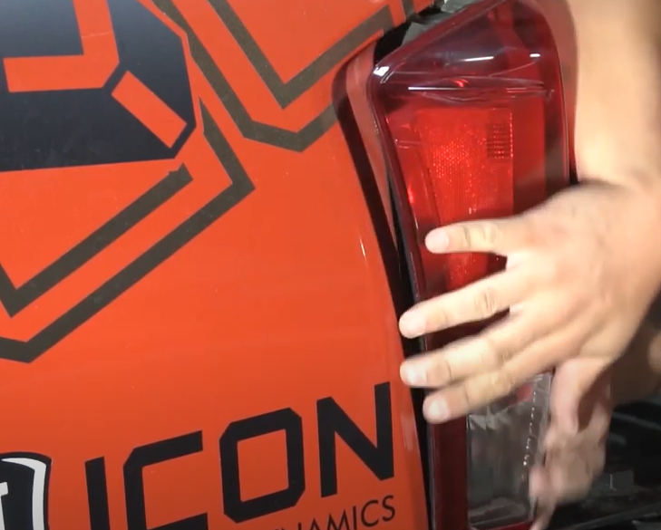
- Unseat tail light.
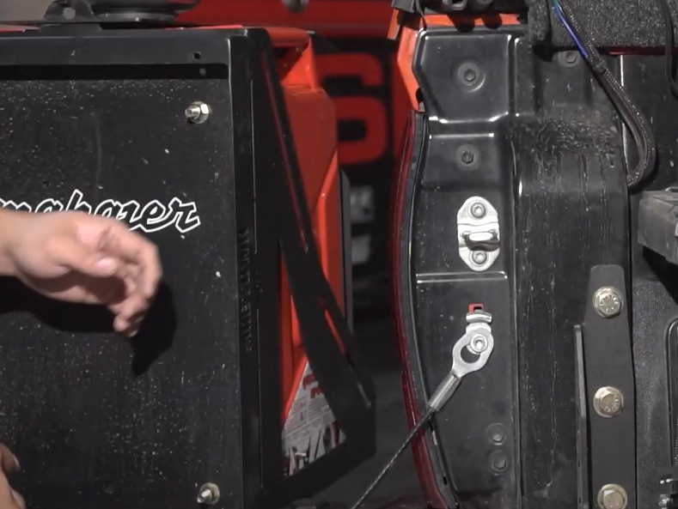
- Remove (2x) 10mm bolts.

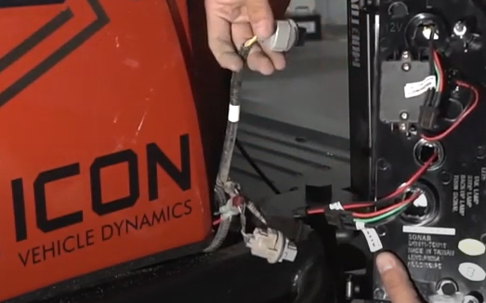
- Remove (3x) bulbs from the sockets.
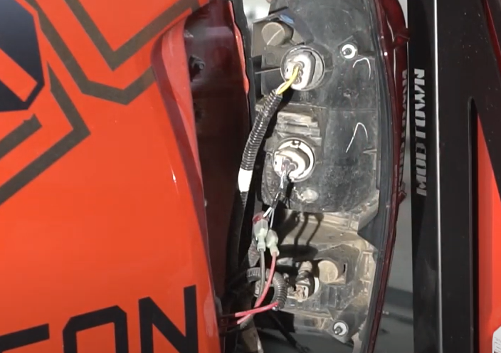
- Remove (3x) bulb sockets.

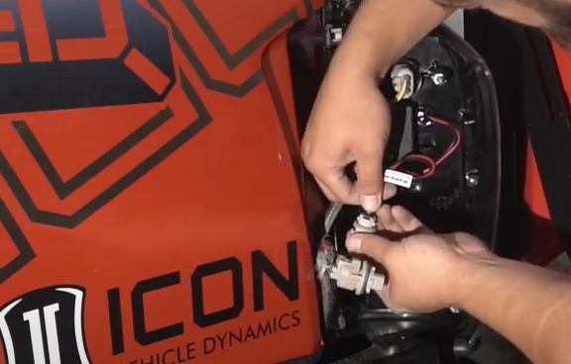
6. Install middle socket insert. (Align red wire from socket to red wire of socket insert) Reinstall socket.
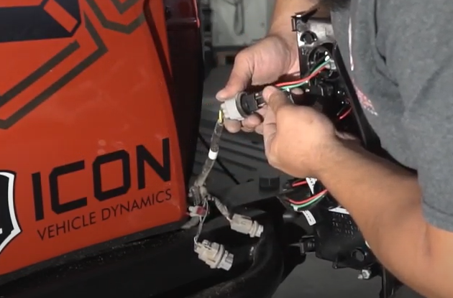
5. Install top socket inserts. (Align yellow wire from socket to red wire of socket insert) Reinstall socket.

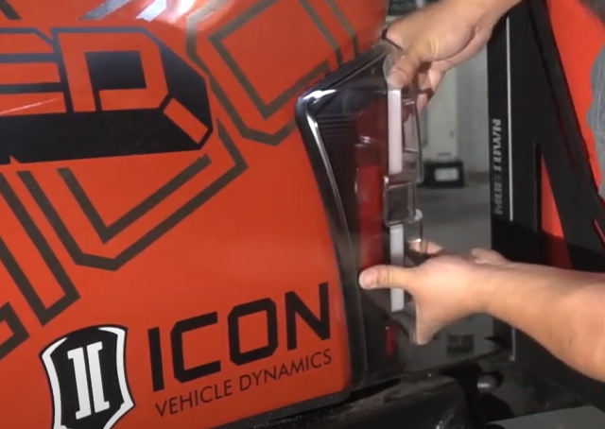
- Seat Spyder tail light.
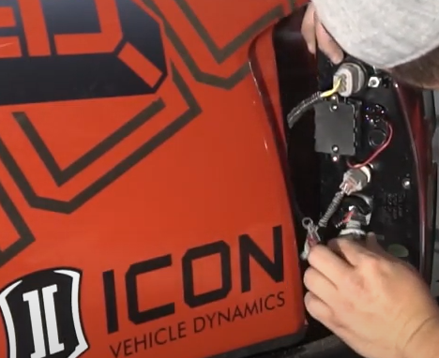
- Install bottom socket insert. (Align blue wire from socket to red wire of socket insert) Reinstall socket.

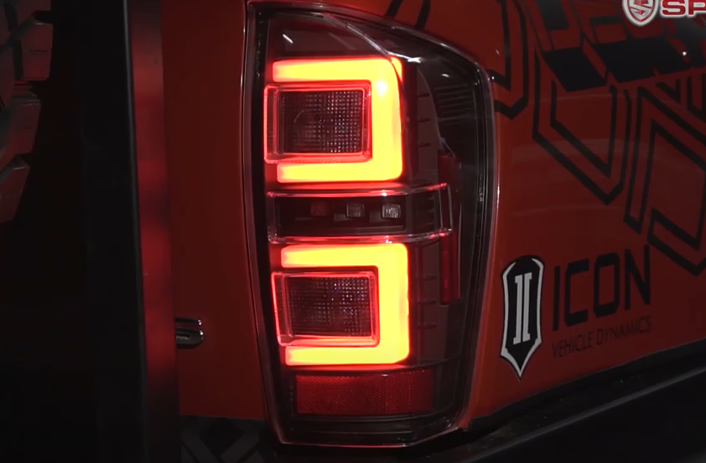
10.Turn on lights and confirm all functions are working properly. You have successfully completed the install of your new Spyder LED tail lights.
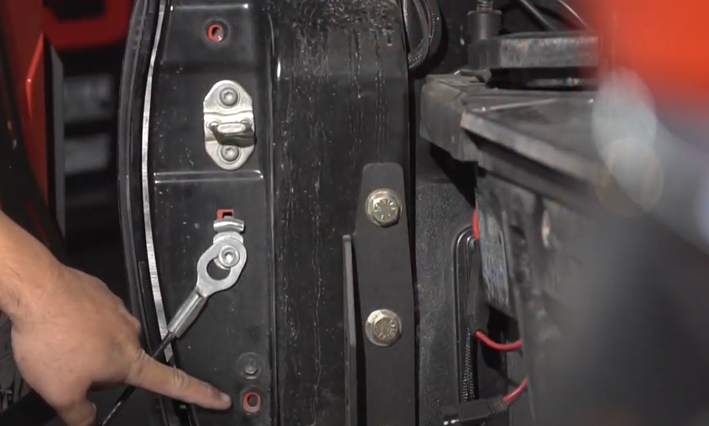
- Reinstall (2x) 10mm bolts.

For further help with installation, please watch our installation video. Follow the direct link below to our YouTube channel for more information:
http://www.youtube.com/watch

DISCLAIMER
Spyder Auto Installation Guide is not liable for damages, injuries, and death while installing the product. This is intended to be an installation guide, to reduce installation time. We have no responsibility for improper installation. If you do not know how to install, please have a professional install it.

