

**Installation Guide:**

ALT-YD-TT05-LED-(All)

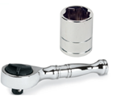Tools Needed:

* ¼” ratchet
* 10mm socket

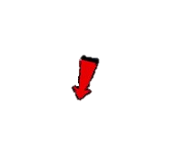

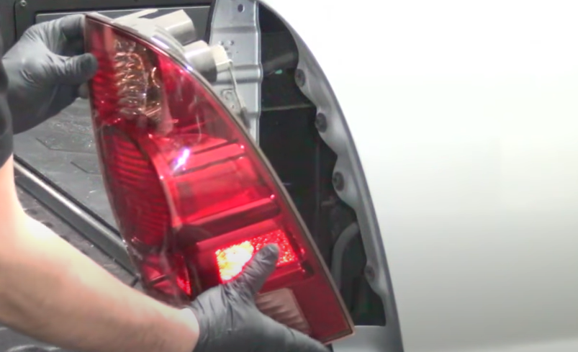

1. Unseat tail light.

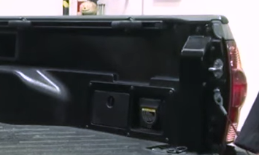

1. Remove (2x) 10mm bolts.



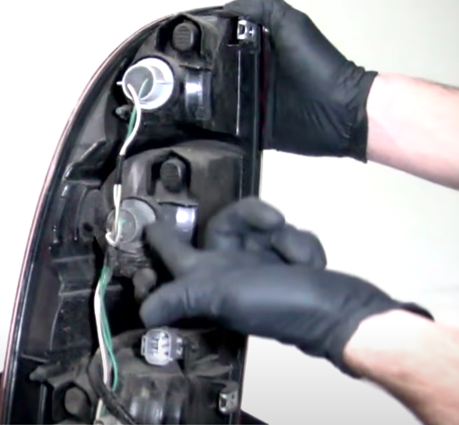

1. Remove bulb sockets and wiring harness.

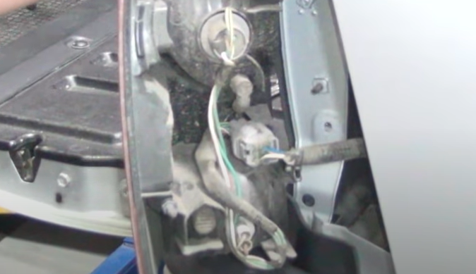

1. Disconnect wire harness.



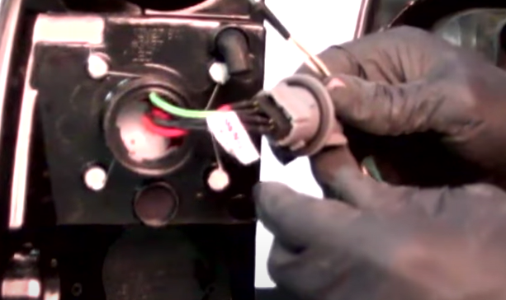

6. Remove brake light bulb and install socket insert. (Align black wire from socket to black wire of socket insert)

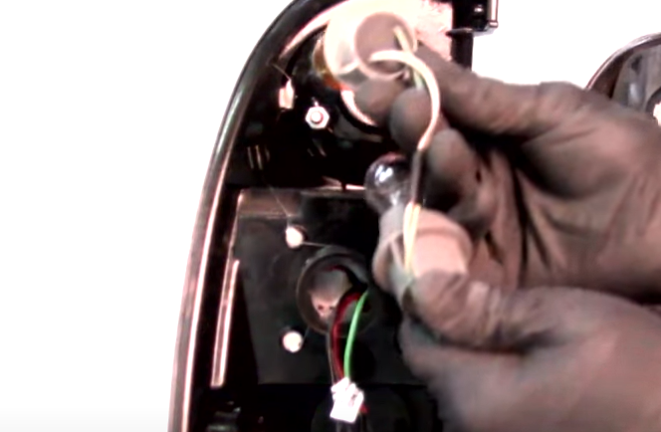

5. Transfer harness to Spyder tail light. Install turn signal socket into Spyder tail light.

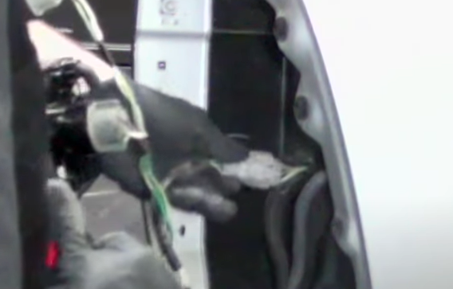

1. Connect Spyder tail light harness.

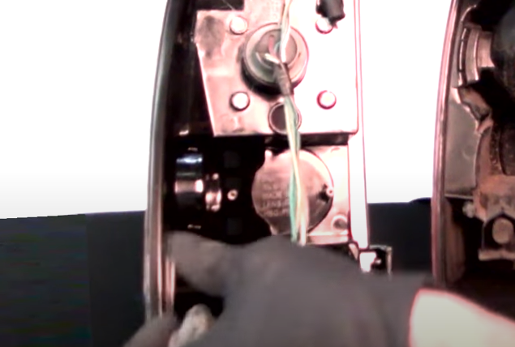

1. Install brake and reverse light bulb sockets onto Spyder tail light.

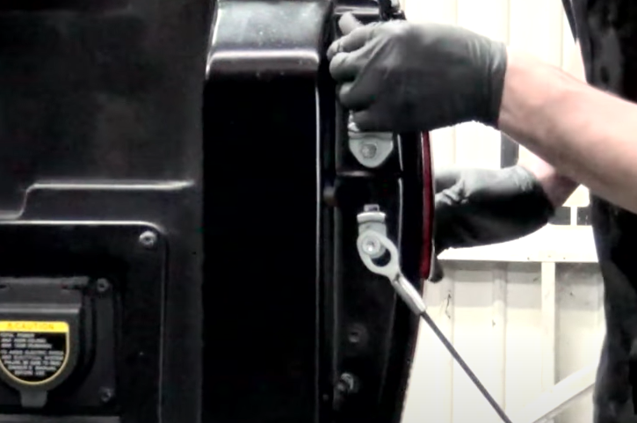

1. Reinstall (2x) 10mm bolts.

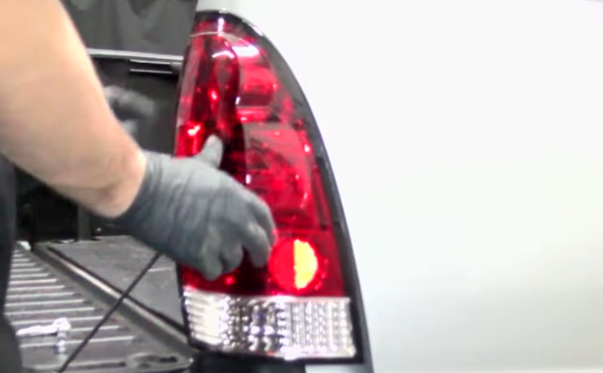

1. Seat Spyder tail light.

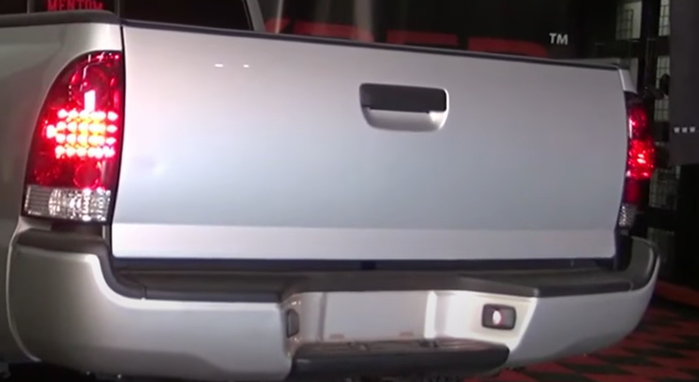

11.Turn on lights and confirm all functions are working properly. You have successfully completed the install of your new Spyder LED tail lights.



For further help with installation, please watch our installation video. Follow the direct link below to our YouTube channel for more information:

http://www.youtube.com/watch

**DISCLAIMER**

Spyder Auto Installation Guide is not liable for damages, injuries, and death while installing the product. This is intended to be an installation guide, to reduce installation time. We have no responsibility for improper installation. If you do not know how to install, please have a professional install it.