Installation Guide:
ALT-YD-TT01-LED-(All)

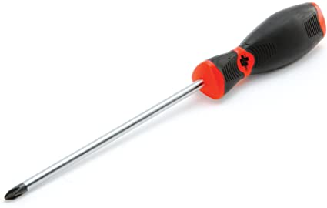
Tools Needed:
- Phillips screwdriver

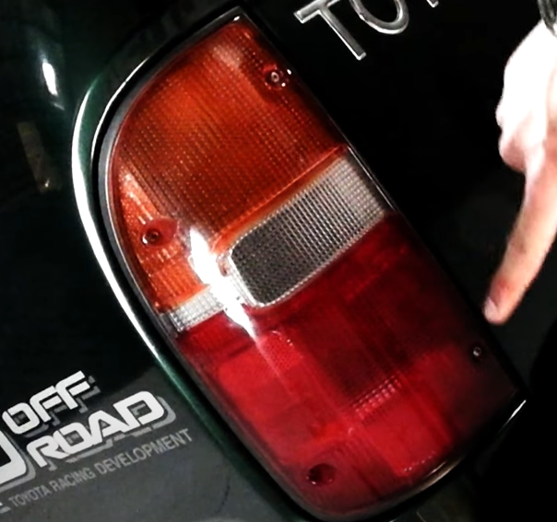
- Remove (4x) phillips screws.
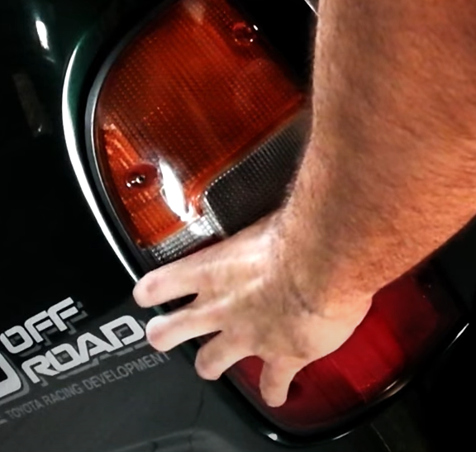
- Unseat tail light.

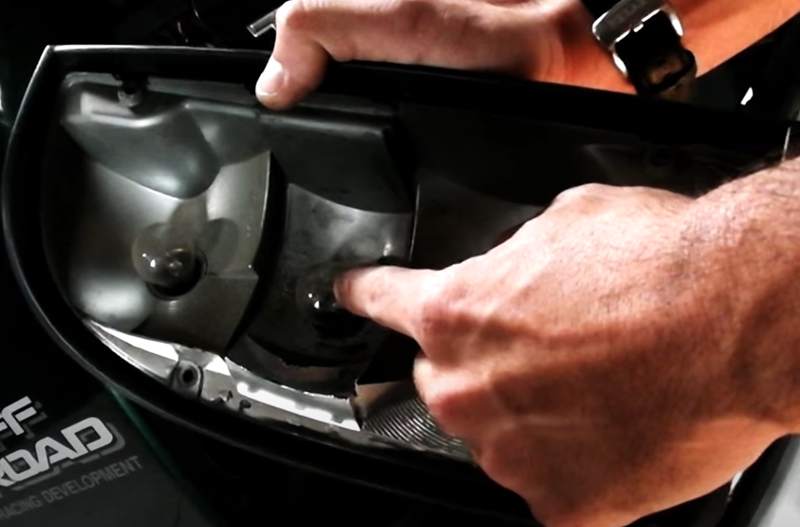
- Separate factory tail light and remove reverse light bulb. (Never touch bulbs with bare hands)
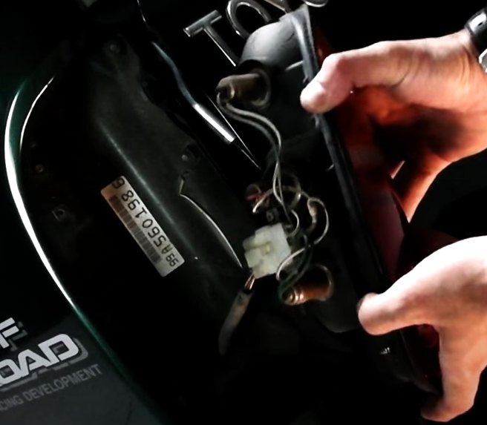
- Disconnect wire harness.

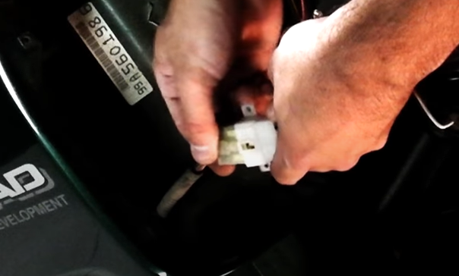
6. Connect Spyder tail light harness.
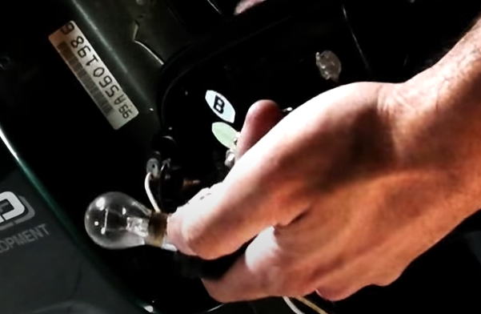
5. Transfer bulb to Spyder tail light reverse light socket.

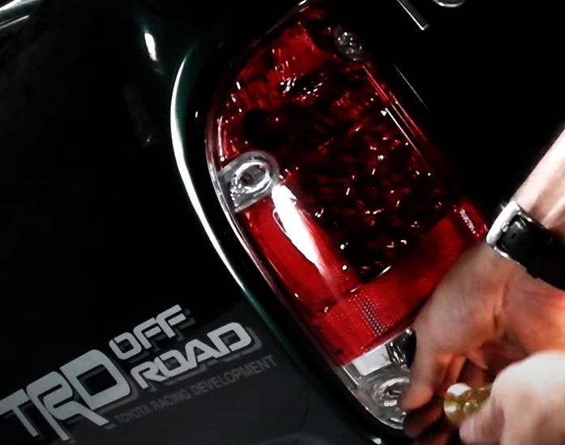
- Reinstall (4x) phillips screws.
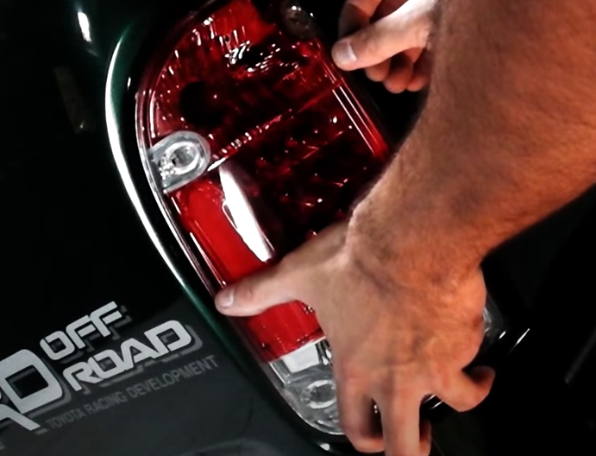
- Seat Spyder tail light.

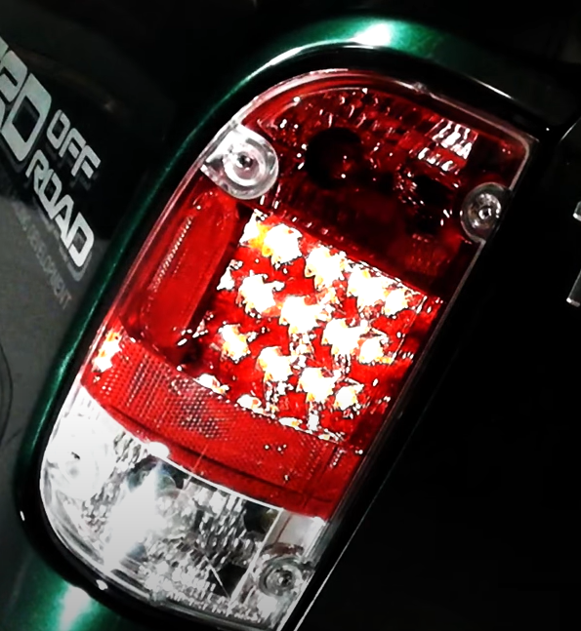
9. Turn on lights and confirm all functions are working properly. You have successfully completed the install of your new Spyder LED tail lights.

For further help with installation, please watch our installation video. Follow the direct link below to our YouTube channel for more information:
http://www.youtube.com/watch

DISCLAIMER
Spyder Auto Installation Guide is not liable for damages, injuries, and death while installing the product. This is intended to be an installation guide, to reduce installation time. We have no responsibility for improper installation. If you do not know how to install, please have a professional install it.

