

**Installation Guide:**

ALT-YD-SFRS12-LBLED-(All)

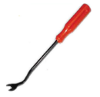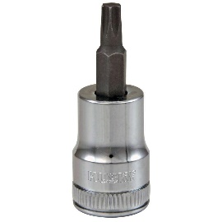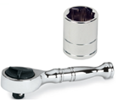Tools Needed:

* ¼” ratchet
* 8mm socket
* Panel popper

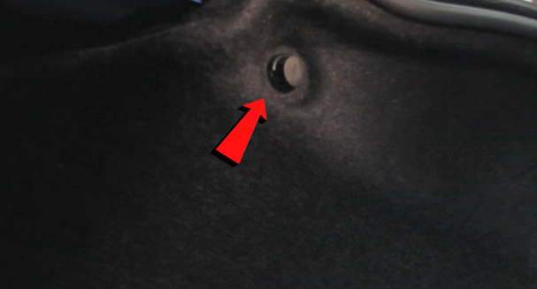

1. Remove plastic retainer.

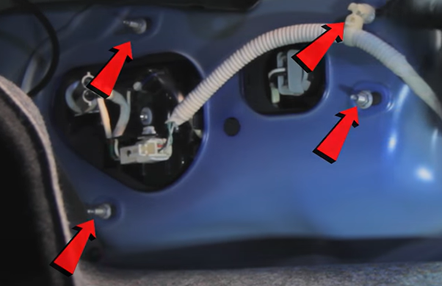

1. Pull back trunk liner and remove (4x) 8mm nuts.

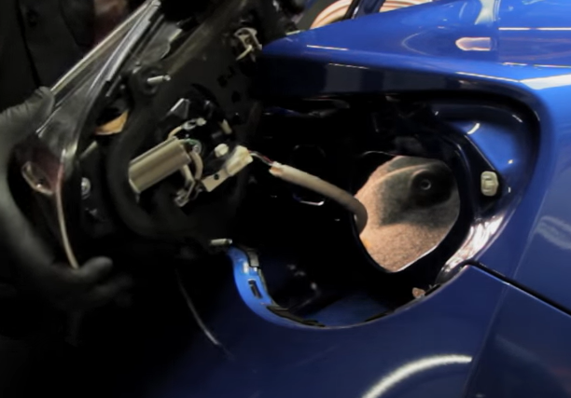

1. Disconnect wiring harness.

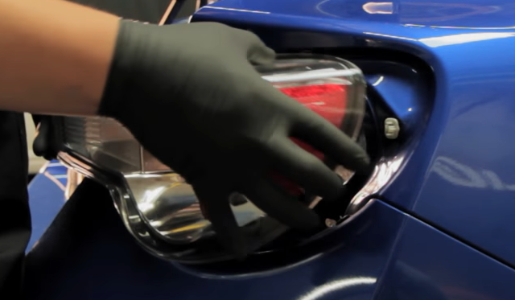

1. Unseat tail light.

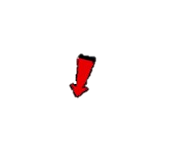

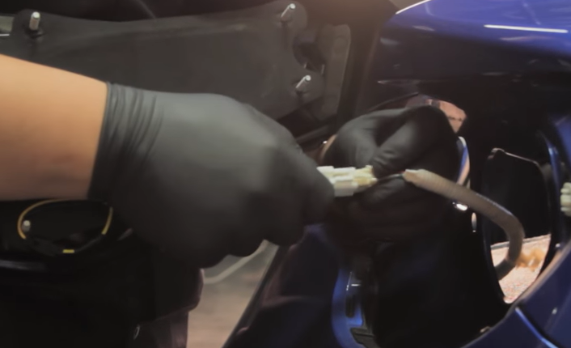

6. Connect Spyder tail light harness.

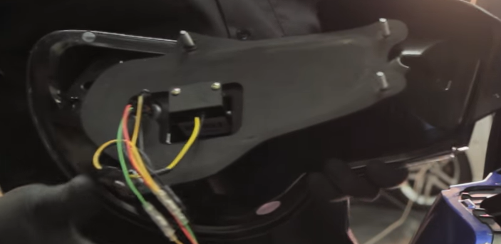

5. Make sure gasket is secure before connecting harness.

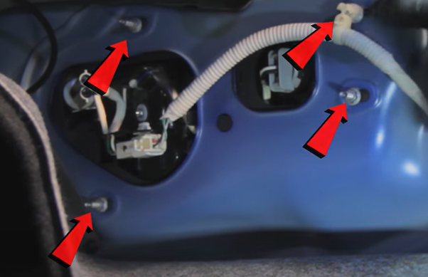

1. Reinstall (4x) 8mm nuts.

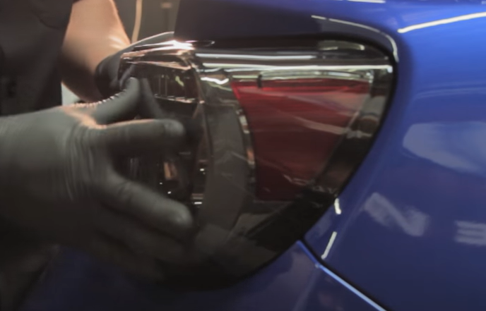

1. Seat Spyder tail light.

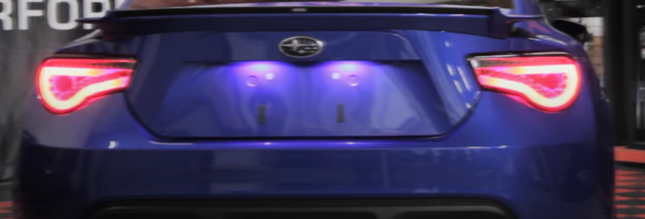

10. Turn on lights and confirm all functions are working properly. You have successfully completed the install of your new Spyder LED tail lights.

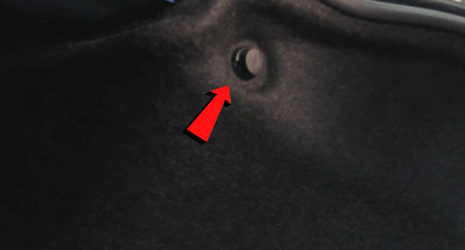

1. Seat liner and reinstall plastic retainer.



For further help with installation, please watch our installation video. Follow the direct link below to our YouTube channel for more information:

http://www.youtube.com/watch

**DISCLAIMER**

Spyder Auto Installation Guide is not liable for damages, injuries, and death while installing the product. This is intended to be an installation guide, to reduce installation time. We have no responsibility for improper installation. If you do not know how to install, please have a professional install it.