Installation Guide:
ALT-YD-PGP97-LED-(All)

Tools Needed:
- None

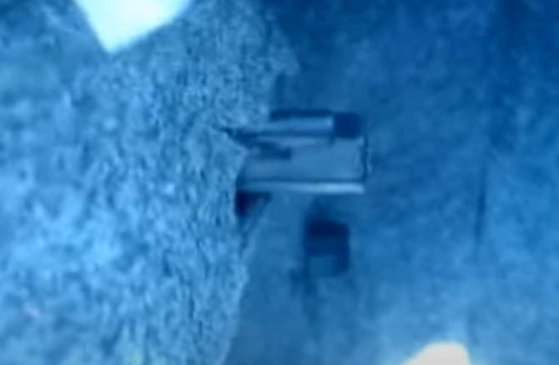
- Remove (2x) plastic nuts.
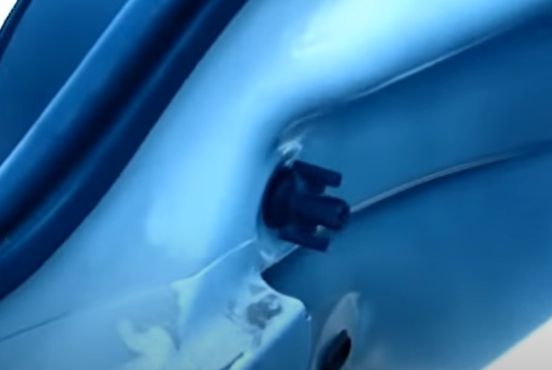
- Pull back carpet liner and remove (1x) plastic nut.

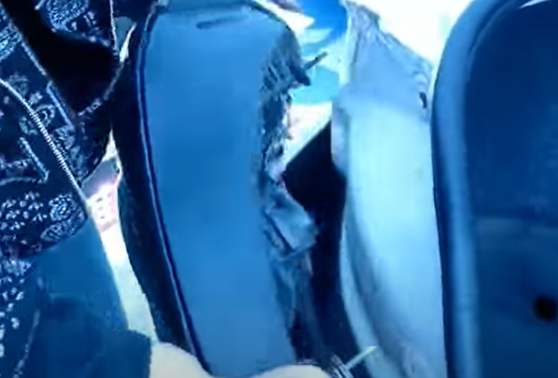
- Unseat tail light.
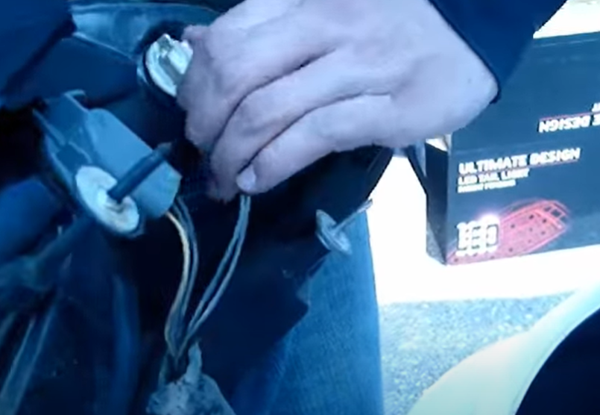
- Remove reverse, brake and side marker sockets from OEM tail light.

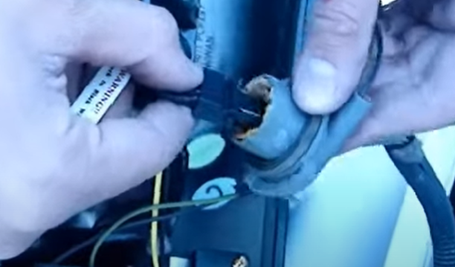
6. Remove brake bulb and insert brake socket insert. (Align black wire of socket insert to black wire of socket)
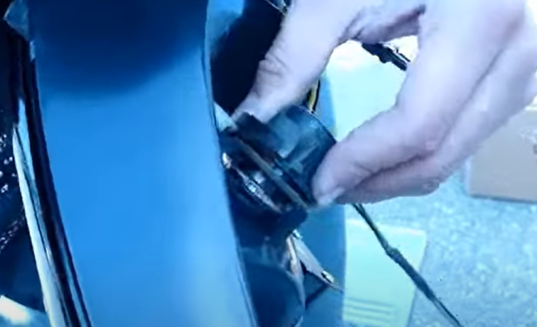
5. Install reverse socket with bulb. (Never touch bulbs with bare hands)

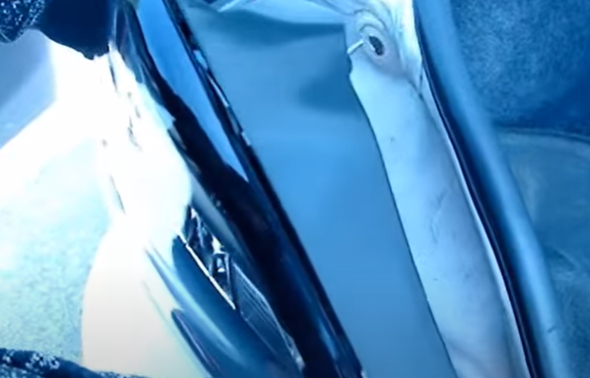
- Seat Spyder tail light.
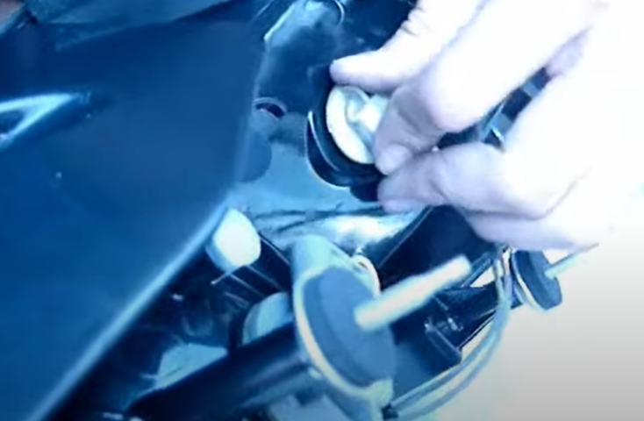
- Install brake and side marker sockets.

- Seat trunk liner and install (2x) plastic nuts.
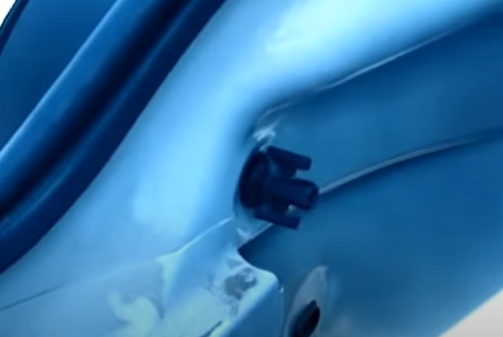
- Reinstall (1x) plastic nut.

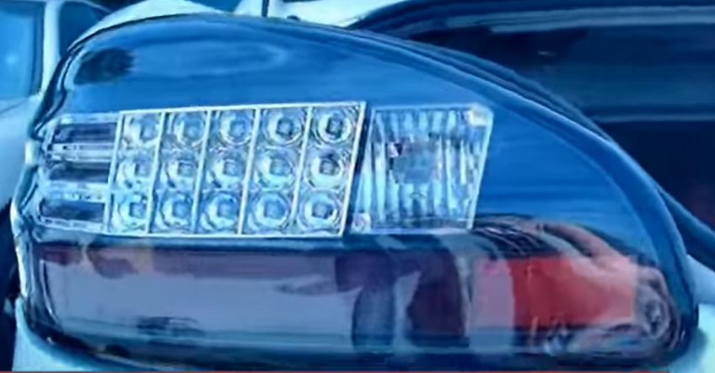
11.Turn on lights and confirm all functions are working properly. You have successfully completed the install of your new Spyder LED tail lights.

For further help with installation, please watch our installation video. Follow the direct link below to our YouTube channel for more information:
http://www.youtube.com/watch

DISCLAIMER
Spyder Auto Installation Guide is not liable for damages, injuries, and death while installing the product. This is intended to be an installation guide, to reduce installation time. We have no responsibility for improper installation. If you do not know how to install, please have a professional install it.

