

**Installation Guide:**

ALT-YD-PCAY03-LED-(All)

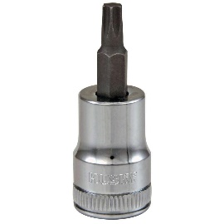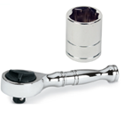Tools Needed:

* ¼” ratchet
* #5 Hex key
* Phillips screwdriver

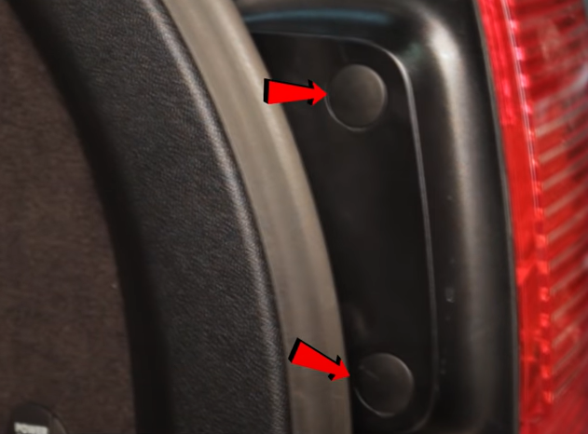

1. Remove (2x) plastic caps.

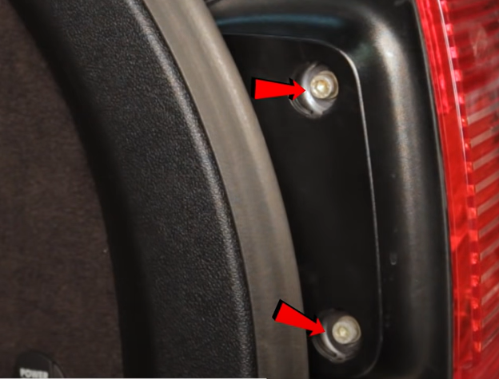

1. Remove (2x) #5 Hex bolts.

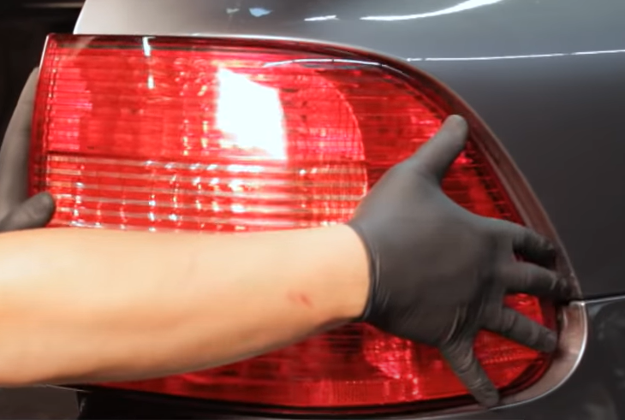

1. Unseat tail light.

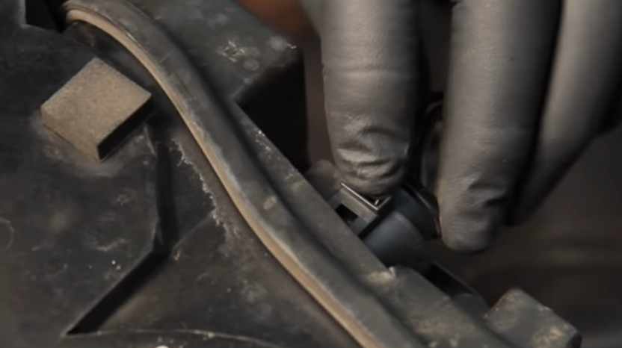

1. Disconnect tail light harness.

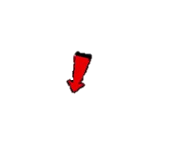

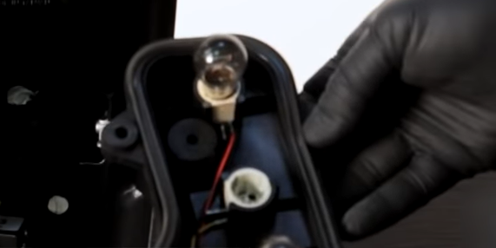

1. Remove (2x) Rear fog and Reverse lamp bulbs. (Never touch bulbs with bare hands)

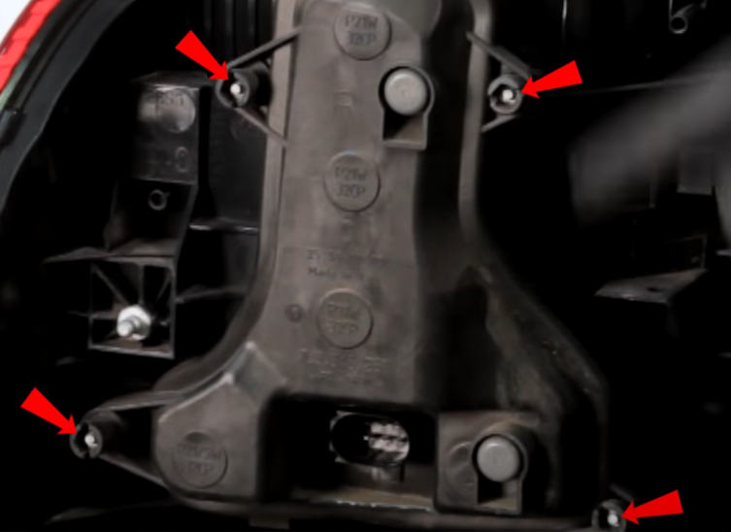

1. Remove (4x) phillips crews securing bulb plate.

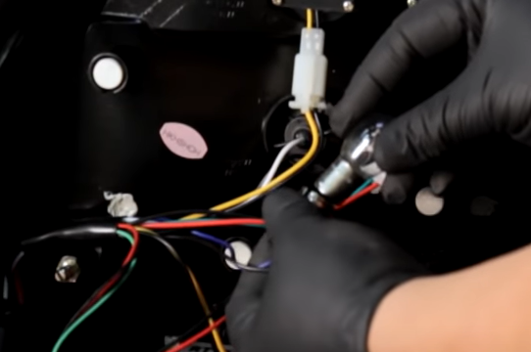

1. Transfer bulbs to Spyder tail light Rear fog and Reverse light sockets.

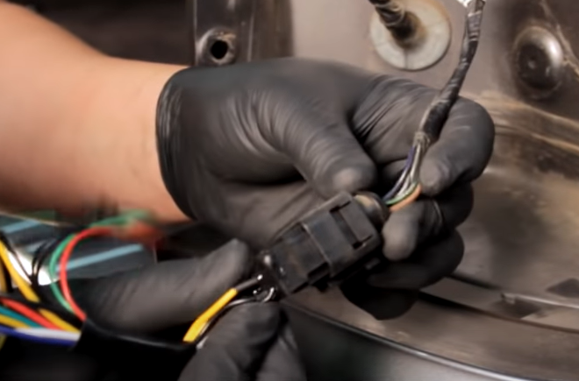

8. Connect Spyder tail light harness.

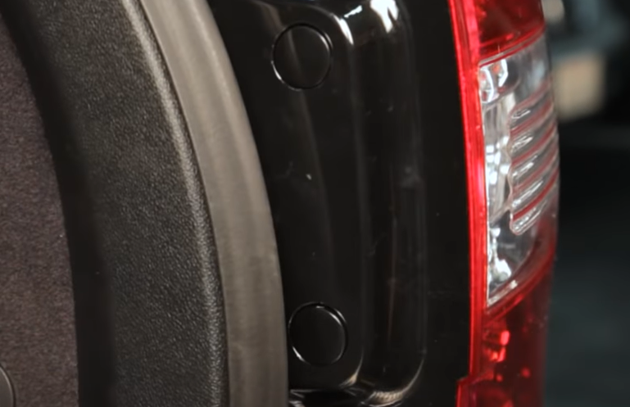

10. Remove (2x) included plastic caps.

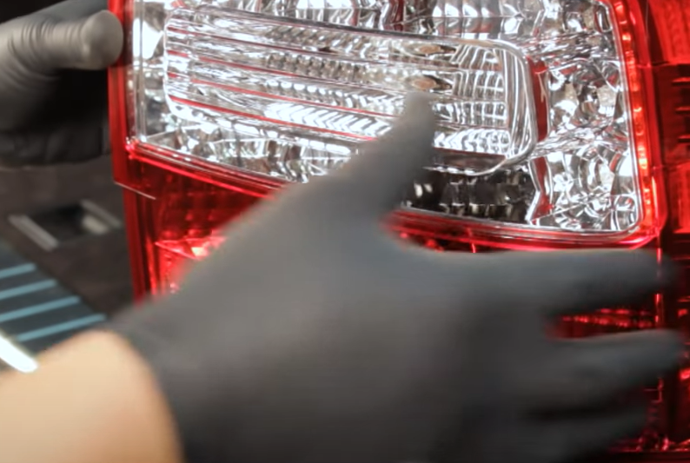

9. Seat Spyder tail light.

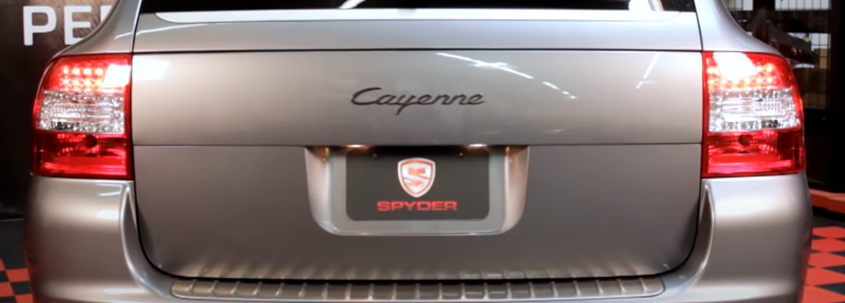

12. Turn on lights and confirm all functions are working properly. You have successfully completed the install of your new Spyder LED tail lights.

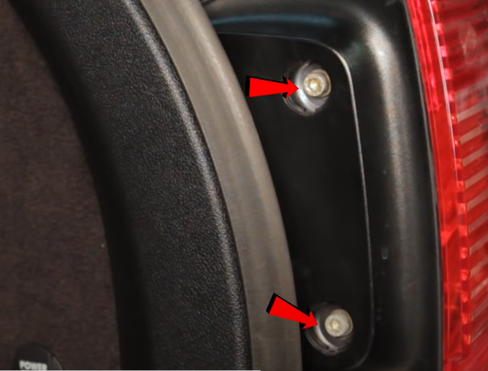

11. Install (2x) #5 Hex bolts and reinstall plastic caps.



For further help with installation, please watch our installation video. Follow the direct link below to our YouTube channel for more information:

http://www.youtube.com/watch

**DISCLAIMER**

Spyder Auto Installation Guide is not liable for damages, injuries, and death while installing the product. This is intended to be an installation guide, to reduce installation time. We have no responsibility for improper installation. If you do not know how to install, please have a professional install it.