Installation Guide:
ALT-YD-P99705-LED-(All)

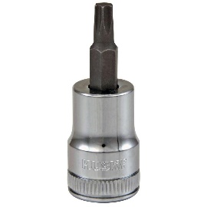
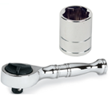
Tools Needed:
- ¼” ratchet
- T25 Torx

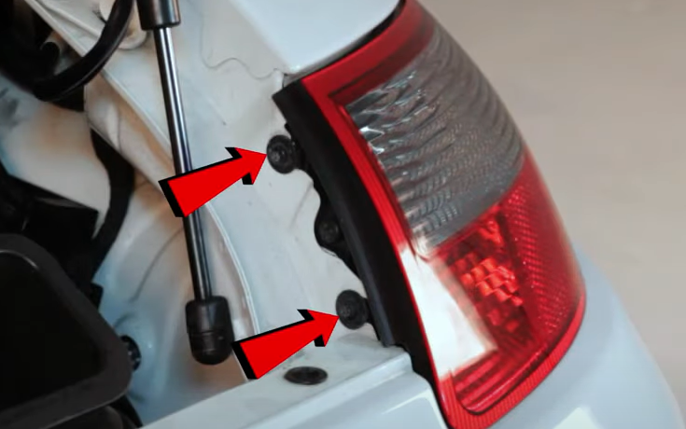
- Remove (2x) T25 torx screws.
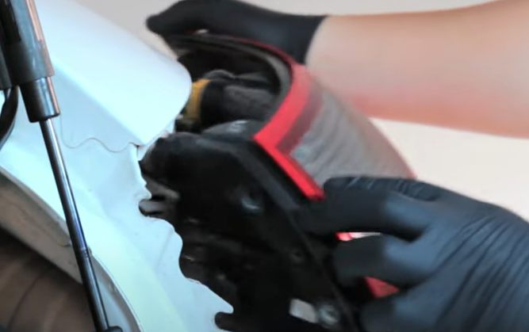
- Unseat tail light.

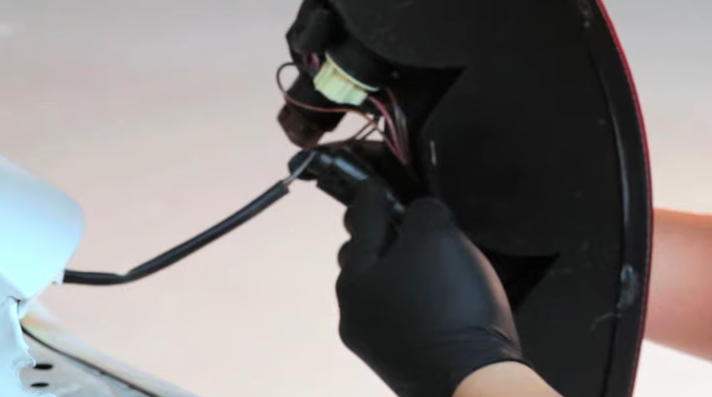
- Disconnect tail light harness.
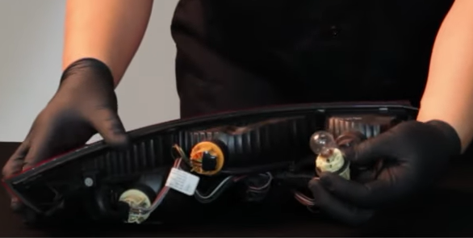
- Remove fog lamp bulb from socket. (Never touch bulbs with bare hands)

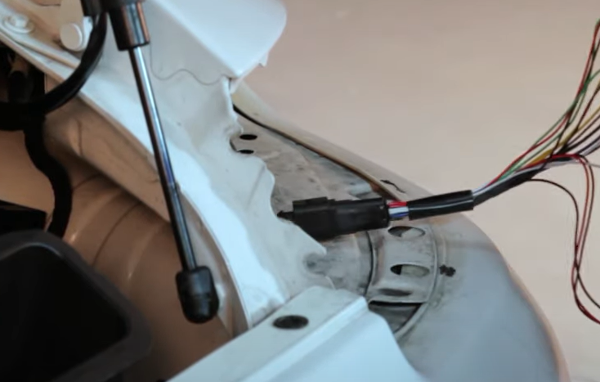
6. Connect Spyder tail light harness.
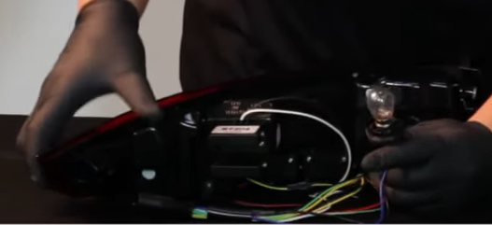
5. Install bulb into Spyder tail light Blue and Black wire bulb socket, then reinstall bulb socket.

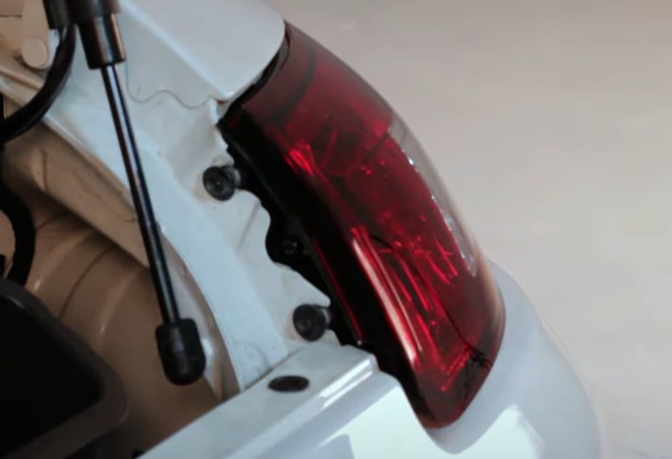
- Reinstall (2x) T25 torx screws.
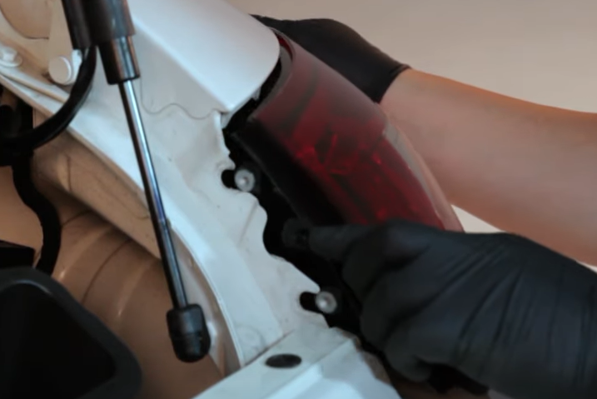
- Seat Spyder tail light.

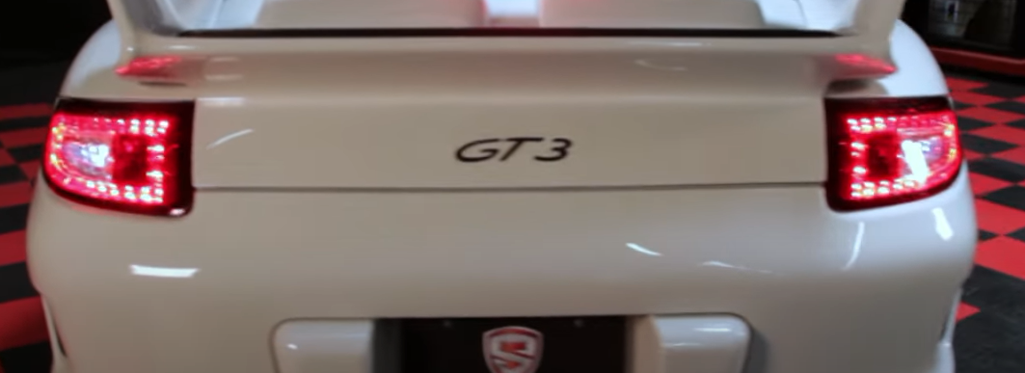
9. Turn on lights and confirm all functions are working properly. You have successfully completed the install of your new Spyder LED tail lights.

For further help with installation, please watch our installation video. Follow the direct link below to our YouTube channel for more information:
http://www.youtube.com/watch

DISCLAIMER
Spyder Auto Installation Guide is not liable for damages, injuries, and death while installing the product. This is intended to be an installation guide, to reduce installation time. We have no responsibility for improper installation. If you do not know how to install, please have a professional install it.

