Installation Guide:
ALT-YD-NTI04-LED-(All)

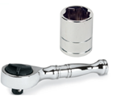
Tools Needed:
- ¼” ratchet
- 10mm socket

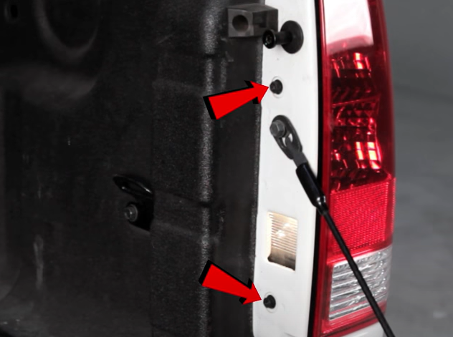
- Remove (2x) 10mm bolts.
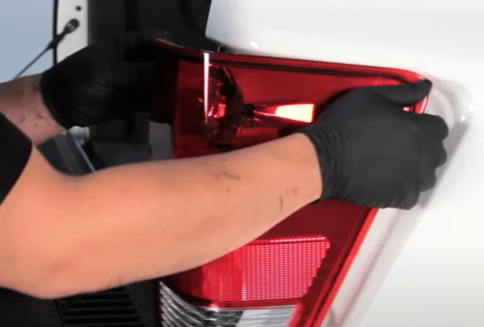
- Unseat tail light.

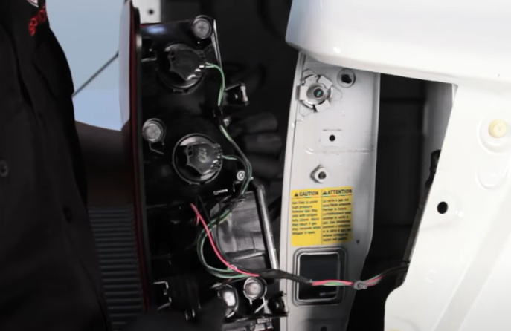
- Remove (4x) tail light sockets. (Never touch bulbs with bare hands)
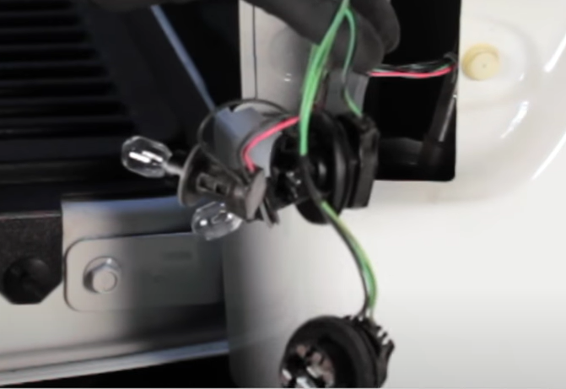
- Remove top (2x) bulbs from socket harness.

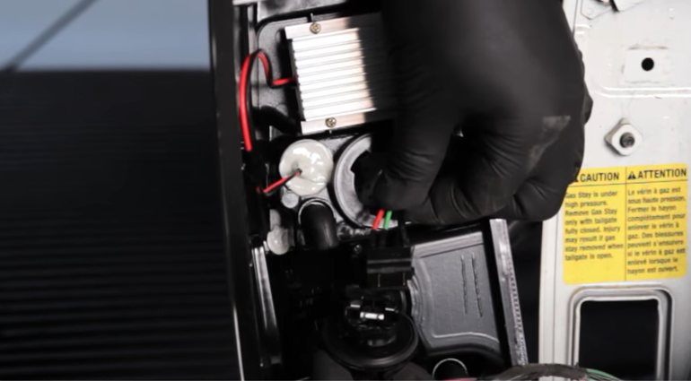
- Install Spyder lower bulb insert into bulb socket. (Align black wire of socket insert to black wire of socket) Install socket.
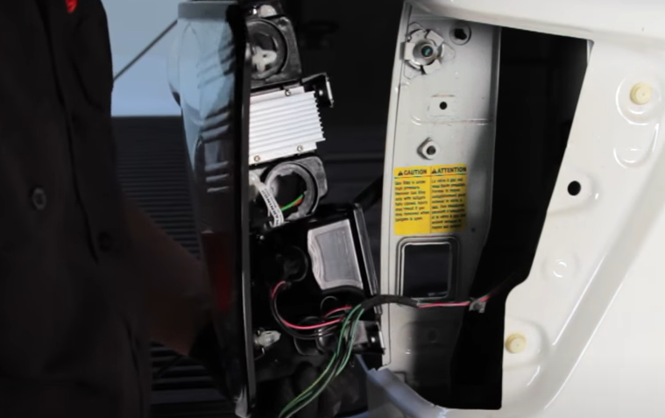
- Install lower two bulb sockets into Spyder tail light.

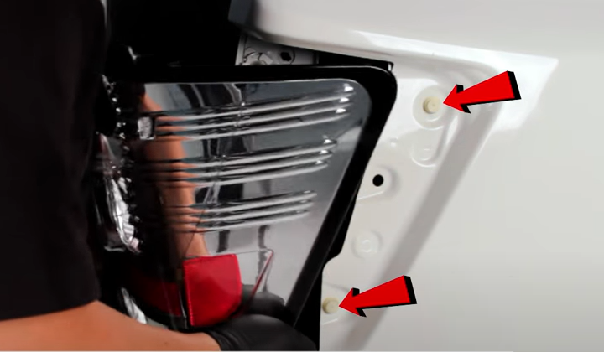
- Align side tabs and seat Spyder tail light.
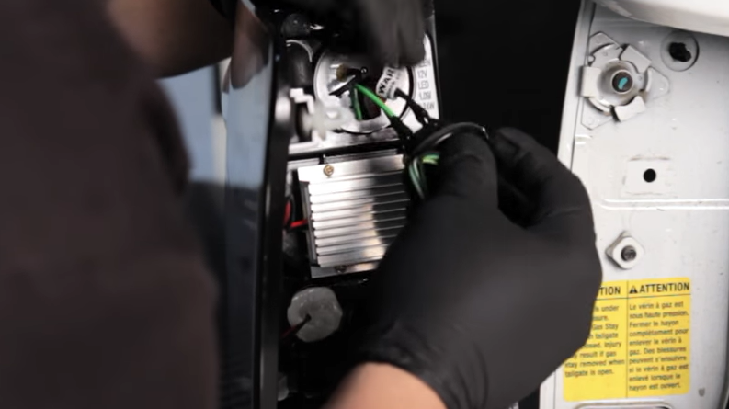
- Install Spyder upper bulb insert into bulb socket. (Align black wire of socket insert to black wire of socket) Install socket.

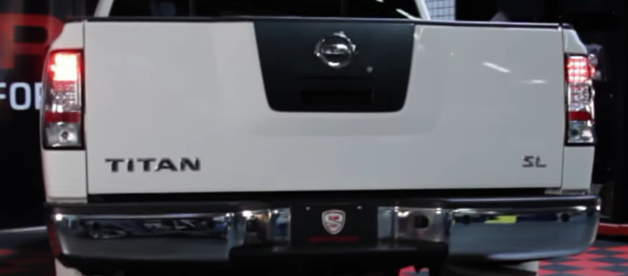
10. Turn on lights and confirm all functions are working properly. You have successfully completed the install of your new Spyder LED tail lights.
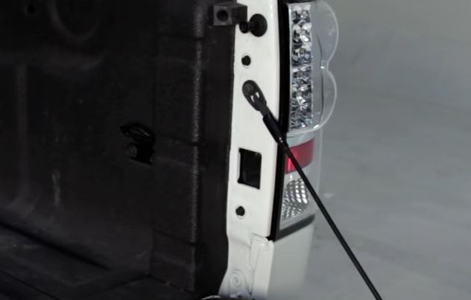
- Reinstall (2x) 10mm bolts.

For further help with installation, please watch our installation video. Follow the direct link below to our YouTube channel for more information:
http://www.youtube.com/watch

DISCLAIMER
Spyder Auto Installation Guide is not liable for damages, injuries, and death while installing the product. This is intended to be an installation guide, to reduce installation time. We have no responsibility for improper installation. If you do not know how to install, please have a professional install it.

