Installation Guide:
ALT-YD-NTI04-(All)
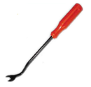
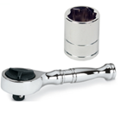
Tools Needed:
- ¼” ratchet
- 10mm socket
- Panel popper

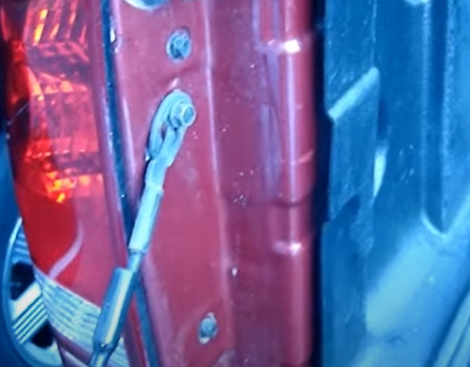
- Remove (2x) 10mm bolts.
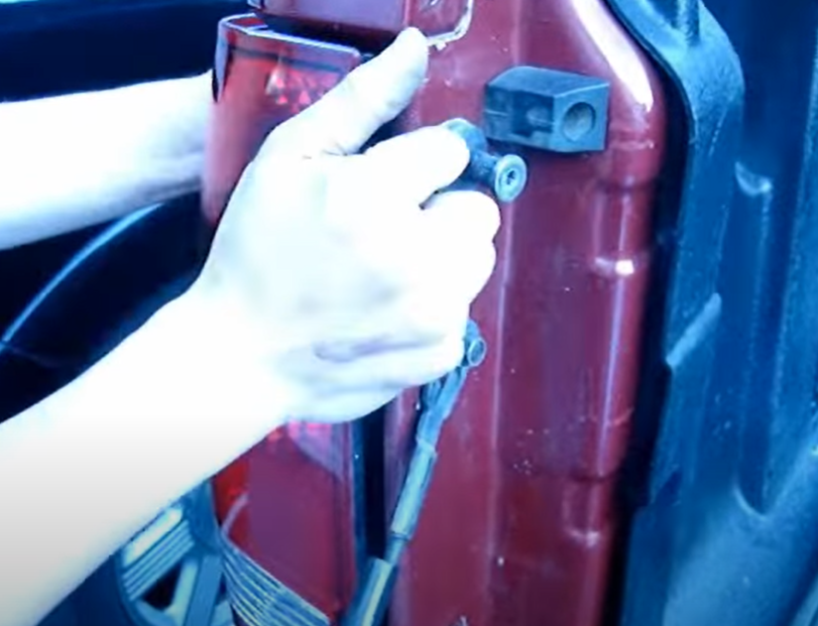
- Unseat tail light.

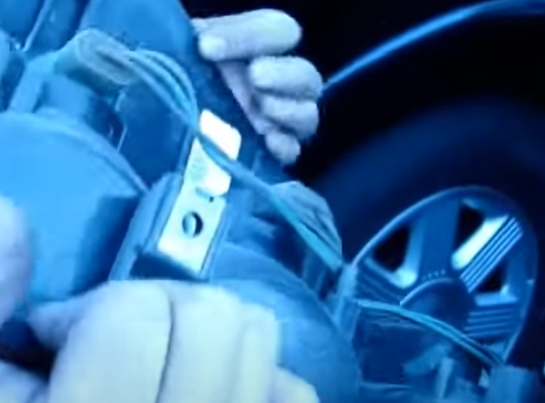
- Remove (3x) tail light sockets.
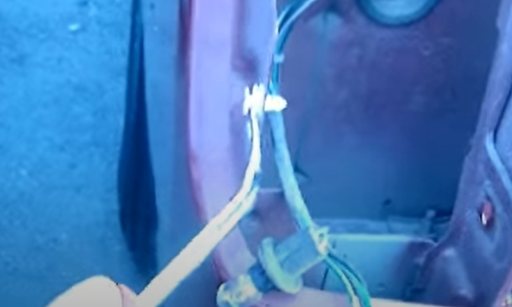
- Use panel popper to remove (2x) plastic retainers.

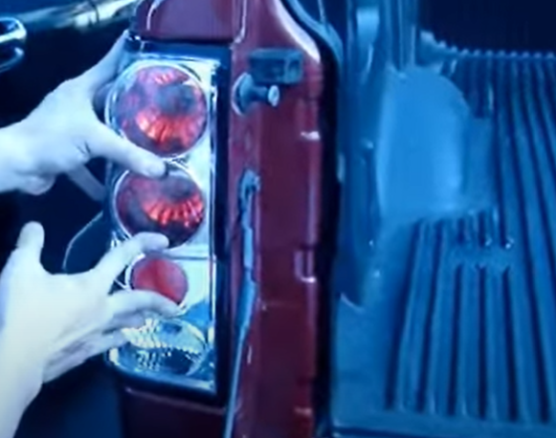
- Seat Spyder tail light.
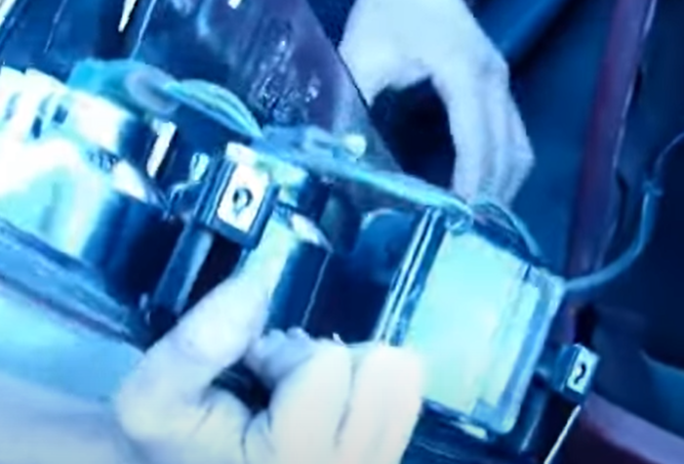
- Install (3x) bulb sockets into Spyder tail light.

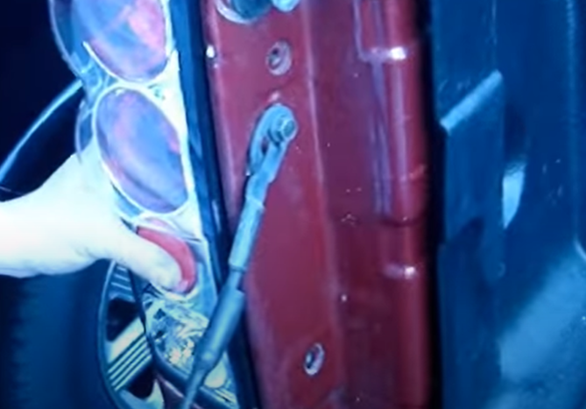
- Install (2x) 10mm bolts.
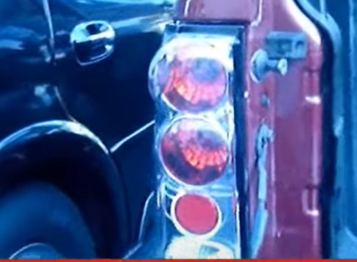
8. Turn on lights and confirm all functions are working properly. You have successfully completed the install of your new Spyder LED tail lights.

For further help with installation, please watch our installation video. Follow the direct link below to our YouTube channel for more information:
http://www.youtube.com/watch

DISCLAIMER
Spyder Auto Installation Guide is not liable for damages, injuries, and death while installing the product. This is intended to be an installation guide, to reduce installation time. We have no responsibility for improper installation. If you do not know how to install, please have a professional install it.

