Installation Guide:
ALT-YD-N350Z02-LED-SM

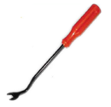
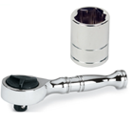
Tools Needed:
- ¼” ratchet
- 8mm socket
- Panel popper

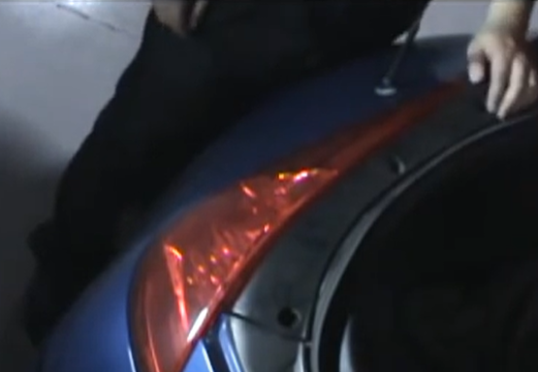
- Remove (3x) plastic clips and 10mm bolts.
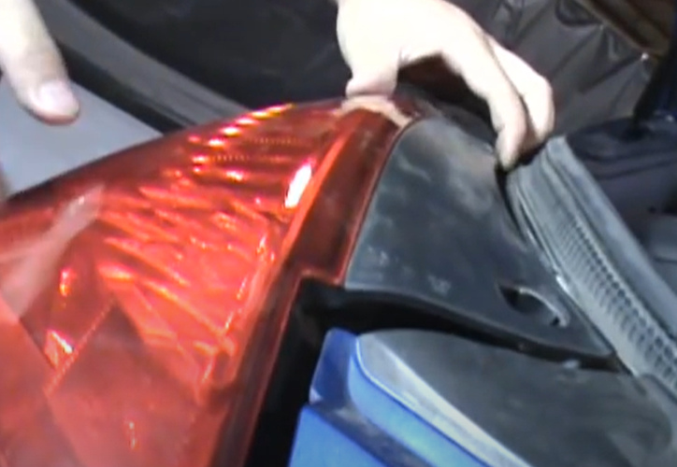
- Unseat tail light.

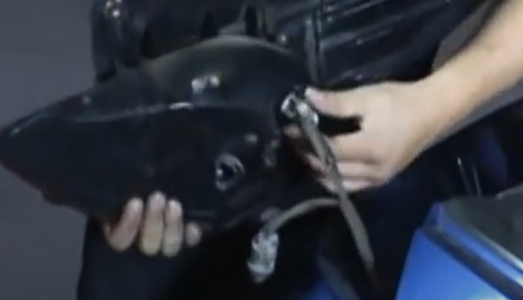
- Remove (2x) tail light sockets.
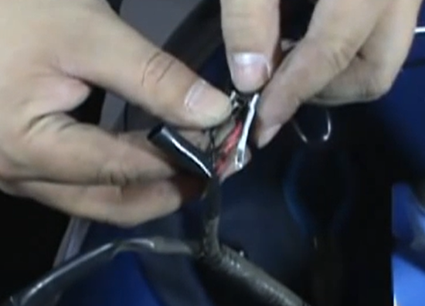
- You will need to tap into factory brake light wiring for Spyder day running light. (Parking tight Blk wire to Blk and Wht to Red wire)

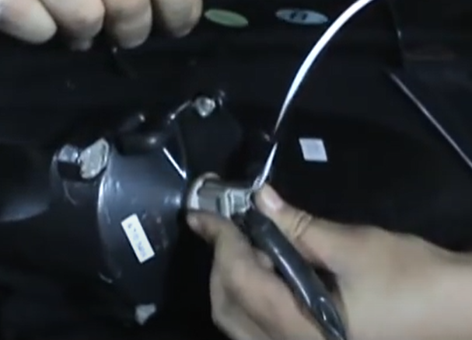
- Install both sockets into Spyder tail light.
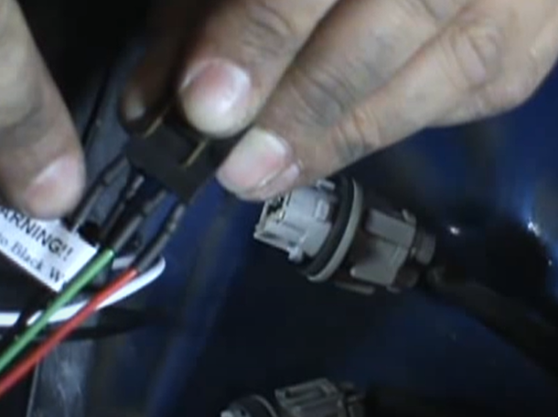
- Connect Spyder socket insert into brake light socket. (Making sure black wire of socket is aligned to black wire of socket insert)

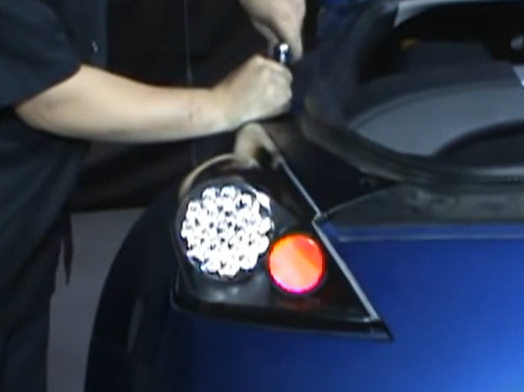
- Reinstall (3x) 10mm bolts and plastic clips.
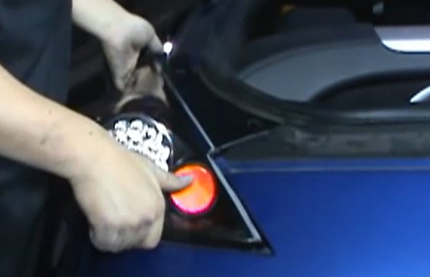
- Seat Spyder tail light.

9. Turn on lights and confirm all functions are working properly. You have successfully completed the install of your new Spyder LED tail lights.

For further help with installation, please watch our installation video. Follow the direct link below to our YouTube channel for more information:
http://www.youtube.com/watch

DISCLAIMER
Spyder Auto Installation Guide is not liable for damages, injuries, and death while installing the product. This is intended to be an installation guide, to reduce installation time. We have no responsibility for improper installation. If you do not know how to install, please have a professional install it.

