

**Installation Guide:**

ALT-YD-MBZC08-LED-(All)

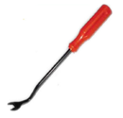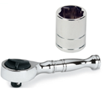Tools Needed:

* ¼” ratchet
* 8mm socket
* Panel popper

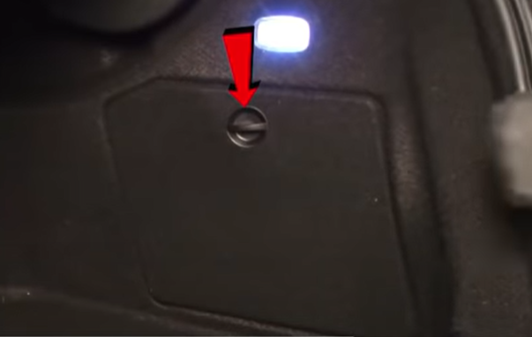

1. Unlock and open access panel.

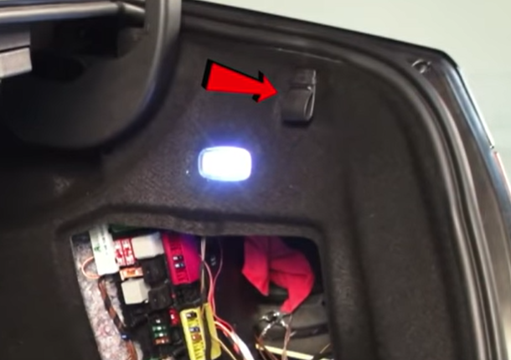

1. Remove grocery hook using panel popper.

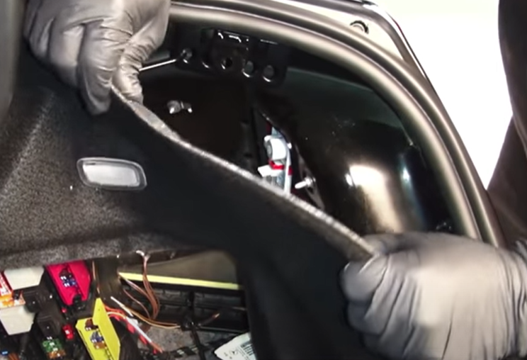

1. Pull back trunk liner to access tail light.

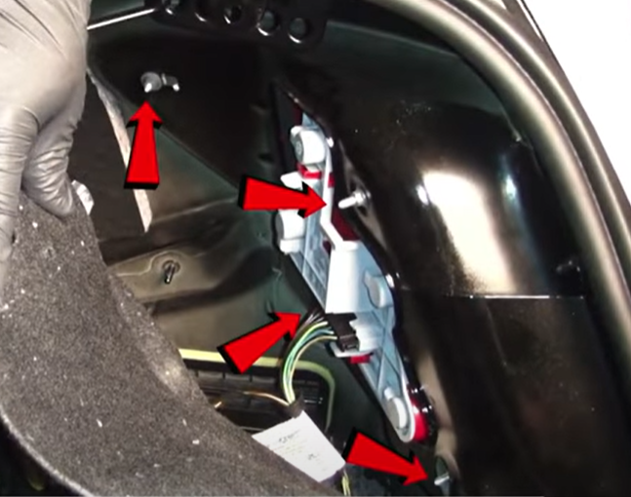

1. Remove (4x) 8mm nuts securing tail light.

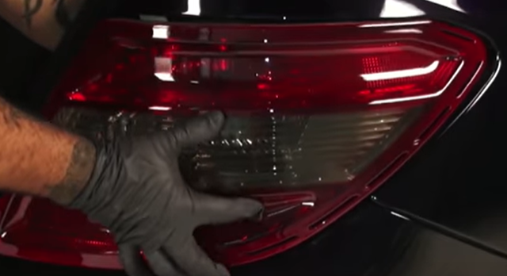

1. Unseat tail light.

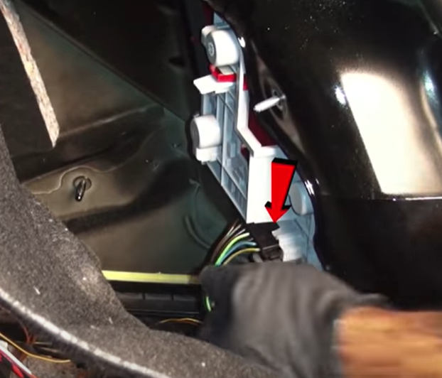

1. Disconnect wiring harness.

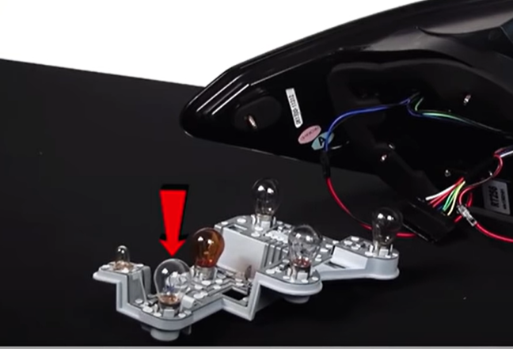

1. Remove reverse light bulb from bulb plate. (Never touch bulb with bare hands)

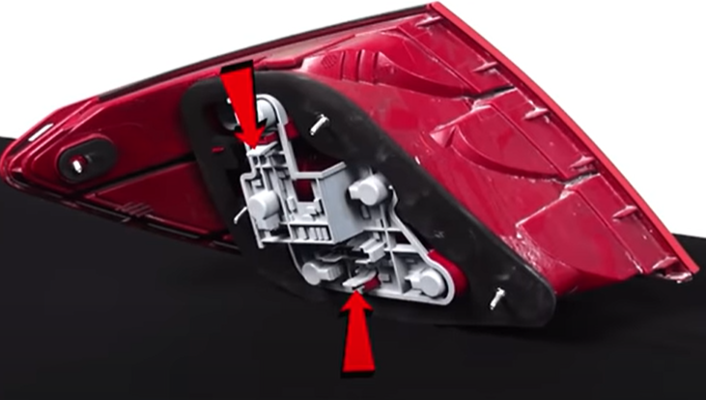

1. Squeeze tabs to release bulb plate from oem tail light.

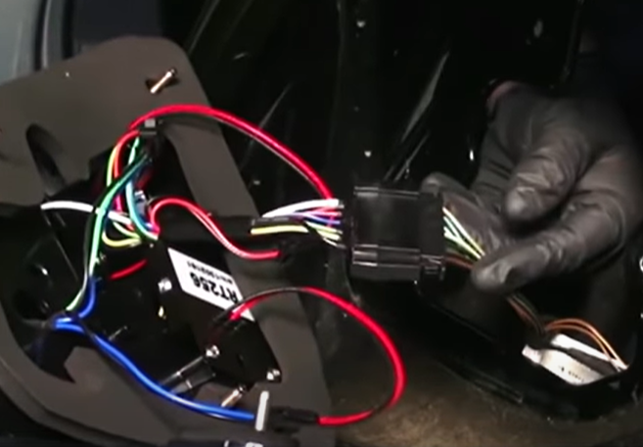

1. Connect Spyder tail light harness.

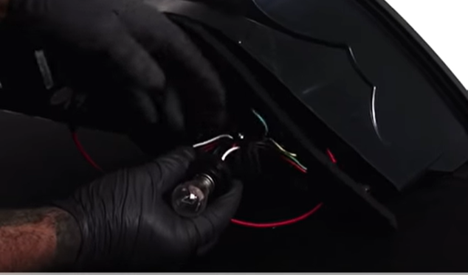

1. Install reverse bulb into Spyder reverse socket and reinstall socket.

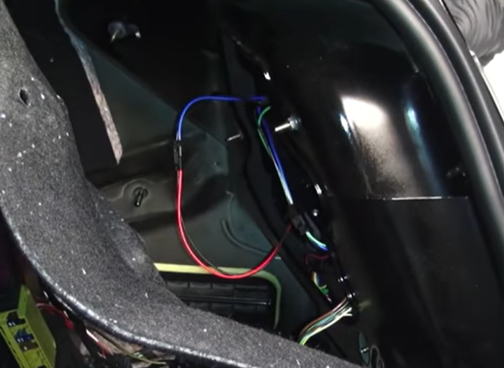

12. Install (4x) 8mm nuts to secure tail light.

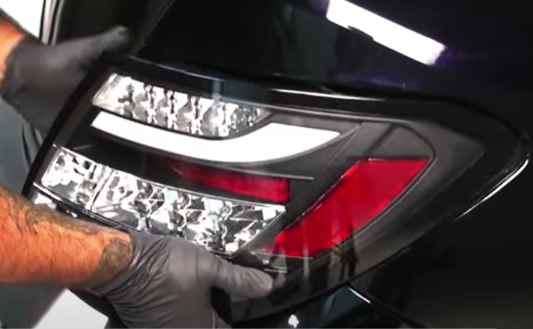

11. Seat Spyder tail light.

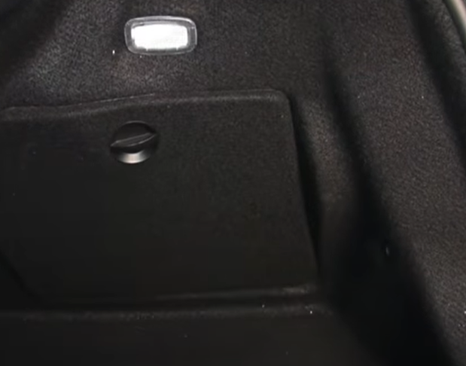

14. Close and lock access panel.

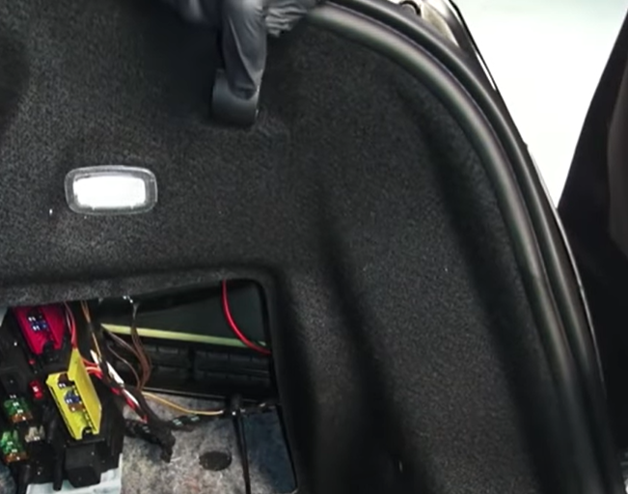

13. Seat trunk liner and install grocery hook.

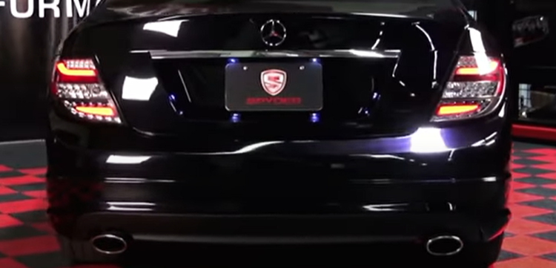

15. Turn on lights and confirm all functions are working properly. You have successfully completed the install of your new Spyder LED tail lights.



For further help with installation, please watch our installation video. Follow the direct link below to our YouTube channel for more information:

http://www.youtube.com/watch

**DISCLAIMER**

Spyder Auto Installation Guide is not liable for damages, injuries, and death while installing the product. This is intended to be an installation guide, to reduce installation time. We have no responsibility for improper installation. If you do not know how to install, please have a professional install it.