

**Installation Guide:**

ALT-YD-MBW16398-LED-(All)

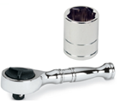Tools Needed:

* ¼” ratchet
* 10mm socket

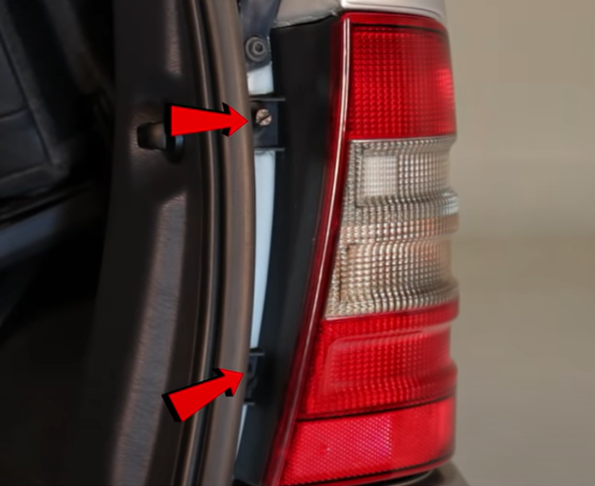

1. Remove (2x) 10mm nuts securing tail light.

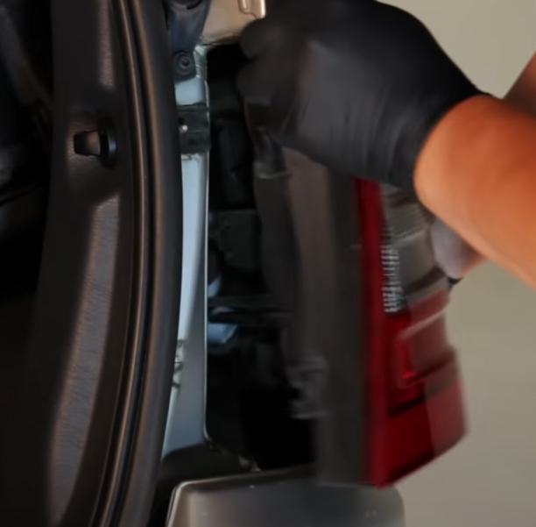

1. Unseat tail light.

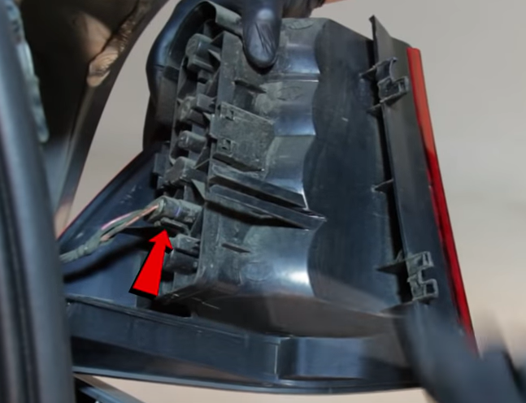

1. Unclip wire harness from tail light.

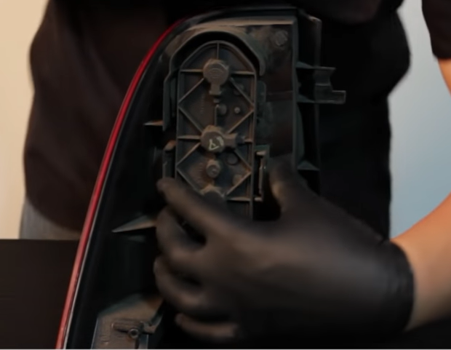

1. Remove bulb bar from tail light by squeezing tabs inward.

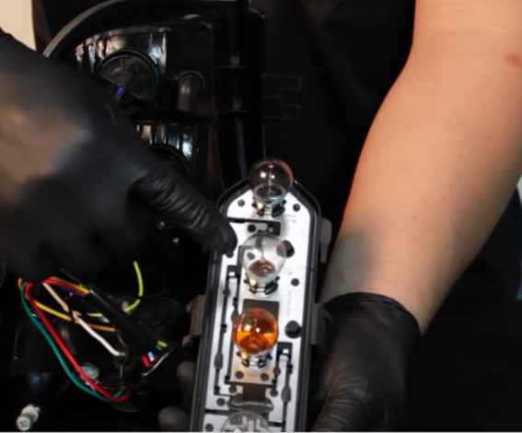

1. Remove second bulb down from bulb bar. (Never touch bulb with bare hands)

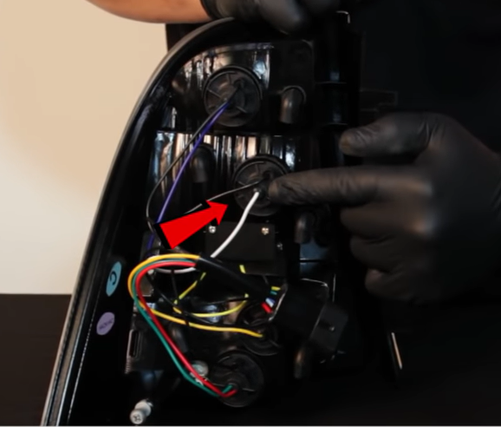

1. Remove reverse bulb socket from Spyder tail.

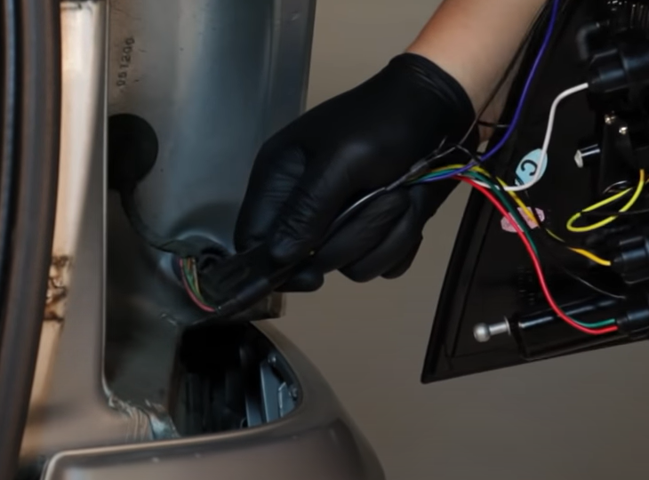

1. Connect Spyder tail light harness.

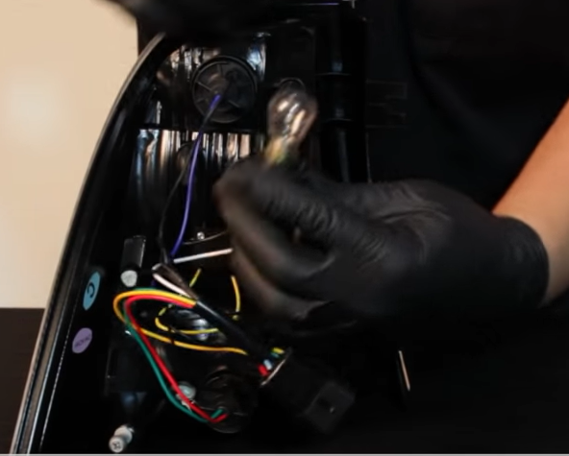

1. Install bulb into Spyder reverse socket and install socket into Spyder tail light.

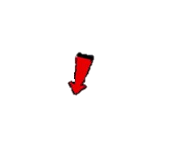

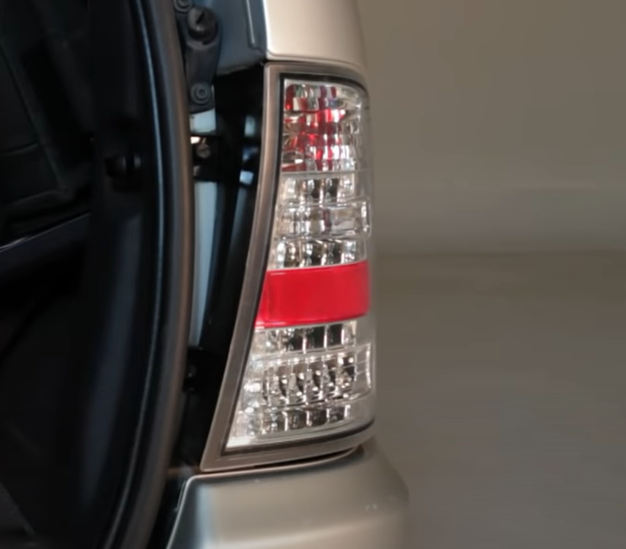

1. Reinstall (2x) 10mm nuts.

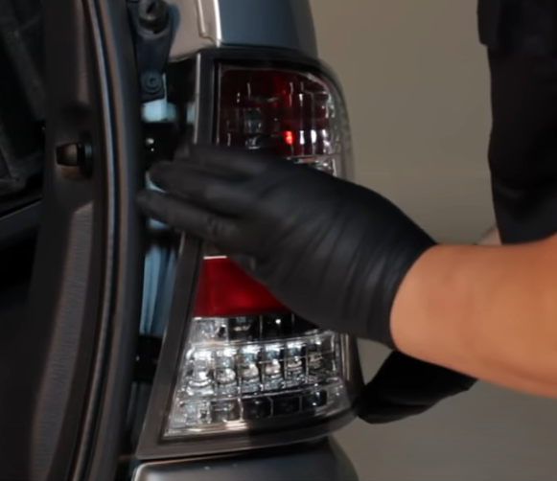

1. Seat Spyder tail light.



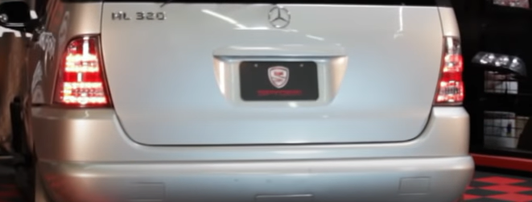

11.Turn on lights and confirm all functions are working properly. You have successfully completed the install of your new Spyder LED tail lights.



For further help with installation, please watch our installation video. Follow the direct link below to our YouTube channel for more information:

http://www.youtube.com/watch

**DISCLAIMER**

Spyder Auto Installation Guide is not liable for damages, injuries, and death while installing the product. This is intended to be an installation guide, to reduce installation time. We have no responsibility for improper installation. If you do not know how to install, please have a professional install it.