Installation Guide:
ALT-YD-LIS300-LED-(All)

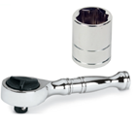
Tools Needed:
- ¼” ratchet
- 10mm socket

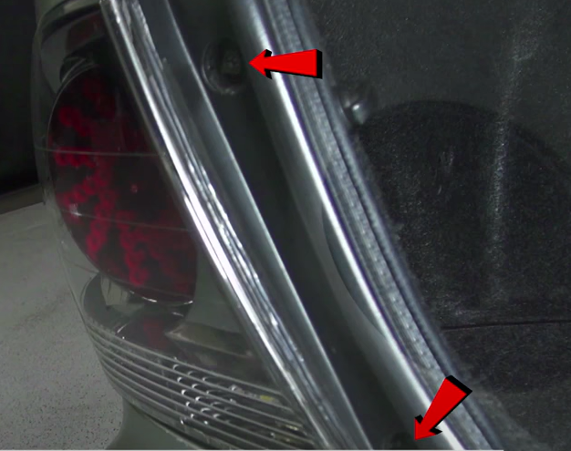
- Remove (2x) 10mm bolts.
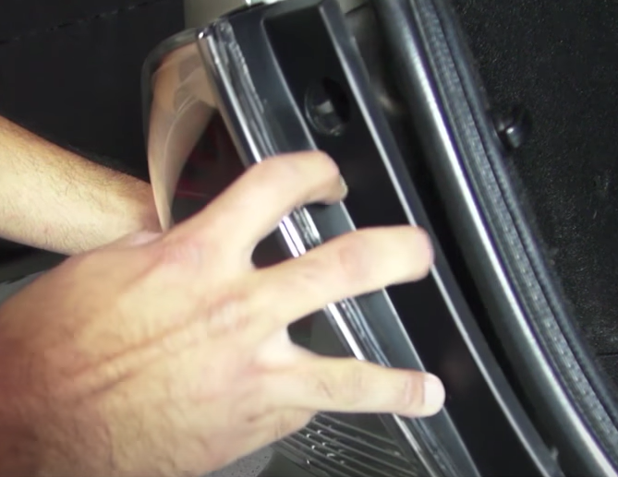
- Unseat tail light.

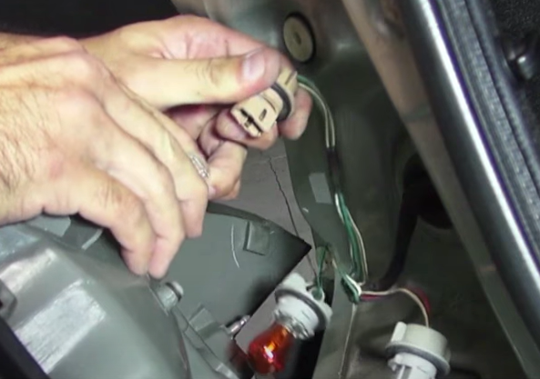
- Remove brake bulb from socket. (Make not to touch bulb with bare hands)
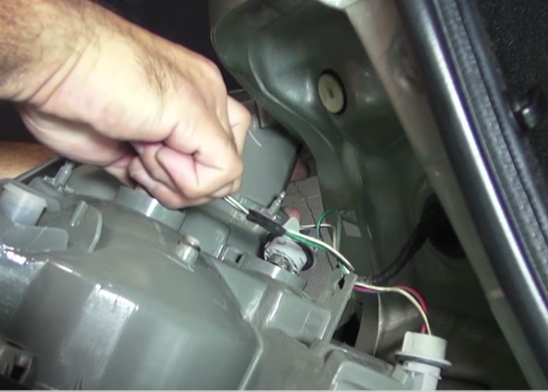
- Remove (3x) bulb sockets.

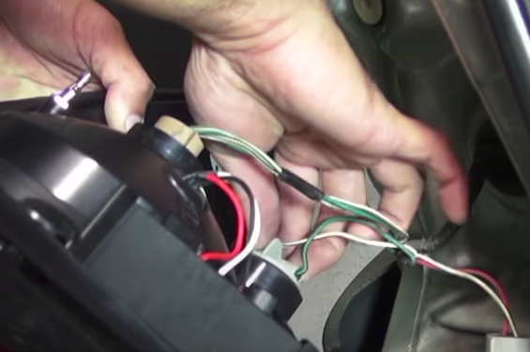
- Install brake, turn and reverse bulb sockets into Spyder tail light.
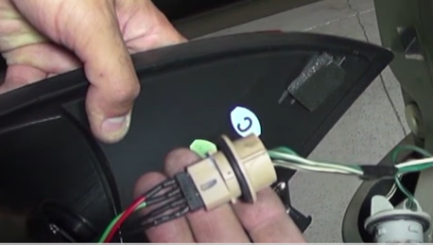
- Install Spyder socket insert into brake socket. (Align black wire of socket to black wire on insert)

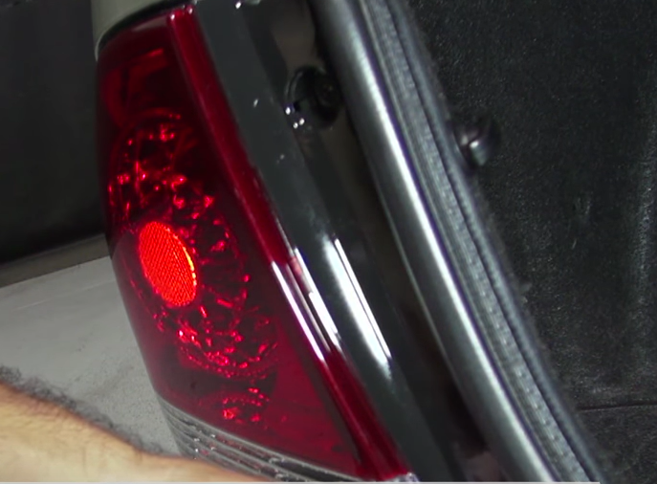
- Reinstall (2x) 10mm bolts securing the tail light.
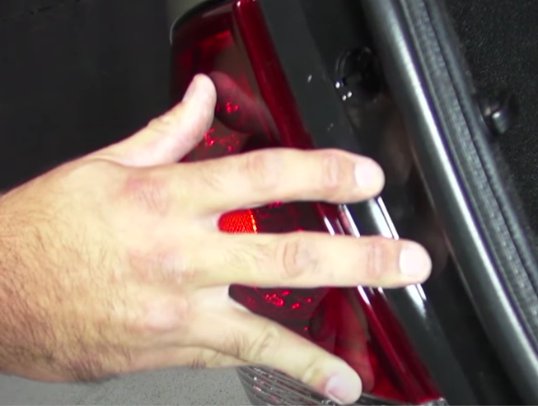
- Seat Spyder tail light.

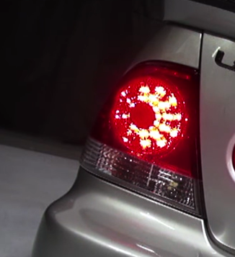
9.Turn on lights and confirm all functions are working properly. You have successfully completed the install of your new Spyder LED tail lights.

For further help with installation, please watch our installation video. Follow the direct link below to our YouTube channel for more information:
http://www.youtube.com/watch

DISCLAIMER
Spyder Auto Installation Guide is not liable for damages, injuries, and death while installing the product. This is intended to be an installation guide, to reduce installation time. We have no responsibility for improper installation. If you do not know how to install, please have a professional install it.

