

**Installation Guide:**

ALT-YD-JW19-SEQ-(All)

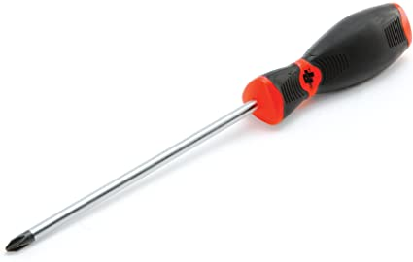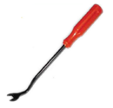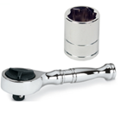Tools Needed:

* ¼” ratchet
* 10mm socket
* Panel popper
* Phillips screw driver

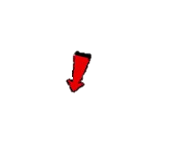

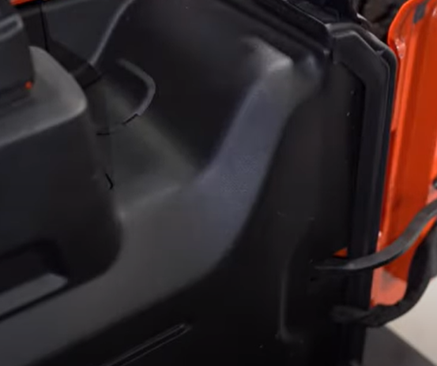

1. Remove plastic cover using panel popper.

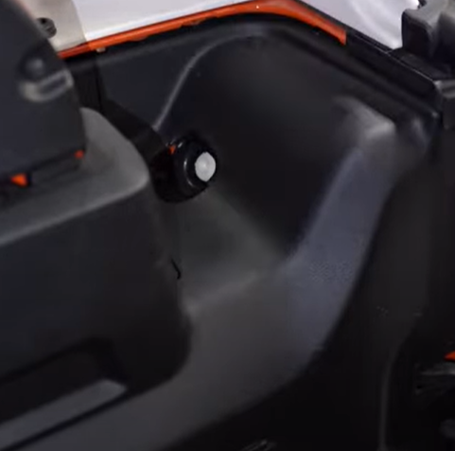

1. Remove 10mm tail light retainer.



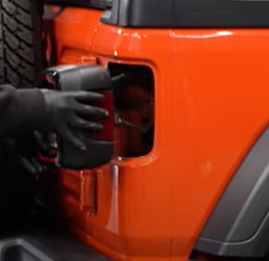

1. Unseat tail light.

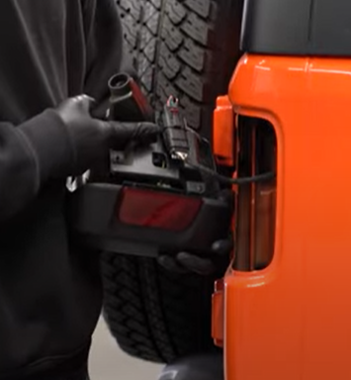

1. Disconnect wire harness clip.



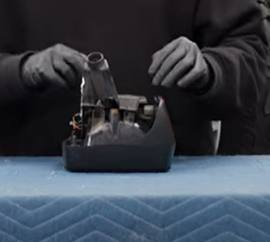

1. Remove (3x) Phillips screws securing bracket to old tail light.

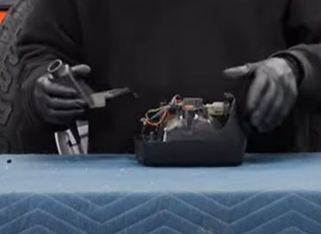

1. Carefully remove bracket from tail light.

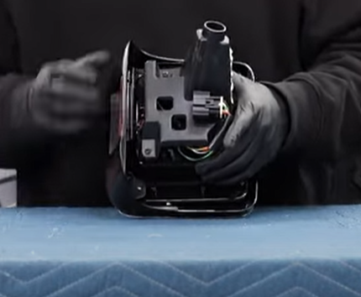

1. Clip Spyder wire harness connector onto bracket.

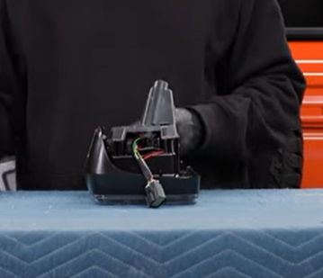

1. Place bracket on Spyder tail light and install (3x) Phillips screws.



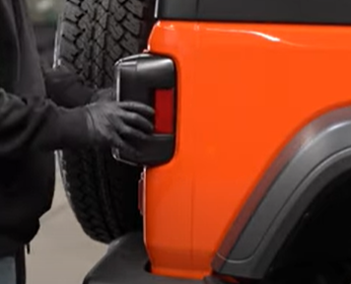

1. Seat Spyder tail light.

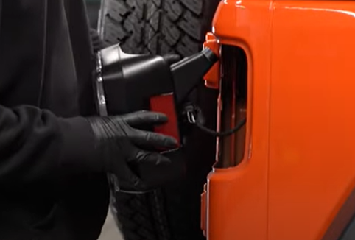

1. Connect wire harness.



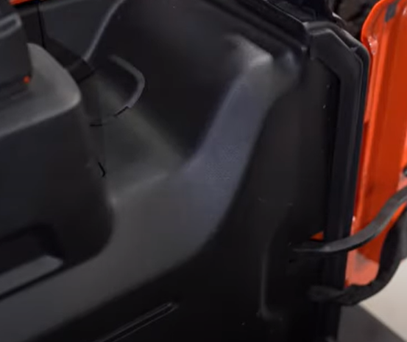

11. Reinstall plastic cover.

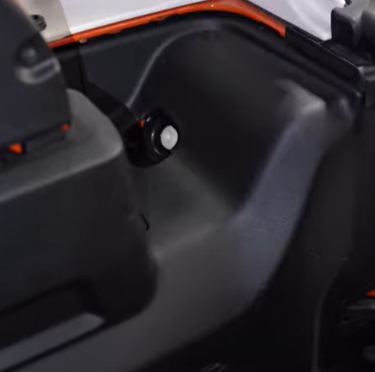

1. Reinstall 10mm tail light retainer.

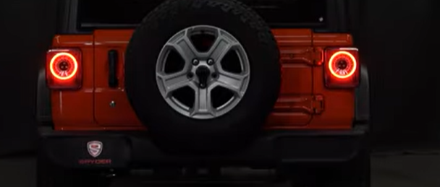

12.Turn on lights and confirm all functions are working properly. You have successfully completed the install of your new Spyder LED tail lights.



For further help with installation, please watch our installation video. Follow the direct link below to our YouTube channel for more information:

http://www.youtube.com/watch

**DISCLAIMER**

Spyder Auto Installation Guide is not liable for damages, injuries, and death while installing the product. This is intended to be an installation guide, to reduce installation time. We have no responsibility for improper installation. If you do not know how to install, please have a professional install it.