Installation Guide:
ALT-YD-JGC05-LED-(All)

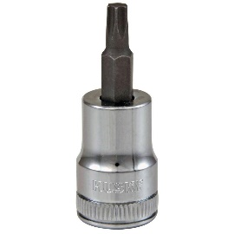
Tools Needed:
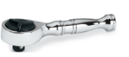
- ¼” ratchet
- T20 socket

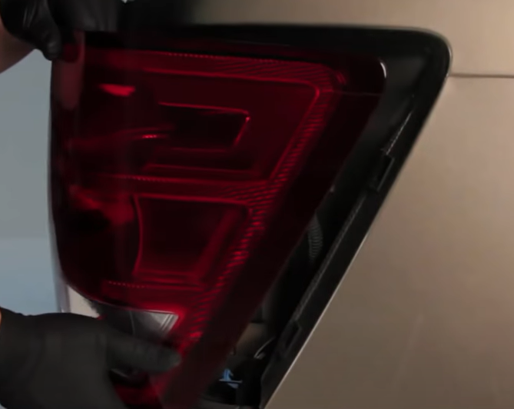
- Unseat tail light using panel popper.
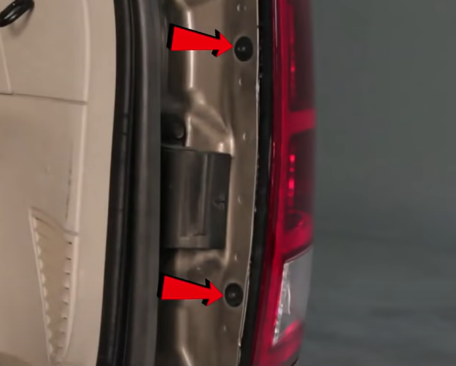
- Remove (2x) T20 screws

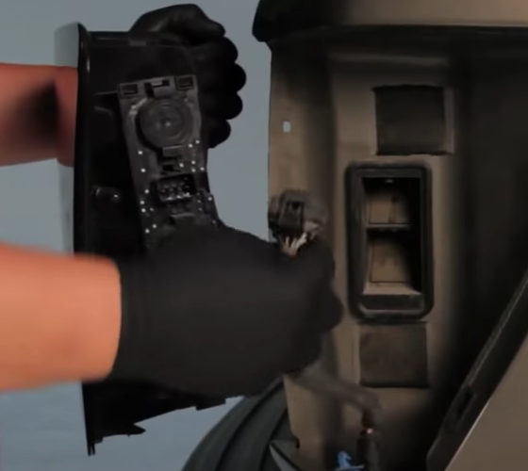
- Disconnect wire harness.
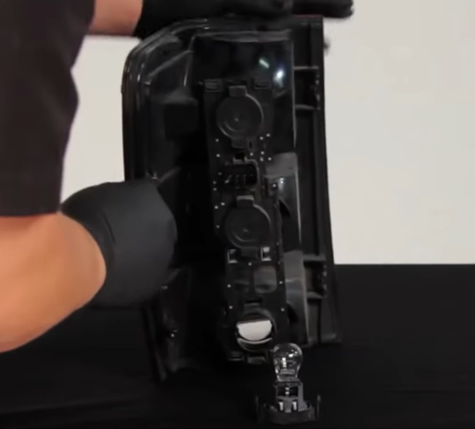
- Remove reverse light bulb from tail light socket. (Never touch bulbs with bare hands)

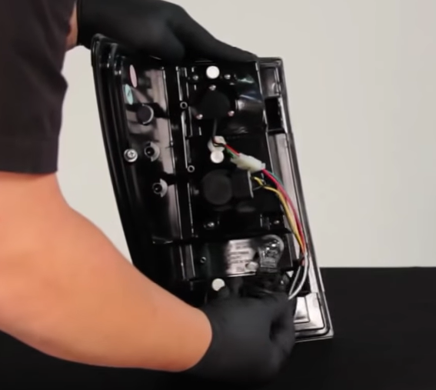
- Install reverse bulb into Spyder tail light socket with black and white wire.
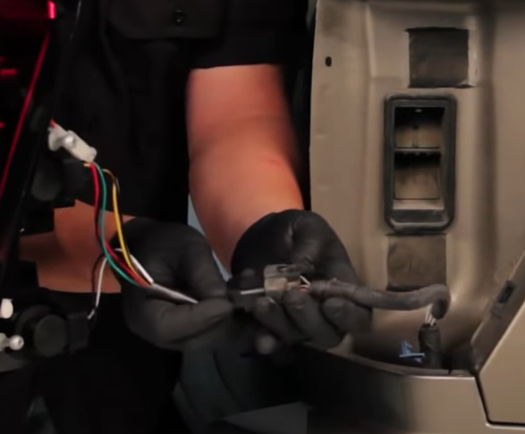
- Connect Spyder tail light harness.

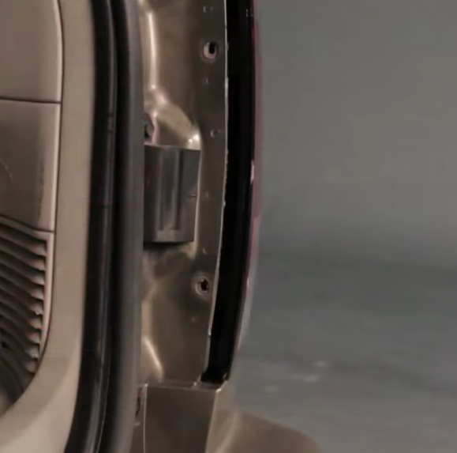
- Reinstall (2x) T20 screws.
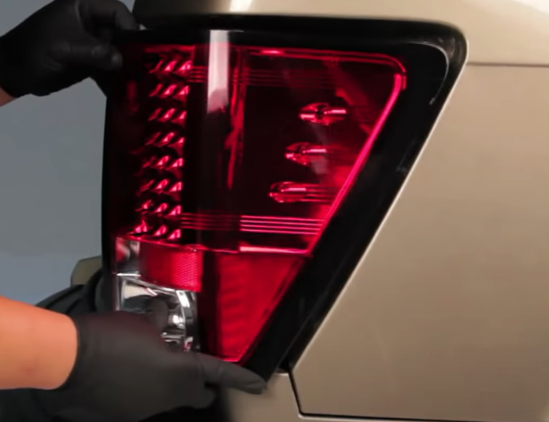
- Seat Spyder tail light.

9. Turn on lights and confirm all functions are working properly. You have successfully completed the install of your new Spyder LED tail lights.

For further help with installation, please watch our installation video. Follow the direct link below to our YouTube channel for more information:
http://www.youtube.com/watch

DISCLAIMER
Spyder Auto Installation Guide is not liable for damages, injuries, and death while installing the product. This is intended to be an installation guide, to reduce installation time. We have no responsibility for improper installation. If you do not know how to install, please have a professional install it.

