Installation Guide:
ALT-YD-GY15-LED-(All)

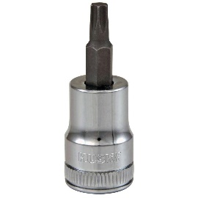
Tools Needed:
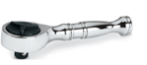
- ¼” ratchet
- T15 socket

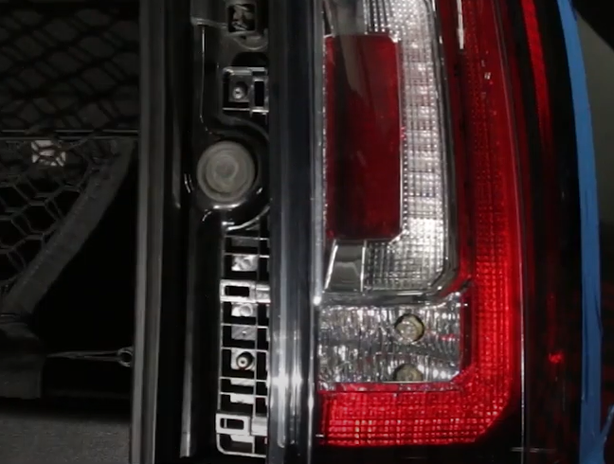
- Remove (2x) T15 torx screws.
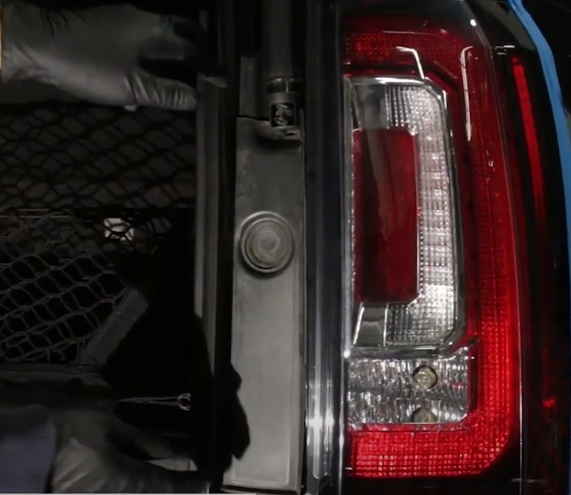
- Carefully remove trim panel.

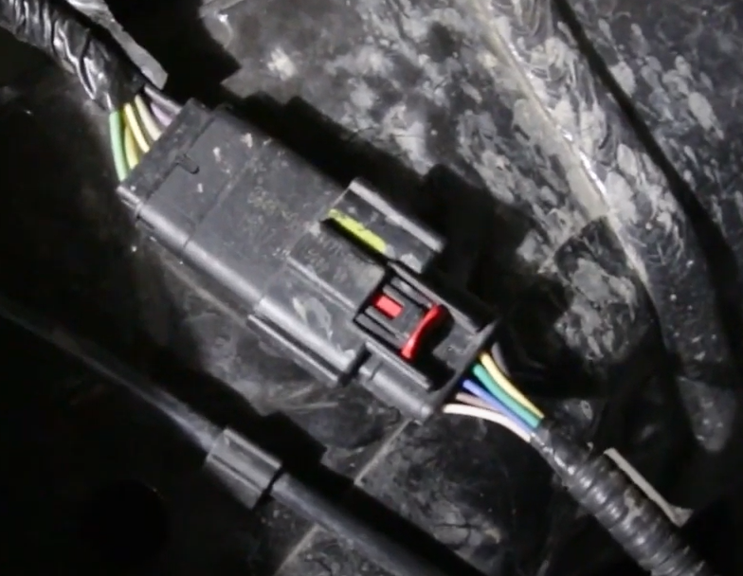
- Locate tail light harness under vehicle and disconnect harness.
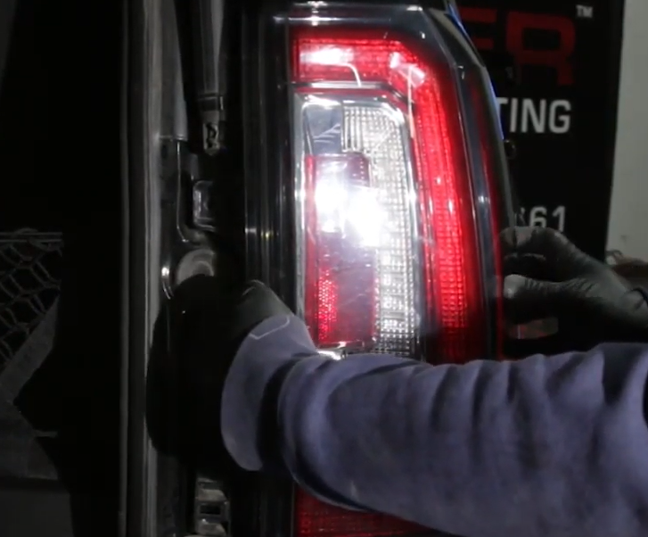
- Unseat tail light and carefully pull out harness.

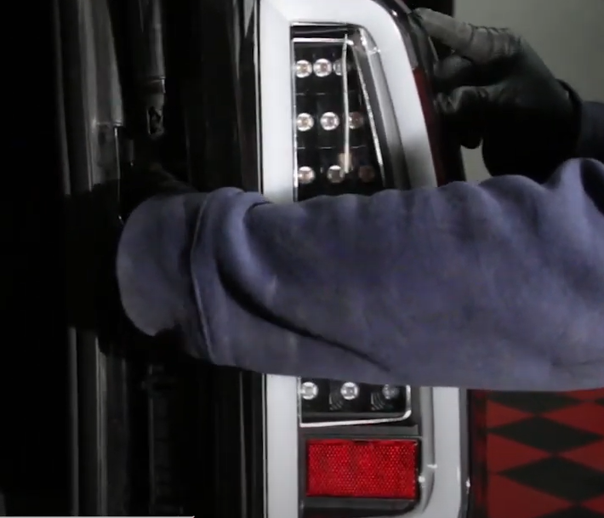
- Feed Spyder harness into vehicle and seat Spyder tail light.
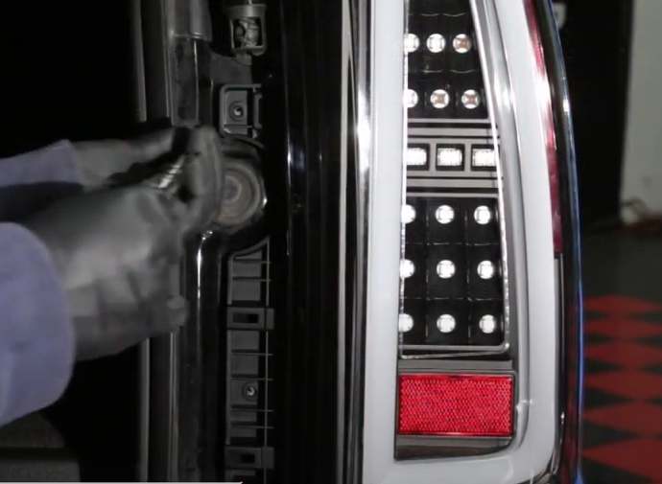
- Reinstall (2x) T15 torx screws.

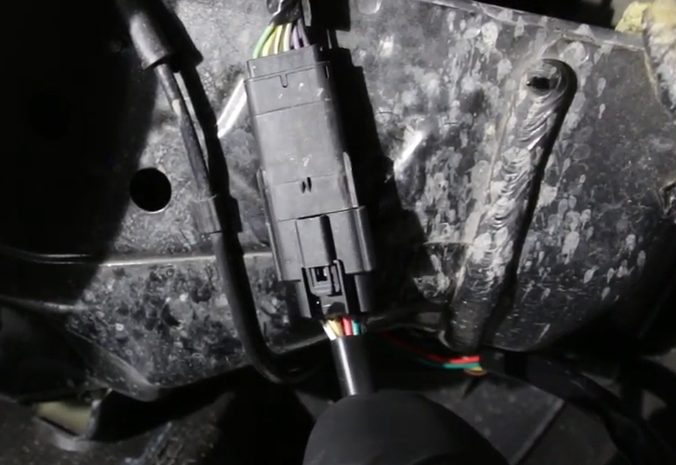
- Under vehicle connect Spyder harness.
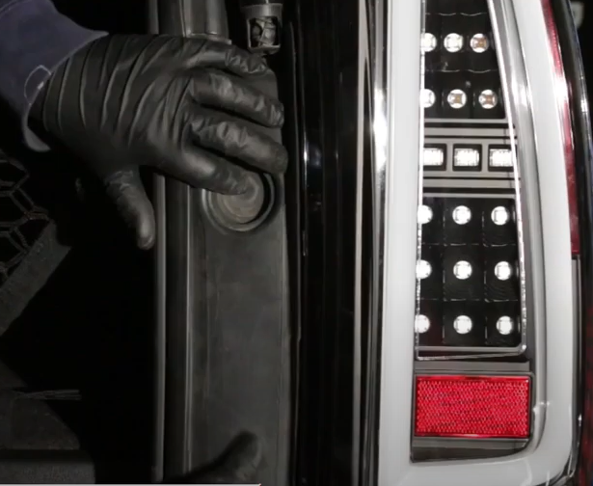
- Reinstall trim panel.

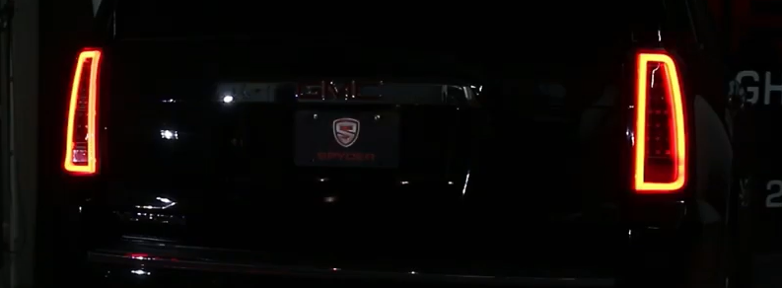
9. Turn on lights and confirm all functions are working properly. You have successfully completed the install of your new Spyder LED tail lights.

For further help with installation, please watch our installation video. Follow the direct link below to our YouTube channel for more information:
http://www.youtube.com/watch

DISCLAIMER
Spyder Auto Installation Guide is not liable for damages, injuries, and death while installing the product. This is intended to be an installation guide, to reduce installation time. We have no responsibility for improper installation. If you do not know how to install, please have a professional install it.

