

**Installation Guide:**

ALT-YD-GS16-LED-(All)

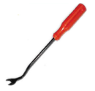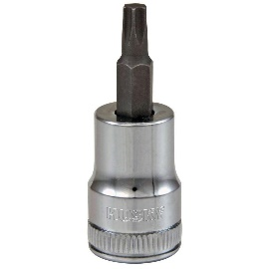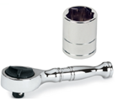Tools Needed:

* ¼” ratchet
* T15 socket
* Panel popper

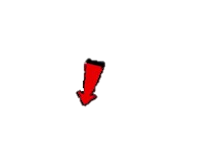

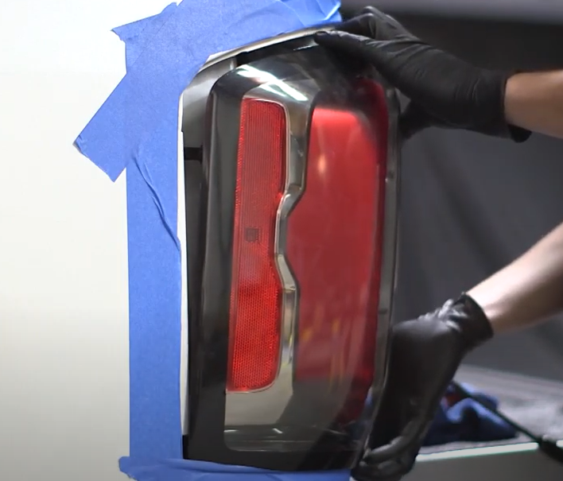

1. Unseat tail light using panel popper.

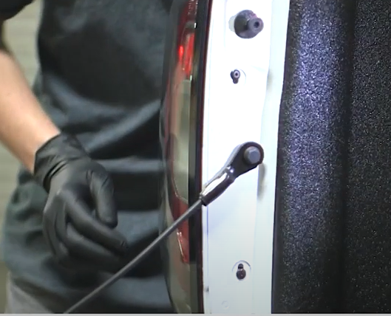

1. Remove (2x) T15 screws



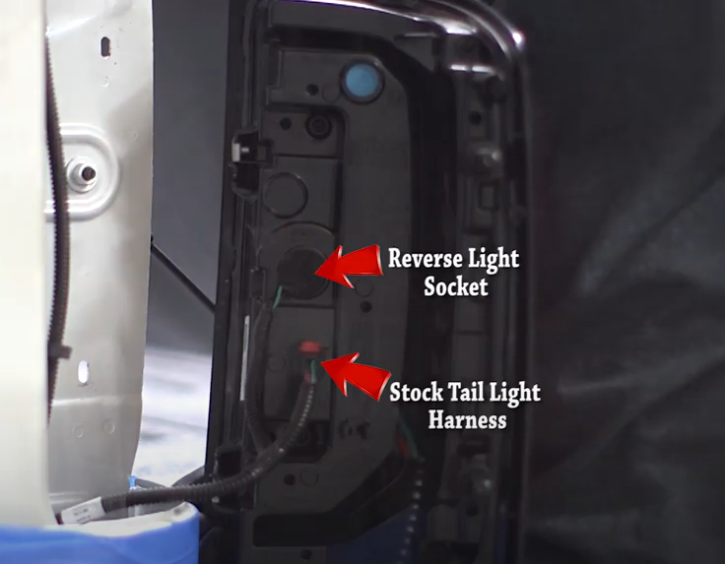

1. Remove reverse bulb sockets and unclip brake/signal.

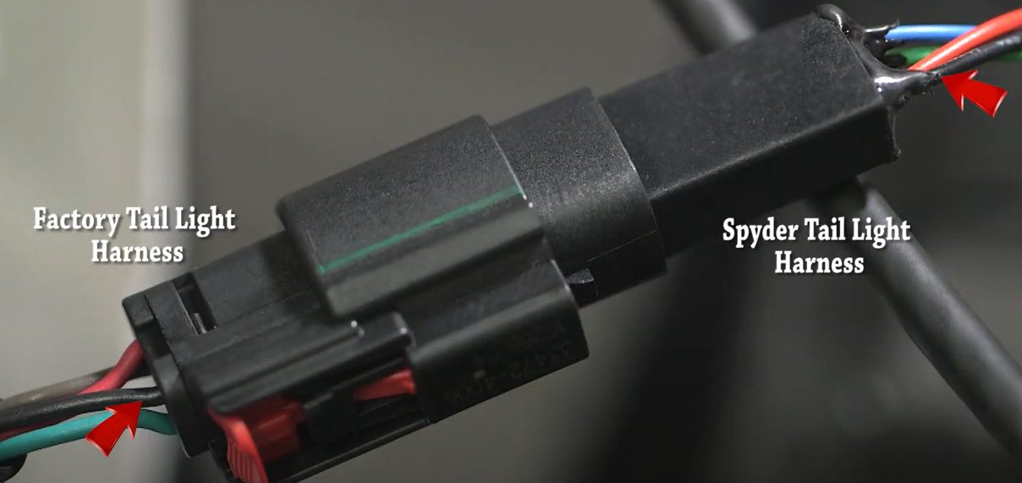

1. Connect Spyder tail light harness. (Make sure black wires match)

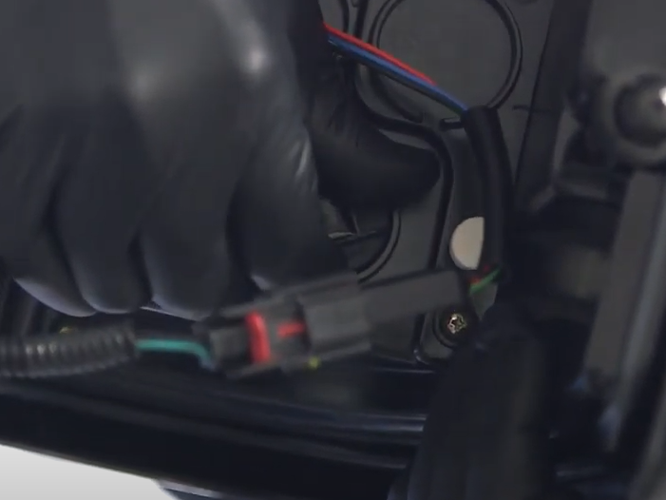

1. Install reverse bulb socket into Spyder tail light

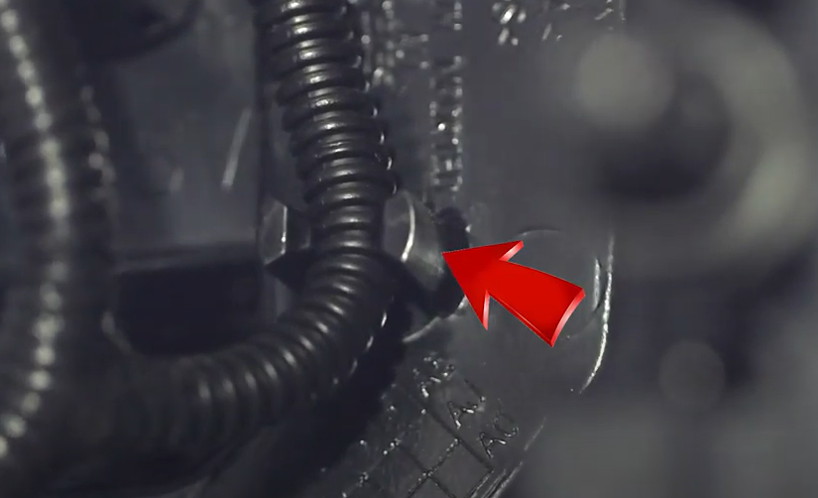

1. Insert and seat factory harness into the holder on Spyder tail light.



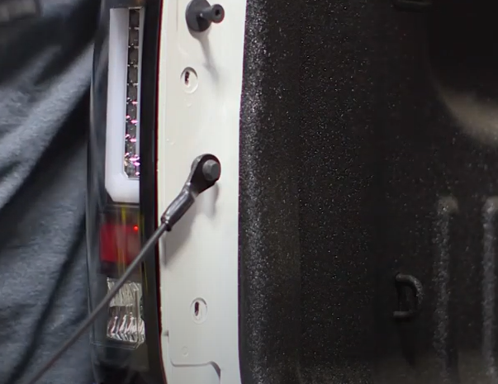

1. Reinstall (2x) T15 screws.

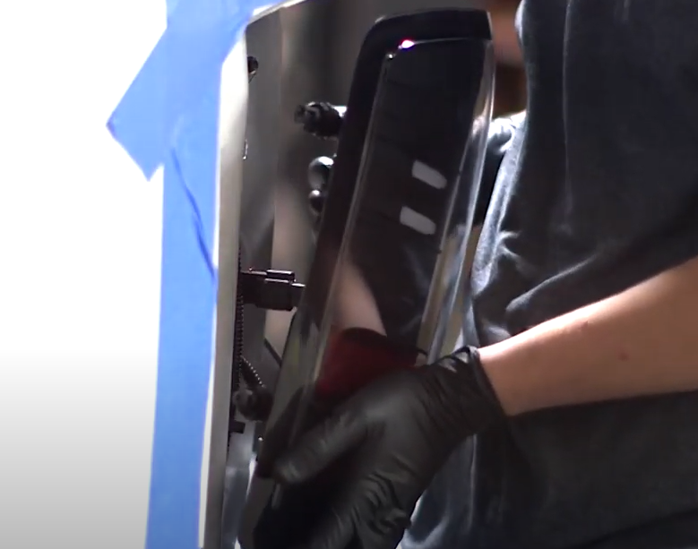

1. Seat Spyder tail light.

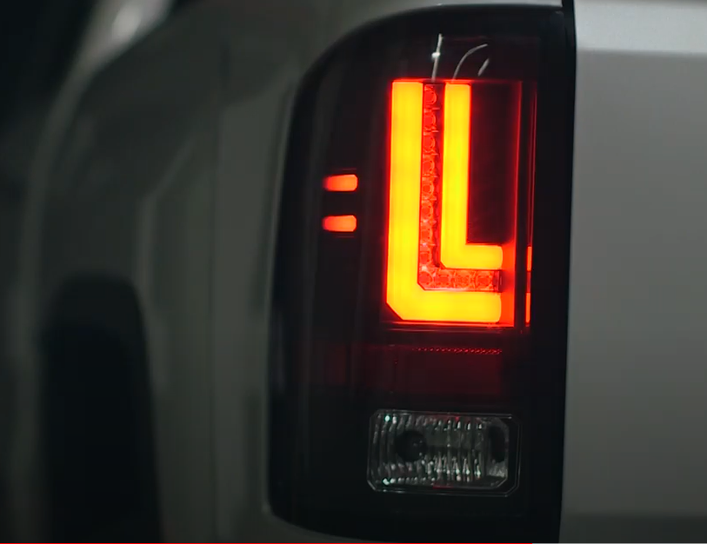

9. Turn on lights and confirm all functions are working properly. You have successfully completed the install of your new Spyder LED tail lights.



For further help with installation, please watch our installation video. Follow the direct link below to our YouTube channel for more information:

http://www.youtube.com/watch

**DISCLAIMER**

Spyder Auto Installation Guide is not liable for damages, injuries, and death while installing the product. This is intended to be an installation guide, to reduce installation time. We have no responsibility for improper installation. If you do not know how to install, please have a professional install it.