Installation Guide:
ALT-YD-GS14-LBLED-(All)
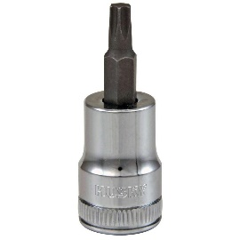
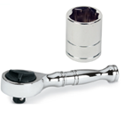
Tools Needed:
- ¼” ratchet
- T15 socket

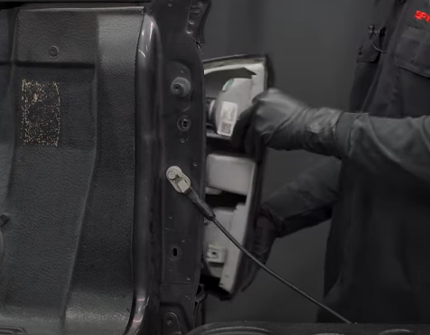
- Unseat tail light using panel popper.
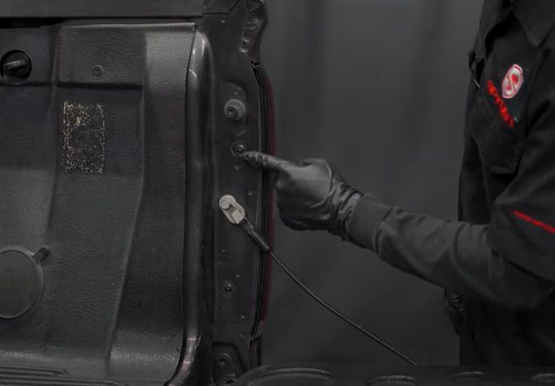
- Remove (2x) T15 screws

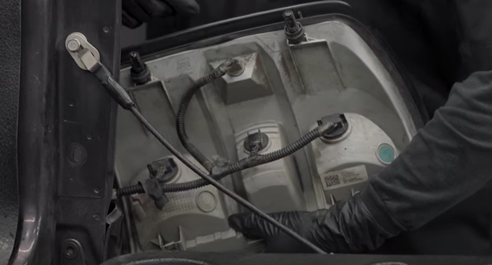
- Remove (4x) bulb sockets from tail light.
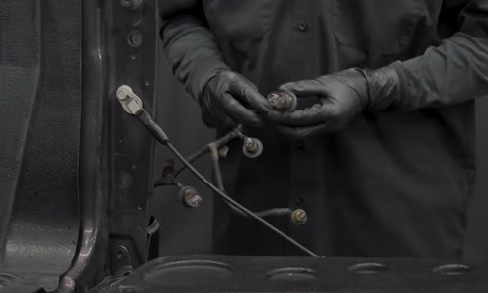
- Remove bulbs from top and bottom brake/signal and also side marker bulb.

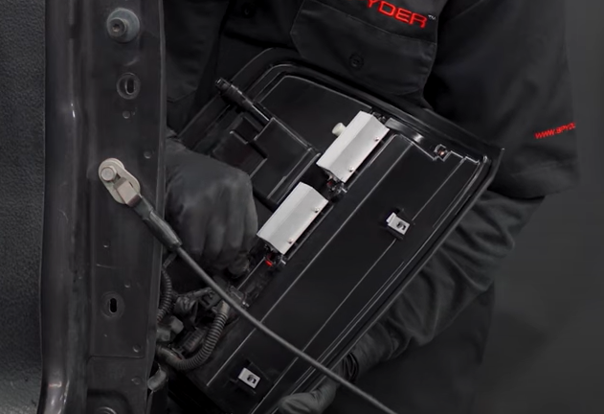
- Seat all sockets onto Spyder tail light.
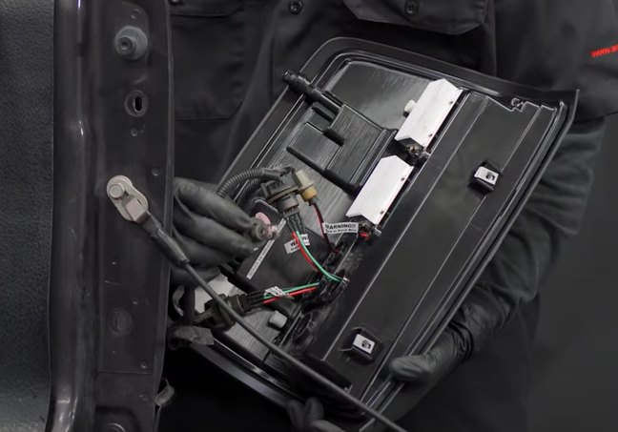
- Install (2x) brake/turn and (1x) Side marker socket insert on Spyder tail light into brake socket. (Make sure to align black wire of socket to black wire of socket insert)

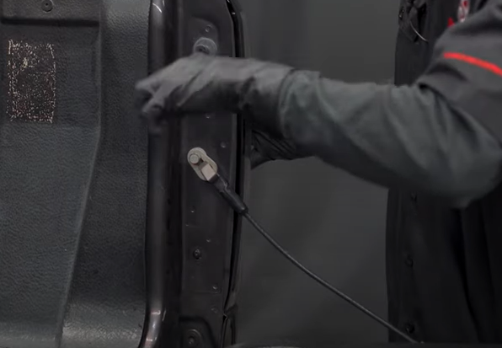
- Reinstall (2x) T15 screws.
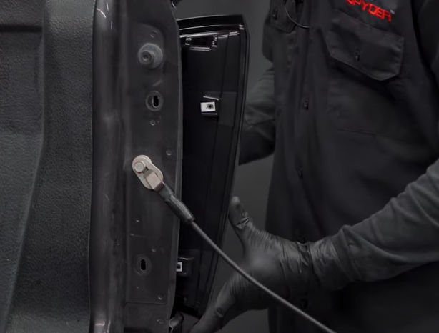
- Seat Spyder tail light.

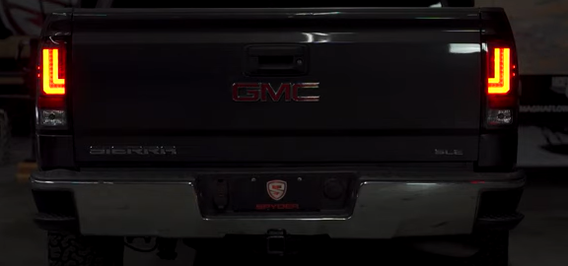
9. Turn on lights and confirm all functions are working properly. You have successfully completed the install of your new Spyder LED tail lights.

For further help with installation, please watch our installation video. Follow the direct link below to our YouTube channel for more information:
http://www.youtube.com/watch

DISCLAIMER
Spyder Auto Installation Guide is not liable for damages, injuries, and death while installing the product. This is intended to be an installation guide, to reduce installation time. We have no responsibility for improper installation. If you do not know how to install, please have a professional install it.

