Installation Guide:
ALT-YD-FS17-LED-(All)
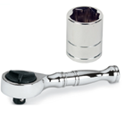
Tools Needed:
- ¼” ratchet
- 8mm socket

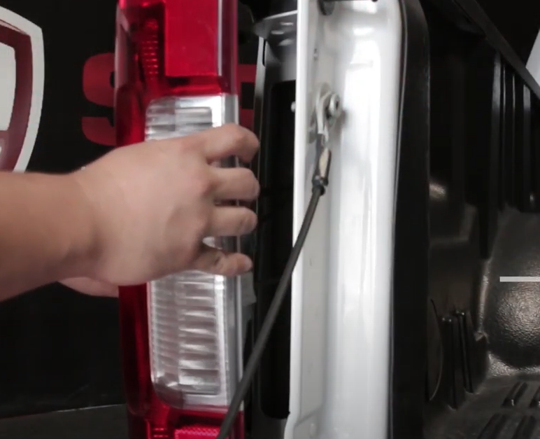
- Unseat tail light using panel popper.
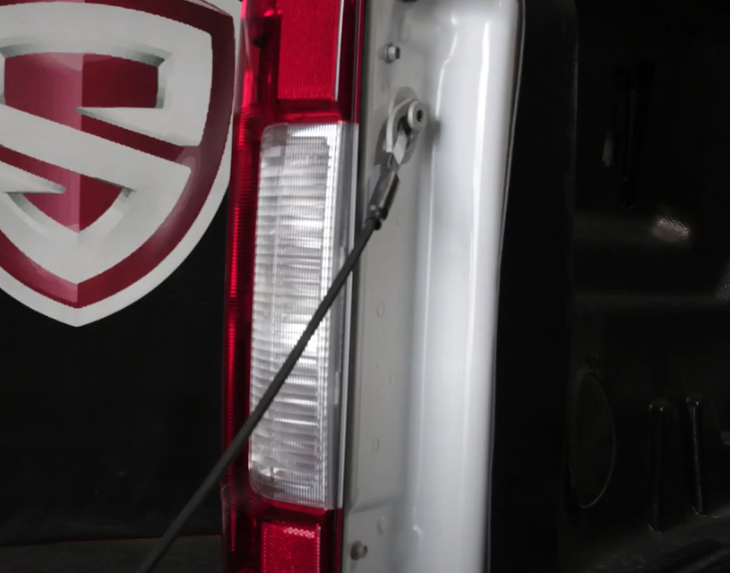
- Remove (2x) 8mm bolts.

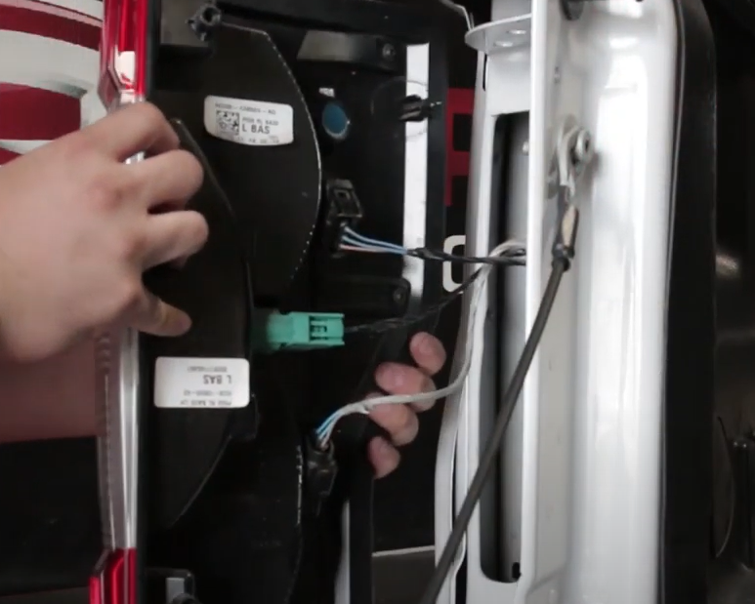
- Unclip (3x) harnesses from tail light
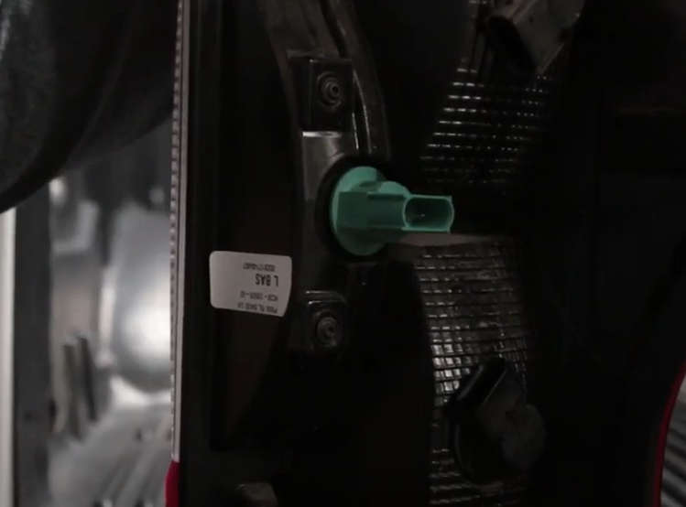
- Remove reverse light bulb socket from old tail light.

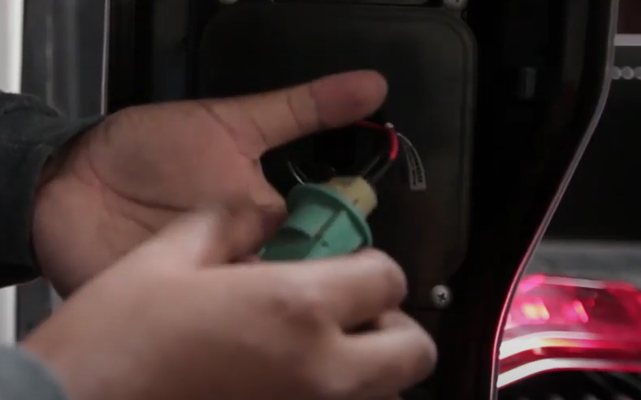
- Remove brake light bulb from sock and install brake socket insert into brake socket on Spyder tail light. (Make sure to align black wire of socket to black wire of socket insert)
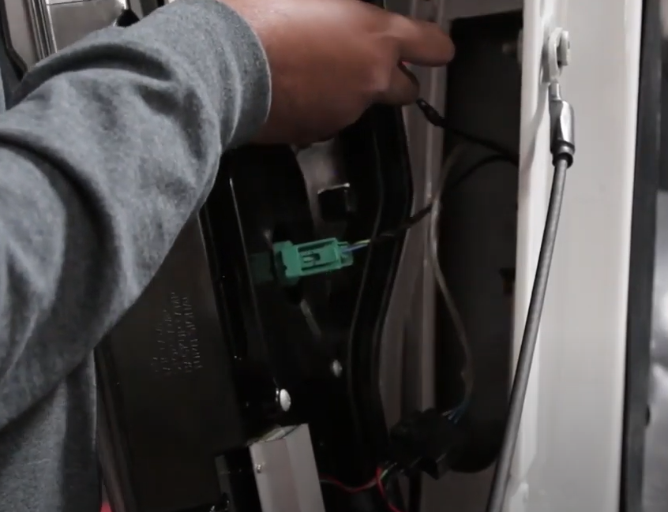
- Seat socket onto Spyder tail light and connect wire harness.

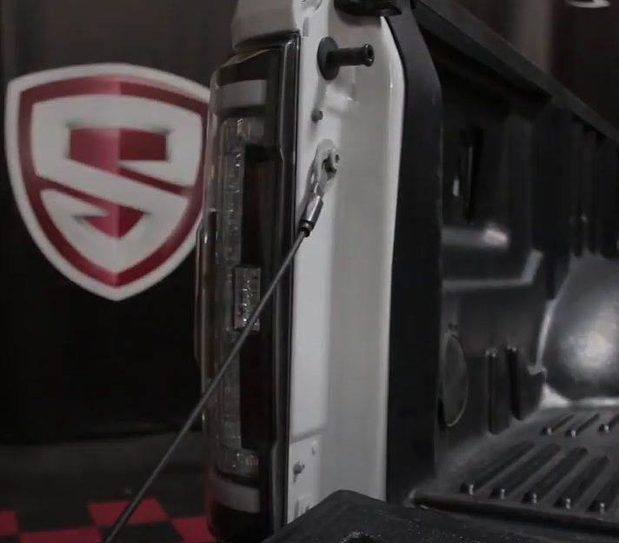
- Reinstall (2x) 8mm bolts.
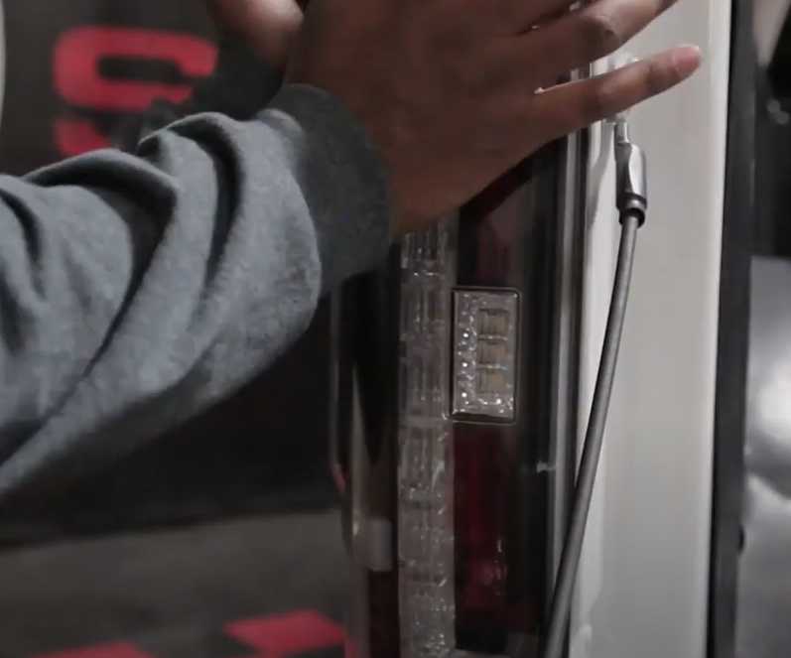
- Seat Spyder tail light.

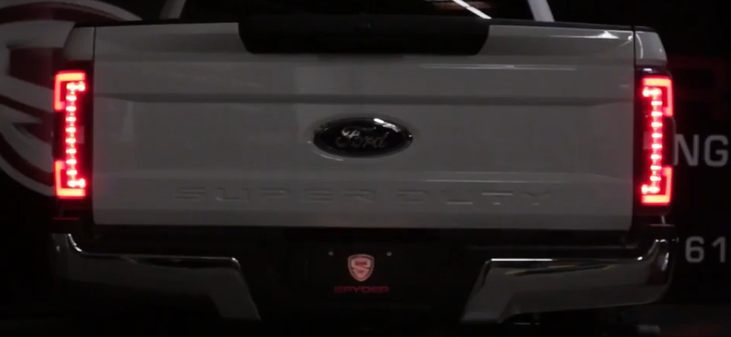
9. Turn on lights and confirm all functions are working properly. You have successfully completed the install of your new Spyder LED tail lights.

For further help with installation, please watch our installation video. Follow the direct link below to our YouTube channel for more information:
http://www.youtube.com/watch

DISCLAIMER
Spyder Auto Installation Guide is not liable for damages, injuries, and death while installing the product. This is intended to be an installation guide, to reduce installation time. We have no responsibility for improper installation. If you do not know how to install, please have a professional install it.

