Installation Guide:
ALT-YD-FS07-LED-(All)
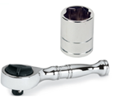
Tools Needed:
- ¼” ratchet
- 10mm socket

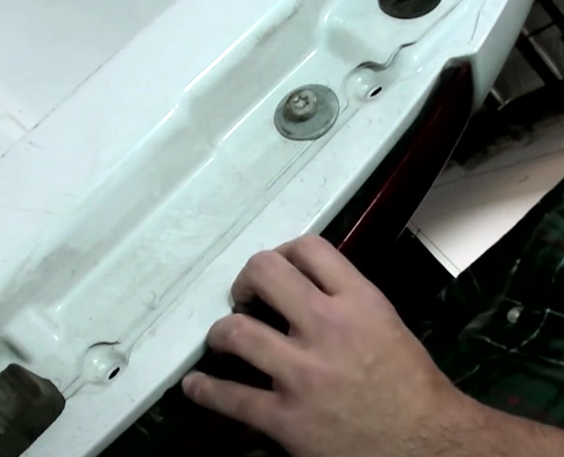
- Unseat tail light.
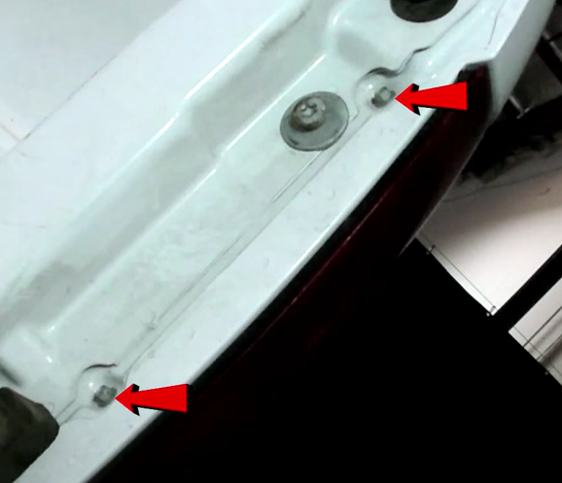
- Remove (2x) 10mm bolts.

- Remove brake and reverse light sockets. (Make sure to not touch bulb with bare hands)
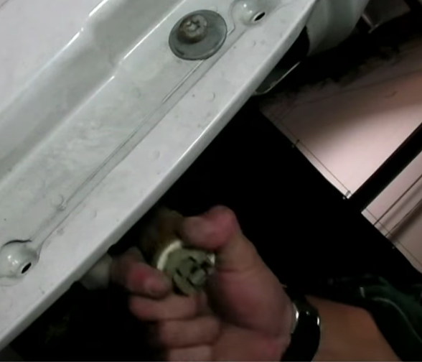
- Remove brake light bulb from sock.

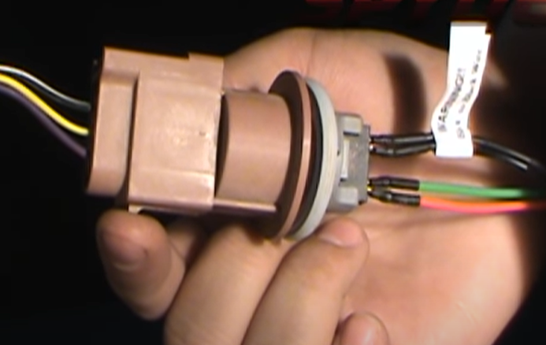
- Install brake socket insert into brake socket. (Make sure to align black wire of socket to black wire of socket insert)
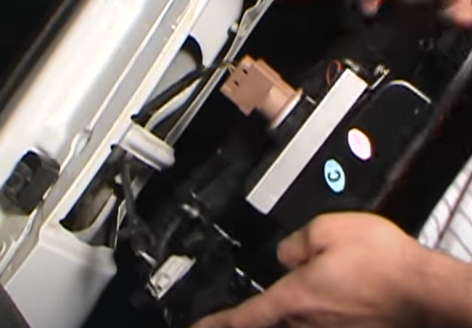
- Install brake and reverse sockets onto Spyder tail light.

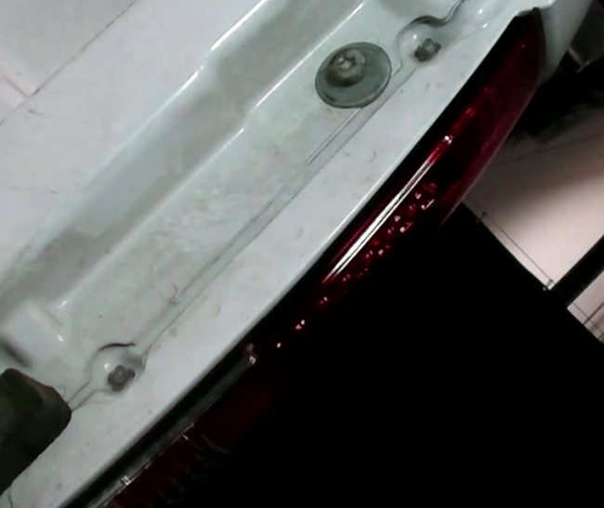
- Reinstall (2x) 10mm bolts.
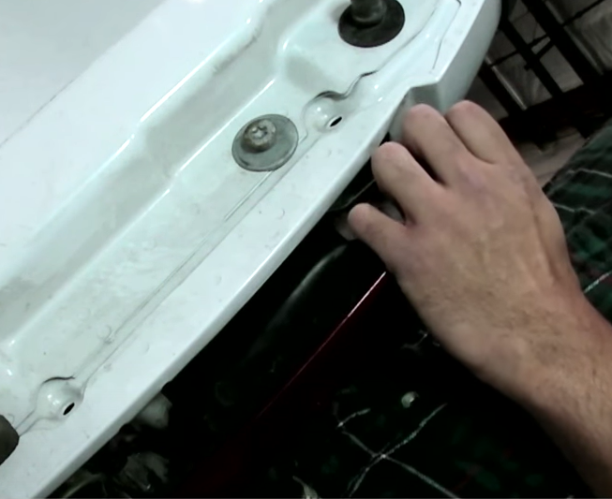
- Seat Spyder tail light.

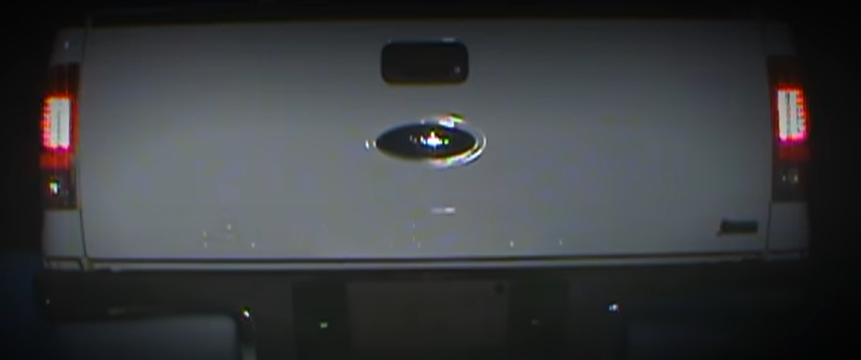
9. Turn on lights and confirm all functions are working properly. You have successfully completed the install of your new Spyder LED tail lights.

For further help with installation, please watch our installation video. Follow the direct link below to our YouTube channel for more information:
http://www.youtube.com/watch

DISCLAIMER
Spyder Auto Installation Guide is not liable for damages, injuries, and death while installing the product. This is intended to be an installation guide, to reduce installation time. We have no responsibility for improper installation. If you do not know how to install, please have a professional install it.

