Installation Guide:
ALT-YD-FR98-LED-(All)
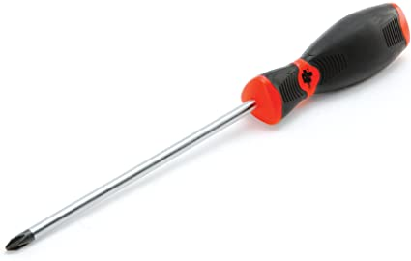
Tools Needed:
- Phillips screwdriver

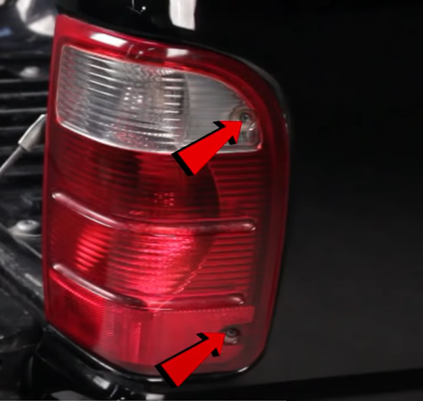
- Remove (2x) outer phillips screws.
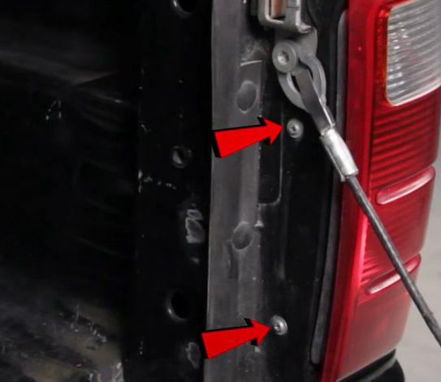
- Remove (2x) phillips screws.

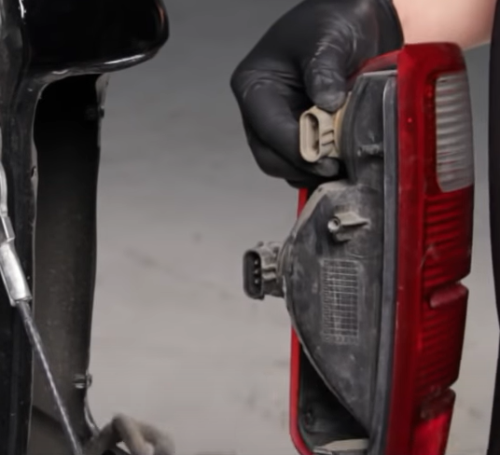
- Disconnect Brake and reverse light harness.
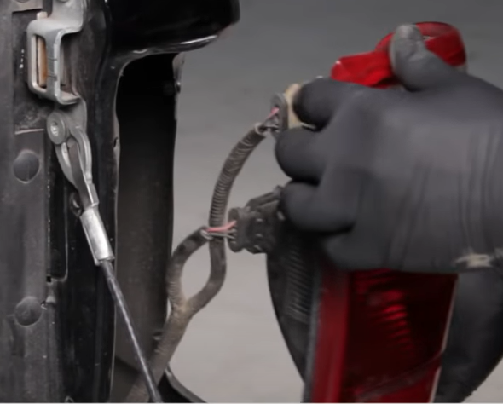
- Unseat tail light.

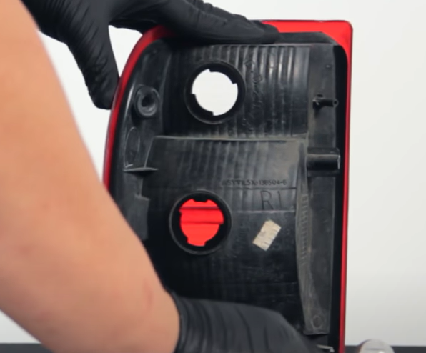
- Remove brake and reverse light sockets.

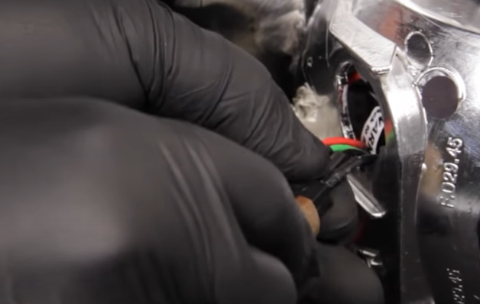
- Remove brake bulb from socket and insert Spyder socket insert into brake socket. (Make sure to align black wire of socket to black wire of socket insert)

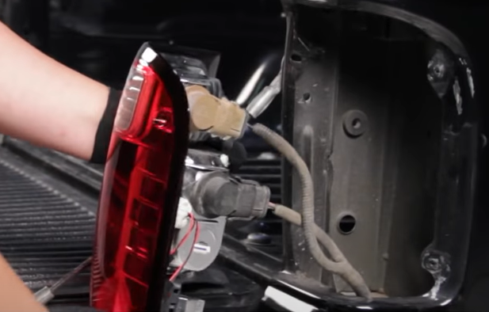
- Connect brake and reverse harness to Spyder tail light.
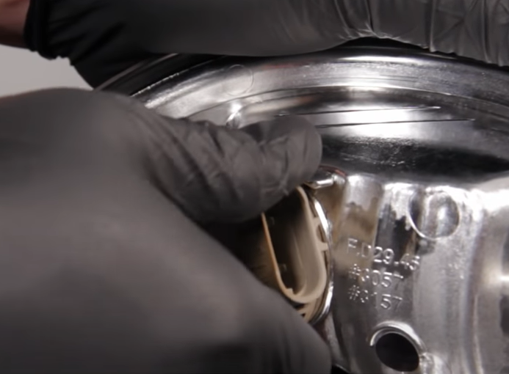
- Install reverse socket onto Spyder tail light.

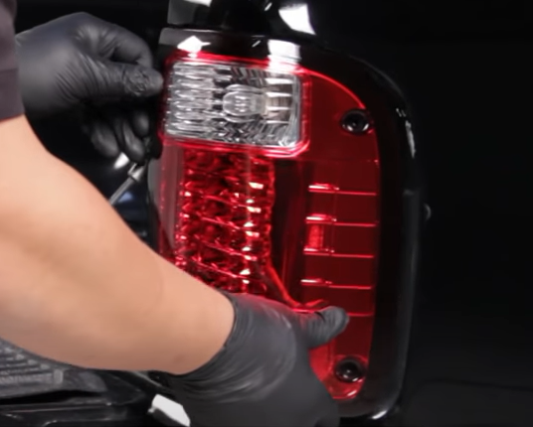
- Seat Spyder tail light.
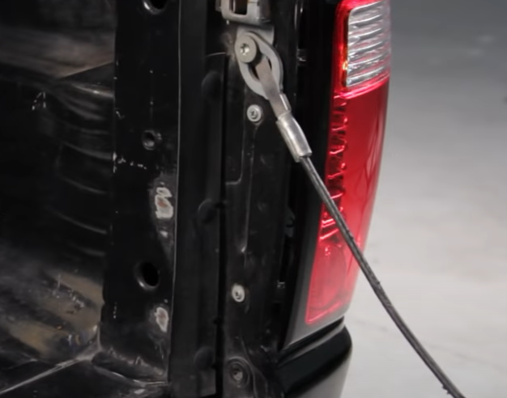
- Reinstall (2x) outer screws and (2x) inner screws.

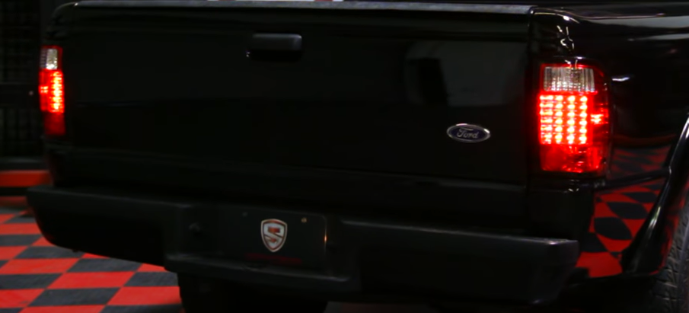
11.Turn on lights and confirm all functions are working properly. You have successfully completed the install of your new Spyder LED tail lights.

For further help with installation, please watch our installation video. Follow the direct link below to our YouTube channel for more information:
http://www.youtube.com/watch

DISCLAIMER
Spyder Auto Installation Guide is not liable for damages, injuries, and death while installing the product. This is intended to be an installation guide, to reduce installation time. We have no responsibility for improper installation. If you do not know how to install, please have a professional install it.

