Installation Guide:
ALT-YD-FF15009-LED-(All)
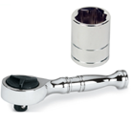
Tools Needed:
- ¼” ratchet
- 8mm socket

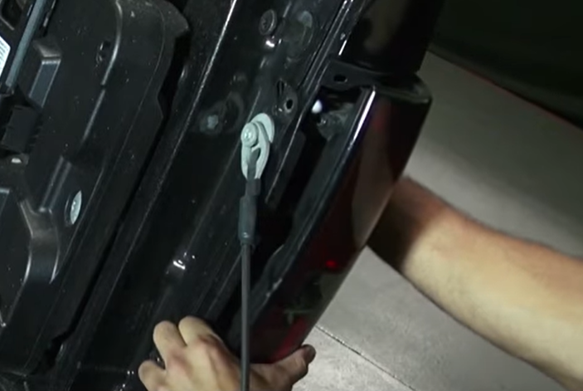
- Unseat tail light.
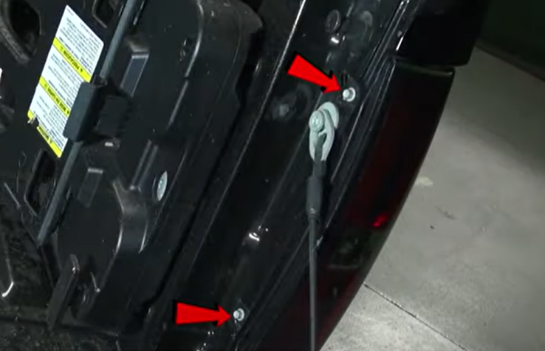
- Remove (2x) 8mm bolts.

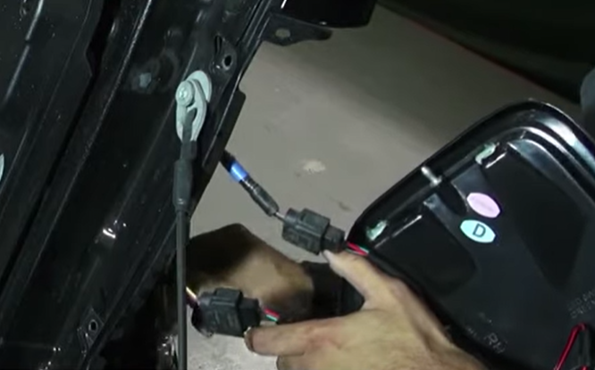
- Connect brake light harness to Spyder tail light.
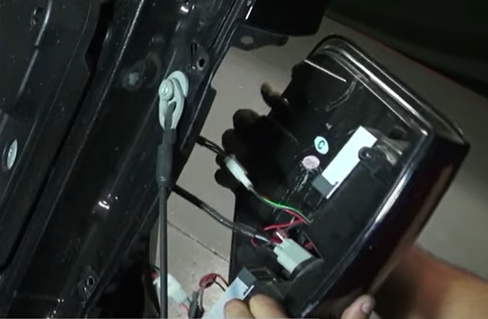
- Remove brake light harness and reverse light socket. (Never touch bulb with bare hands)

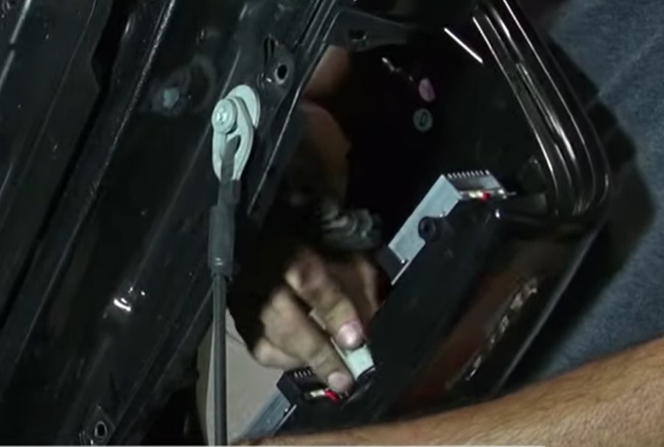
- Install reverse light socket onto Spyder tail light.

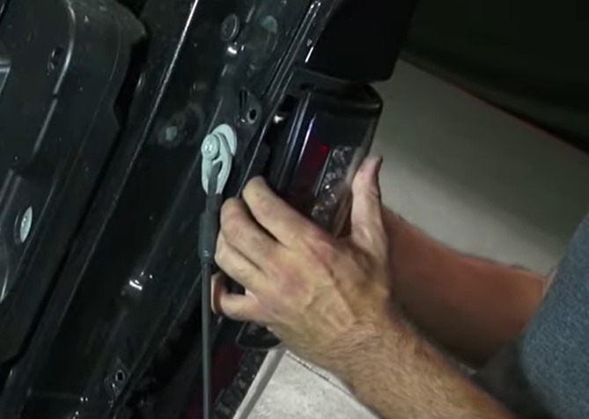
- Seat Spyder tail light.

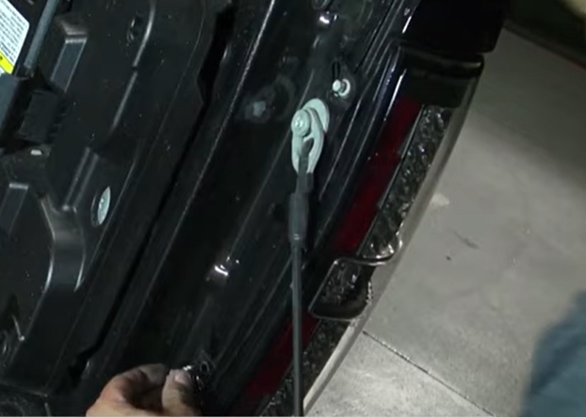
- Reinstall (2x) 10mm bolts.

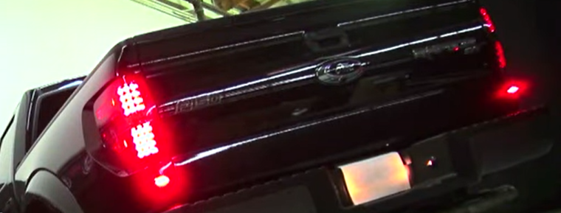
8. Turn on lights and confirm all functions are working properly. You have successfully completed the install of your new Spyder LED tail lights.

For further help with installation, please watch our installation video. Follow the direct link below to our YouTube channel for more information:
http://www.youtube.com/watch

DISCLAIMER
Spyder Auto Installation Guide is not liable for damages, injuries, and death while installing the product. This is intended to be an installation guide, to reduce installation time. We have no responsibility for improper installation. If you do not know how to install, please have a professional install it.

