Installation Guide:
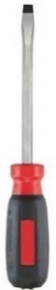
ALT-YD-FF12-LED-(All)
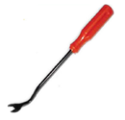
Tools Needed:
- Flathead Screwdriver or Panel popper

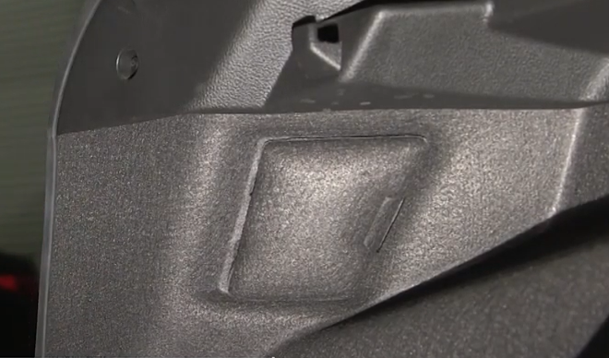
- Remove tail light access panel.
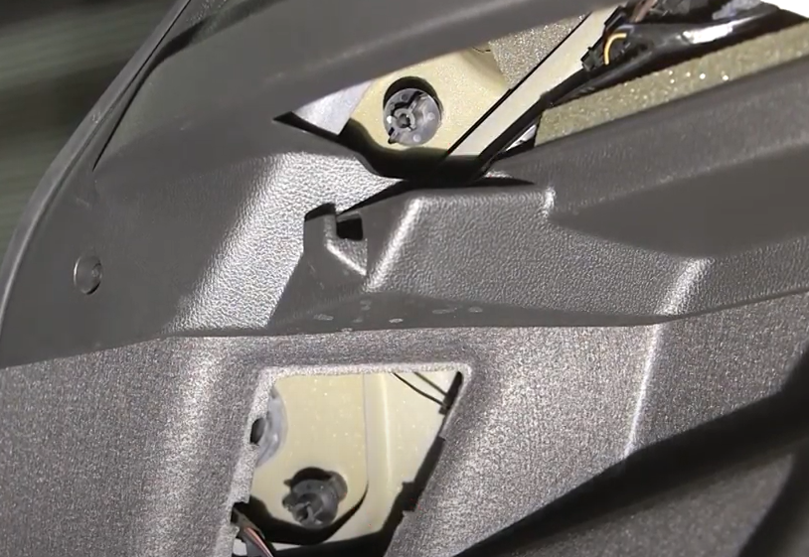
- Remove (2x) thumb screws retainers.

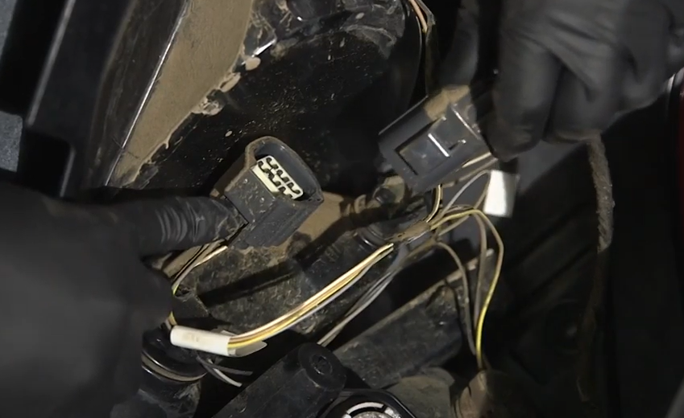
- Disconnect factory tail light harness.
- Unseat factory tail light.

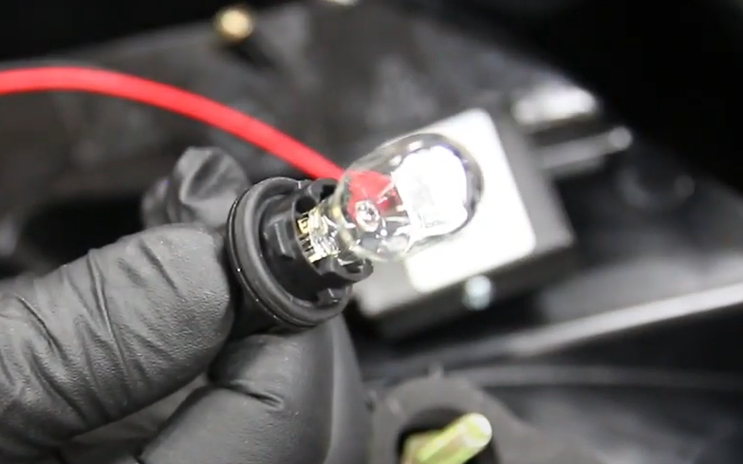
- Transfer factory tail light reverse light bulb to Spyder tail light. (Never touch bulb with bare hands)

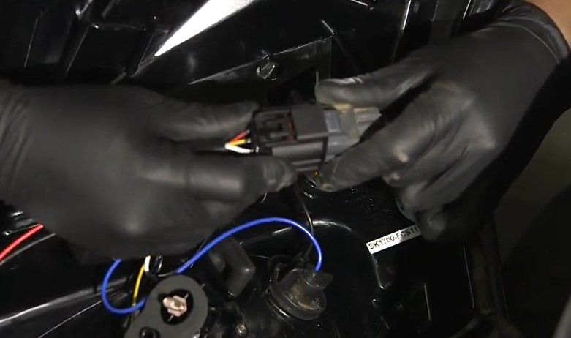
- Connect Spyder tail light harness.

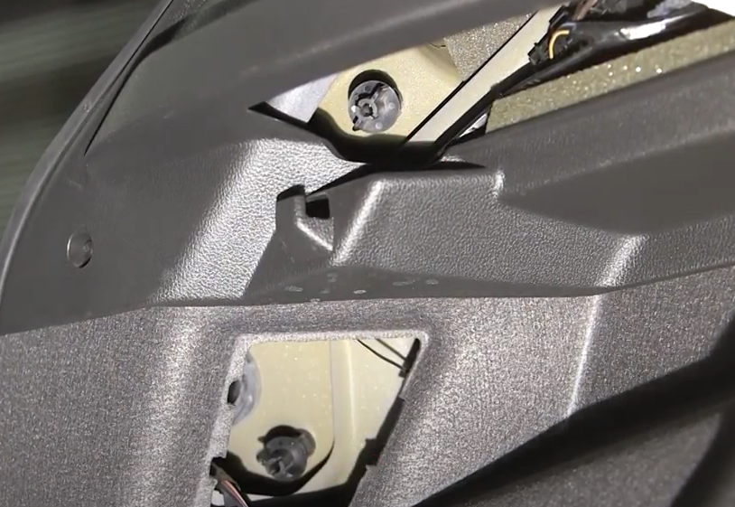
- Reinstall (2x) thumb screws.
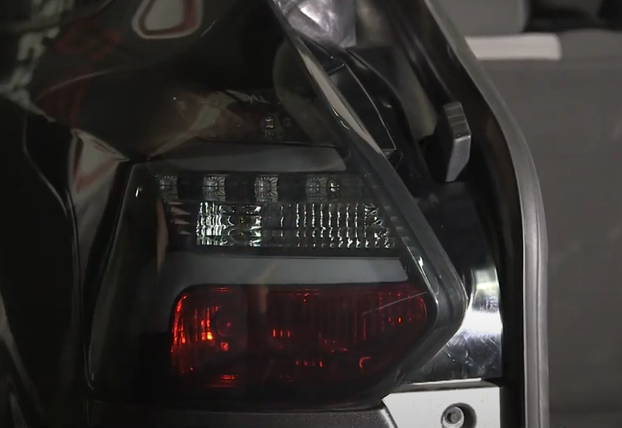
- Seat Spyder tail light.

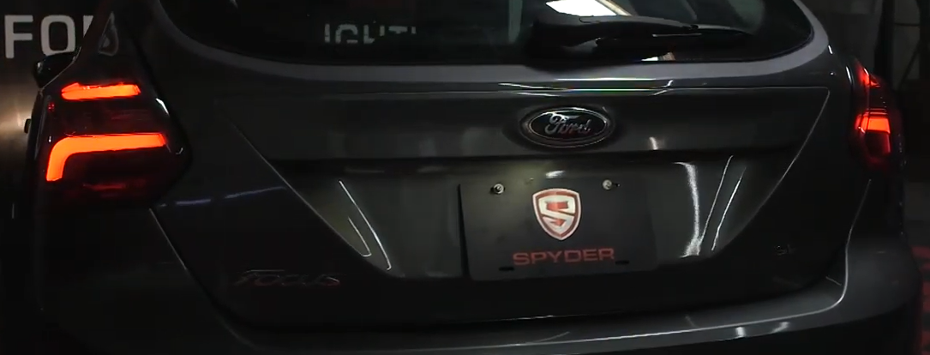
10. Turn on lights and confirm all functions are working properly. You have successfully completed the install of your new Spyder LED tail lights.
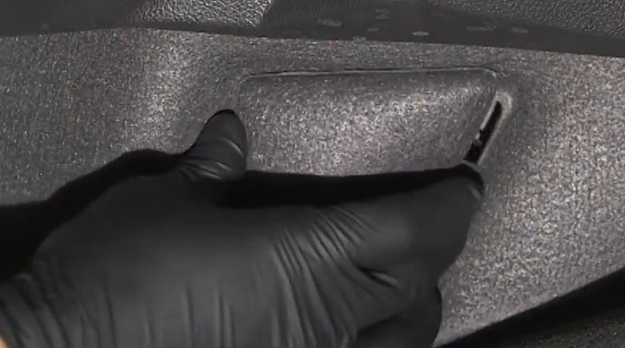
- Reinstall tail light access panel.

For further help with installation, please watch our installation video. Follow the direct link below to our YouTube channel for more information:
http://www.youtube.com/watch

DISCLAIMER
Spyder Auto Installation Guide is not liable for damages, injuries, and death while installing the product. This is intended to be an installation guide, to reduce installation time. We have no responsibility for improper installation. If you do not know how to install, please have a professional install it.

