Installation Guide:
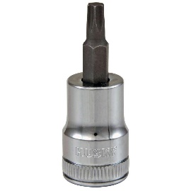
ALT-YD-DRAM13-LED-(All)
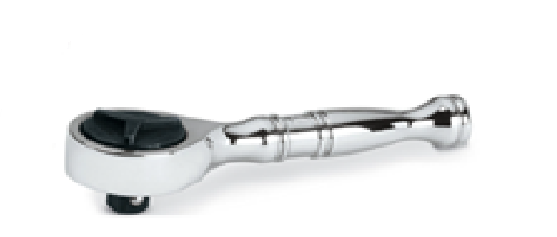
Tools Needed:
- ¼” ratchet
- T20 Torx socket

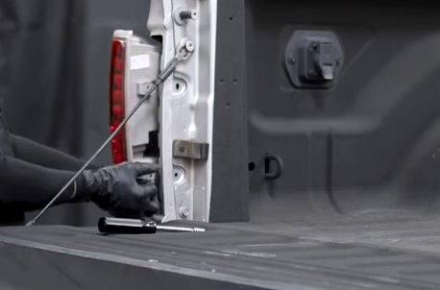
- Unseat tail light.
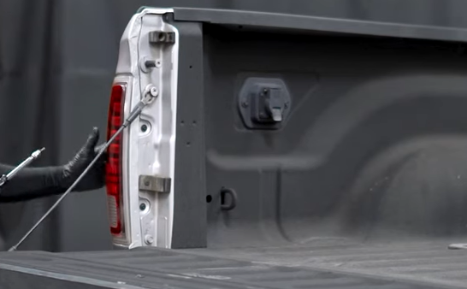
- Remove (2x) T20 torx screws.

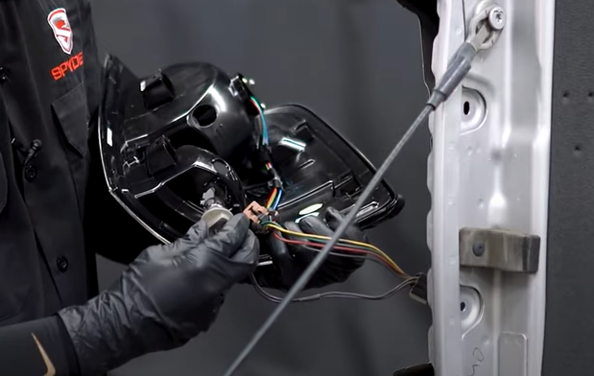
- Install reverse socket and brake light harness onto Spyder tail light.
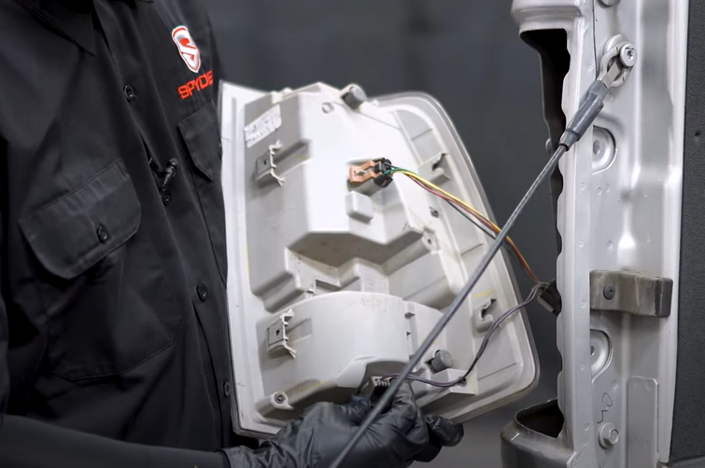
- Remove reverse socket and brake light harness. (Never touch bulb with bare hands)

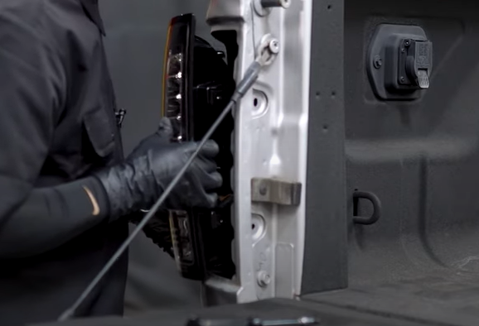
- Seat Spyder tail light.

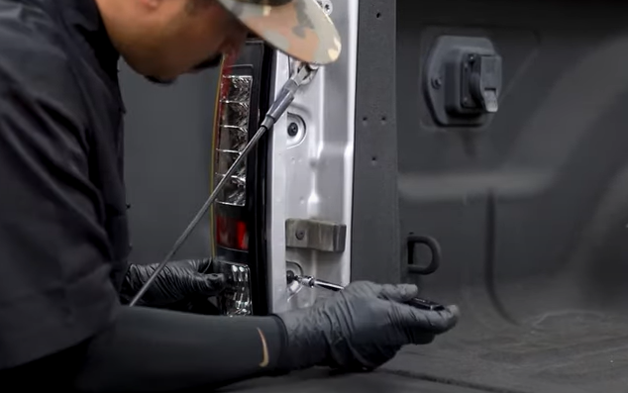
- Reinstall (2x) T20 torx screws.

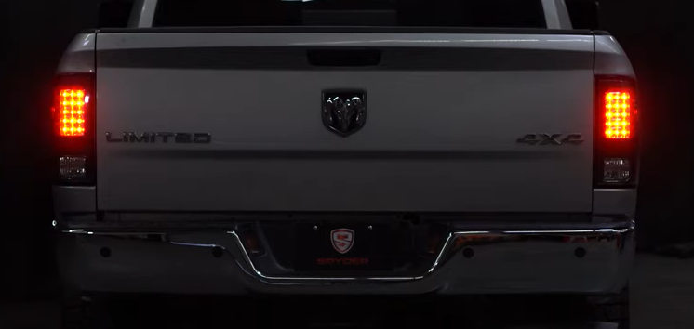
9. Turn on lights and confirm all functions are working properly. You have successfully completed the install of your new Spyder LED tail lights.

For further help with installation, please watch our installation video. Follow the direct link below to our YouTube channel for more information:
http://www.youtube.com/watch

DISCLAIMER
Spyder Auto Installation Guide is not liable for damages, injuries, and death while installing the product. This is intended to be an installation guide, to reduce installation time. We have no responsibility for improper installation. If you do not know how to install, please have a professional install it.

