Installation Guide:
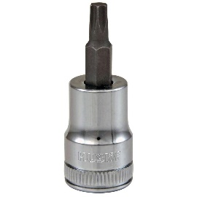
ALT-YD-DRAM09V2-LED-(All)
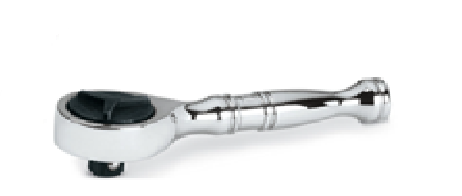
Tools Needed:
- ¼” ratchet
- T25 Torx socket

- Unseat tail light.
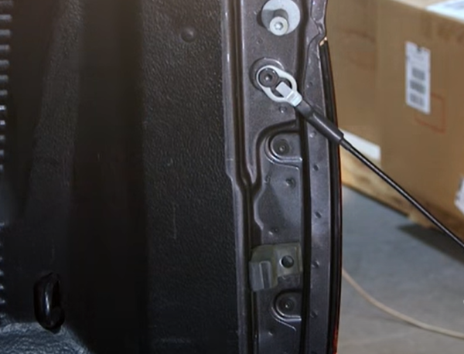
- Remove (2x) T25 torx screws.

- Remove brake bulb from socket.
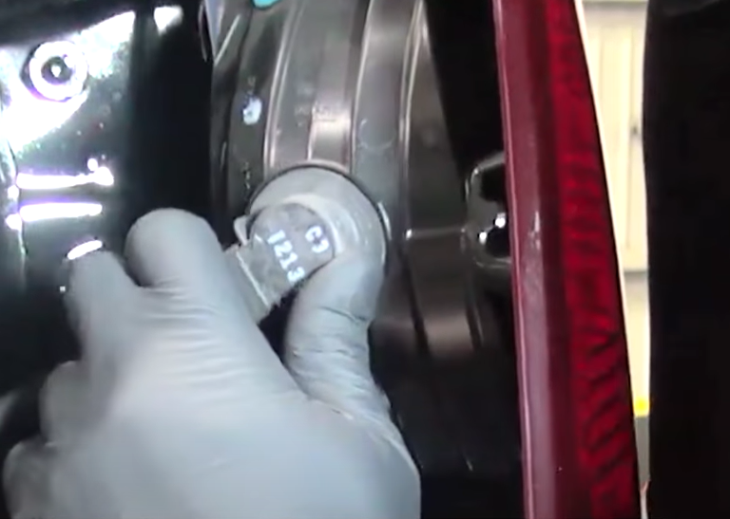
- Remove reverse and brake tail light sockets. (Never touch bulb with bare hands)

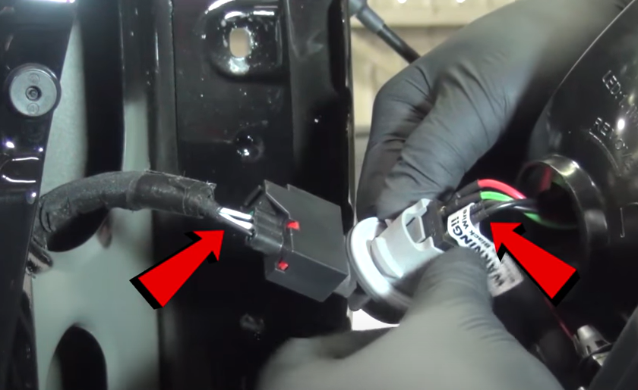
- Install socket insert with black wire on the black wire side of socket.

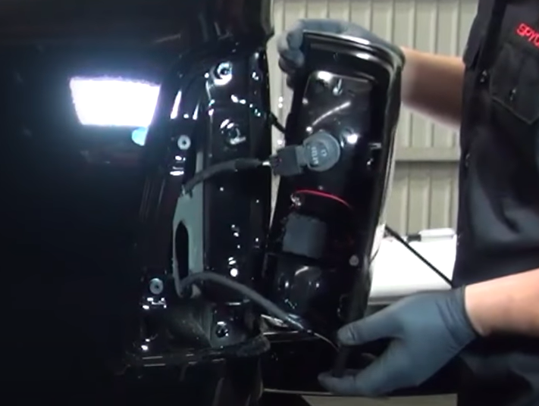
- Install sockets into Spyder tail light.

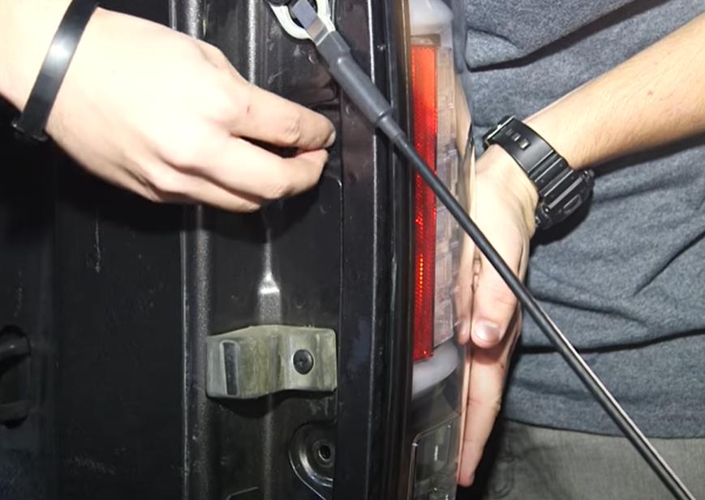
- Reinstall (2x) T25 torx screws.
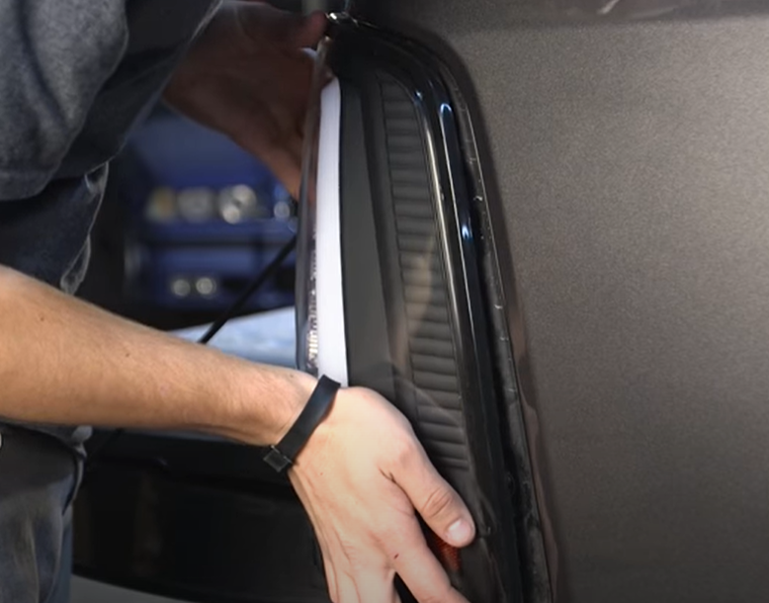
- Seat Spyder tail light.

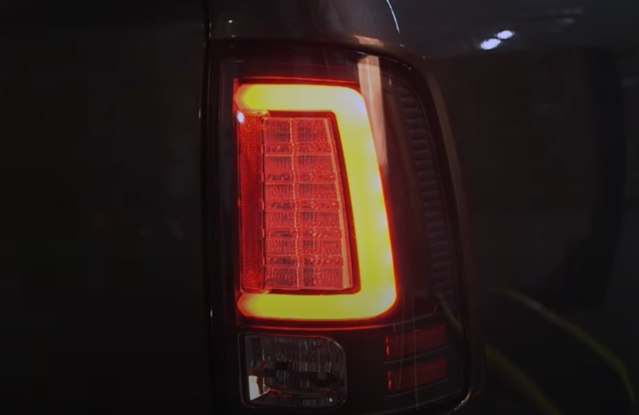
9. Turn on lights and confirm all functions are working properly. You have successfully completed the install of your new Spyder LED tail lights.

For further help with installation, please watch our installation video. Follow the direct link below to our YouTube channel for more information:
http://www.youtube.com/watch

DISCLAIMER
Spyder Auto Installation Guide is not liable for damages, injuries, and death while installing the product. This is intended to be an installation guide, to reduce installation time. We have no responsibility for improper installation. If you do not know how to install, please have a professional install it.

