Installation Guide:
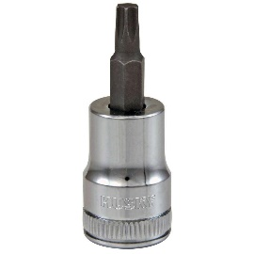
ALT-YD-DRAM06-LED-(All)
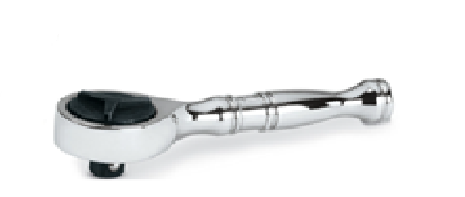
Tools Needed:
- ¼” ratchet
- T15 Torx socket
Items Needed:
- 3157 Bulb

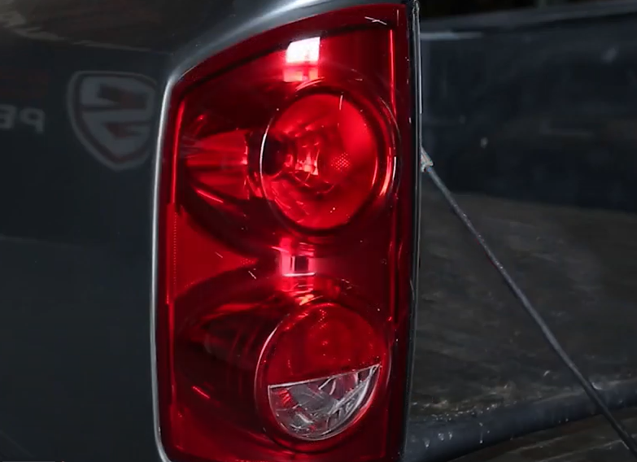
- Unseat tail light.
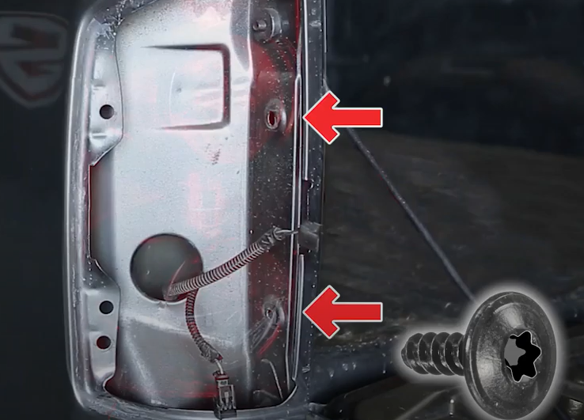
- Remove (2x) T15 torx screws.

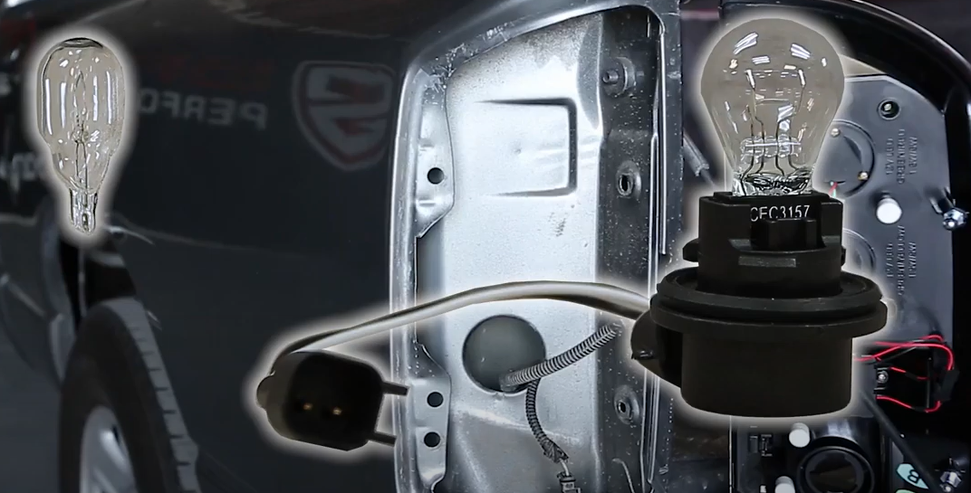
- Install new bulb (3157) into Spyder socket and install into tail light.
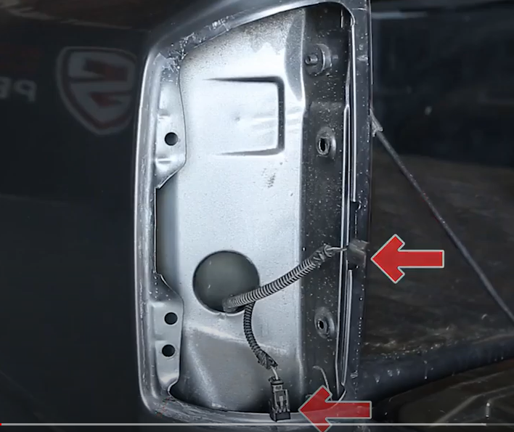
- Disconnect tail light harness (2x) clips.

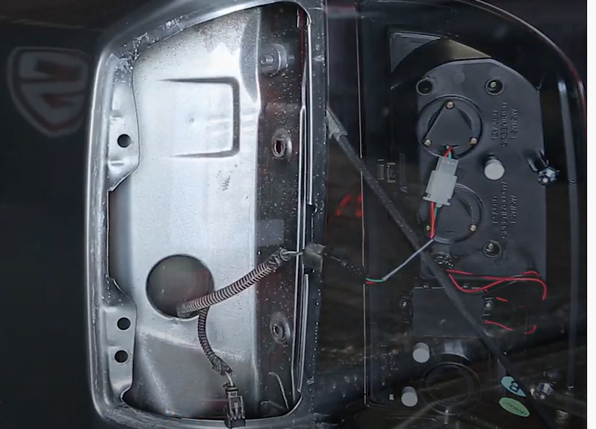
- Connect (2x) harness clips onto Spyder tail light.

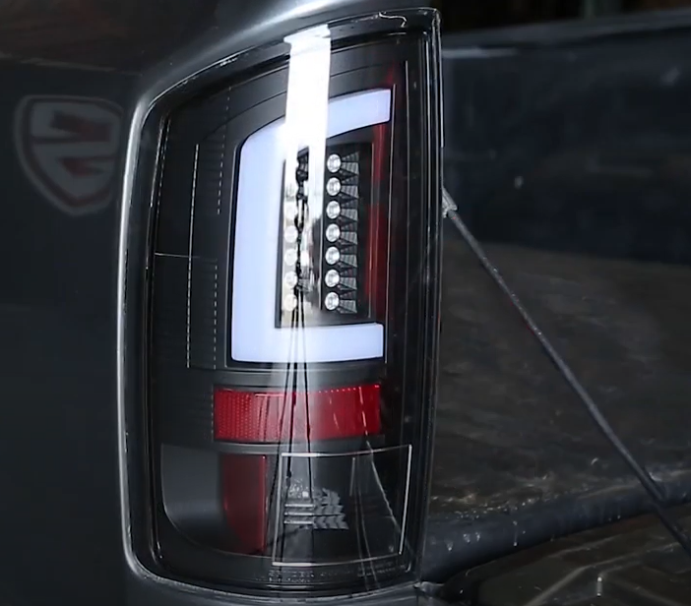
- Seat Spyder tail light and reinstall (2x) T15 torx screws.

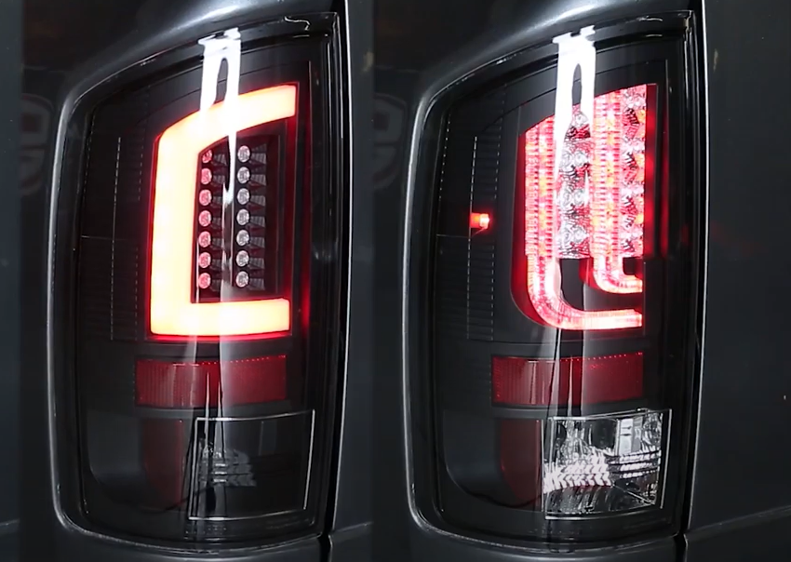
19. Turn on lights and confirm all functions are working properly. You have successfully completed the install of your new Spyder LED tail lights.

For further help with installation, please watch our installation video. Follow the direct link below to our YouTube channel for more information:
http://www.youtube.com/watch

DISCLAIMER
Spyder Auto Installation Guide is not liable for damages, injuries, and death while installing the product. This is intended to be an installation guide, to reduce installation time. We have no responsibility for improper installation. If you do not know how to install, please have a professional install it.

