

**Installation Guide:**

ALT-YD-DCH05-LED-(All)

Tools Needed:

* None

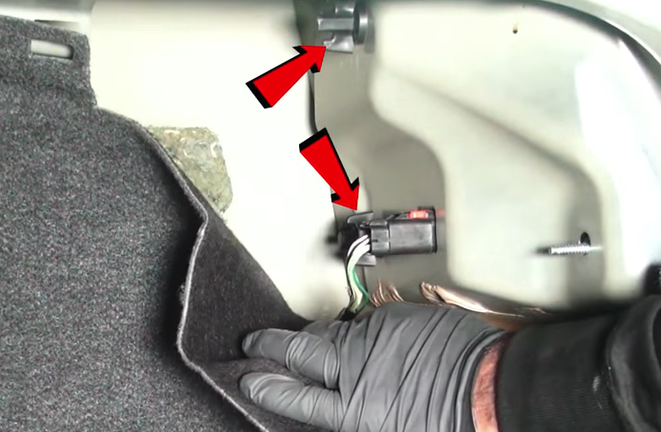

1. Pull back carpet liner and remove (2x) thumbscrews.

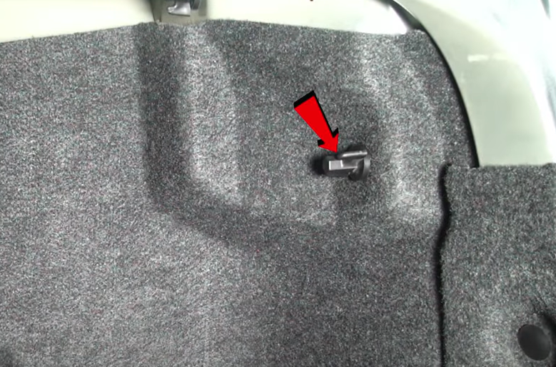

1. Remove (1x) thumbscrew.

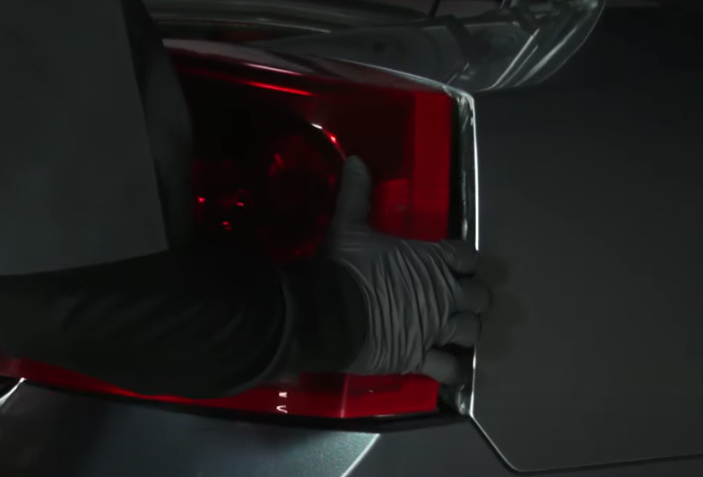

1. Unseat and remove tail light.

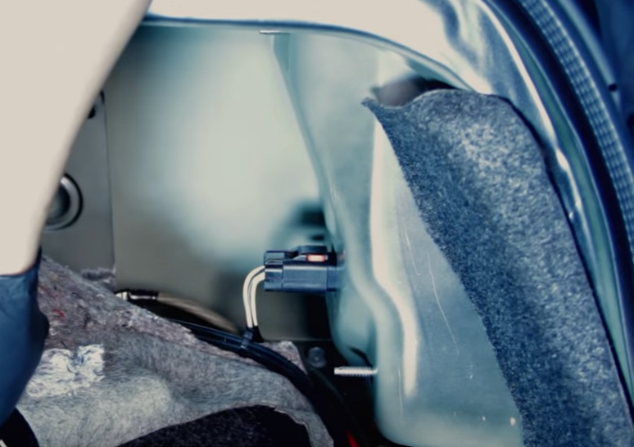

1. Disconnect tail light harness.

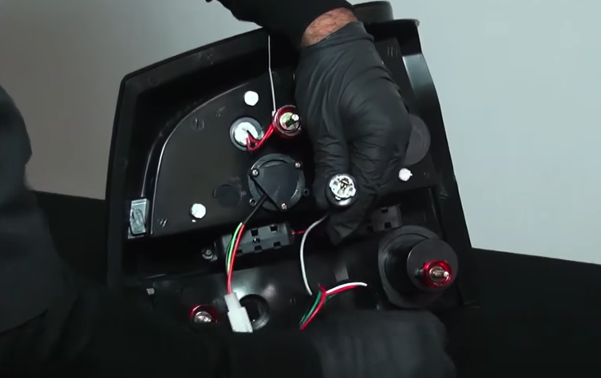

1. Remove Blk/Wht wire bulb socket from Spyder tail light and transfer reverse bulb.

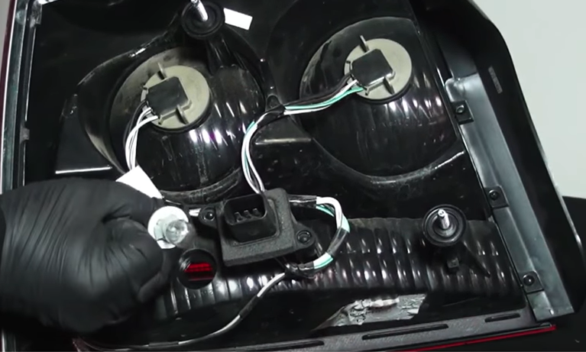

1. Remove reverse light socket and remove bulb. (Never touch bulb with bare hands)

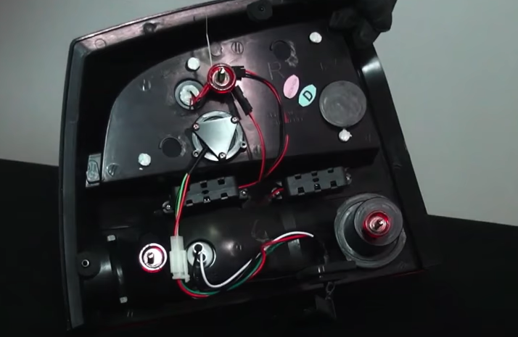

1. Reinstall reverse socket on Spyder tail light.

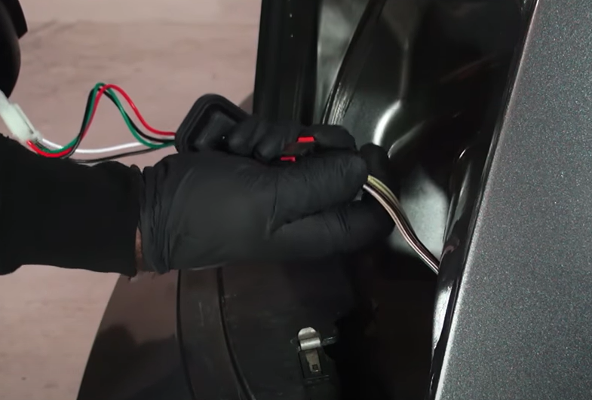

1. Connect Spyder tail light harness.

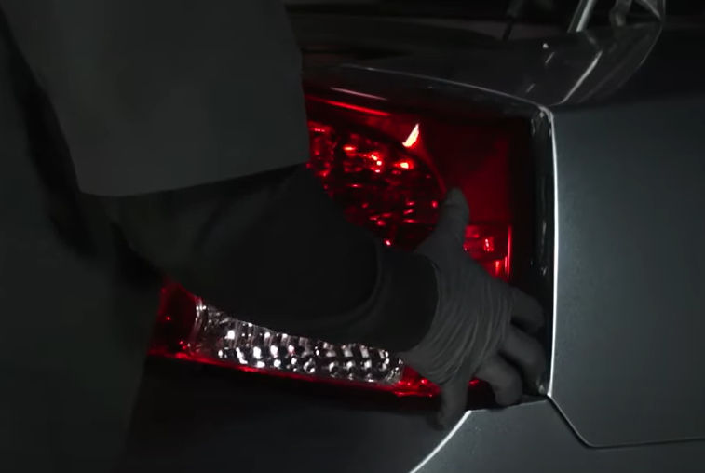

10. Seat Spyder tail light.

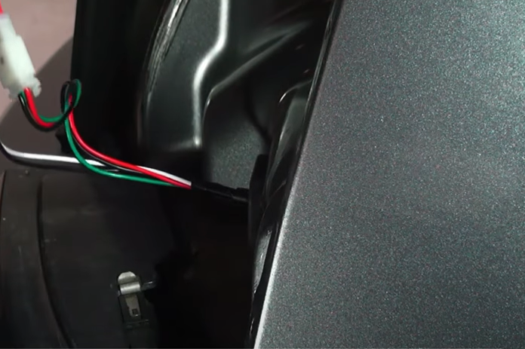

1. 9. Make sure to properly seat wire harness gromet on Spyder tail light before seating tail light.

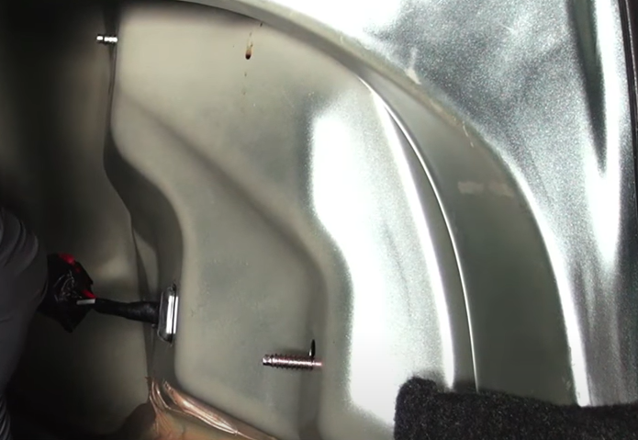

11. Reinstall (2x) thumbscrews.

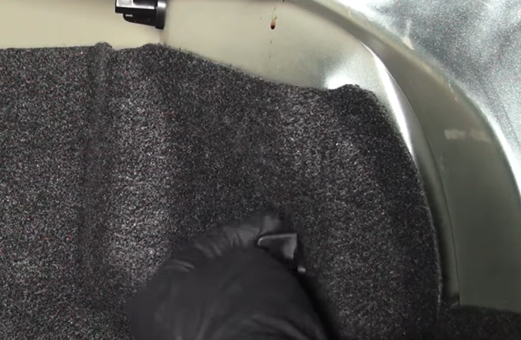

12. Reinstall (1x) thumbscrew securing trunk carpet liner.

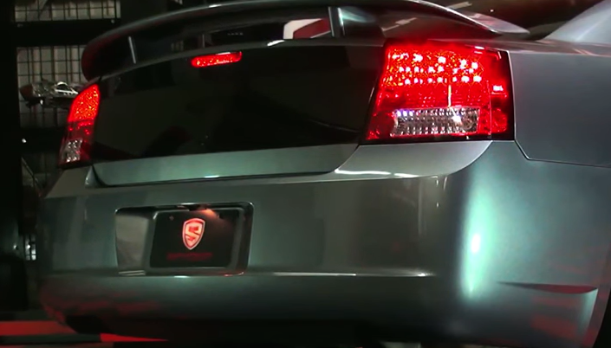

12. Turn on lights and confirm all functions are working properly. You have successfully completed the install of your new Spyder LED tail lights.



For further help with installation, please watch our installation video. Follow the direct link below to our YouTube channel for more information:

http://www.youtube.com/watch

**DISCLAIMER**

Spyder Auto Installation Guide is not liable for damages, injuries, and death while installing the product. This is intended to be an installation guide, to reduce installation time. We have no responsibility for improper installation. If you do not know how to install, please have a professional install it.