Installation Guide:
ALT-YD-CTB02-BK-(All)
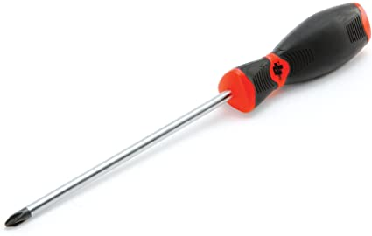
Tools Needed:
- Phillips Screwdriver

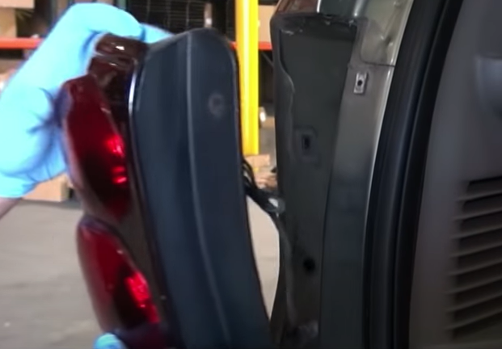
- Unseat tail light and disconnect harness.
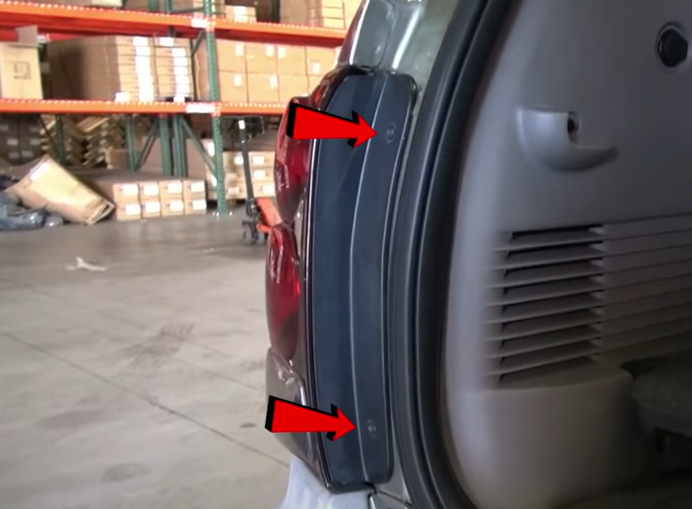
- Remove (2x) phillips screws.

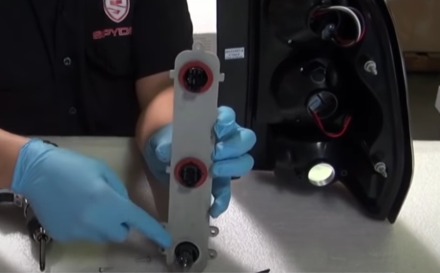
- Remove upper (2x) bulbs from bulb bar. (Never touch bulbs with bar hands)
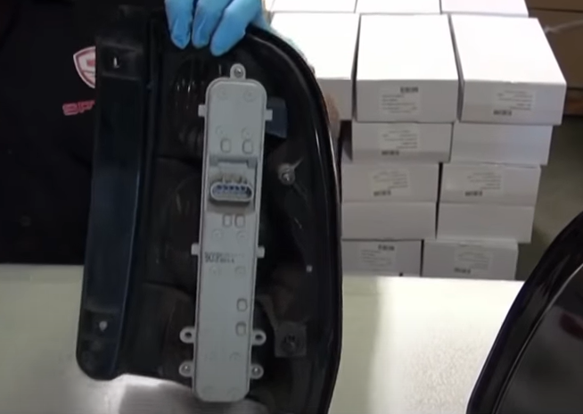
- Remove (3x) phillips screws securing bulb bar.

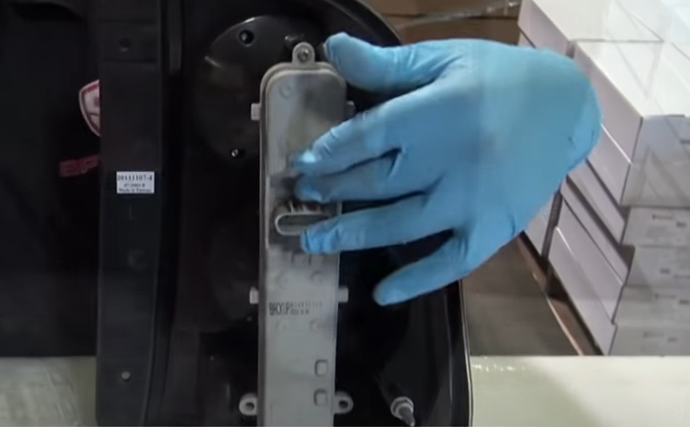
- Install socket bar onto Spyder tail light and reinstall (3x) phillips screws.
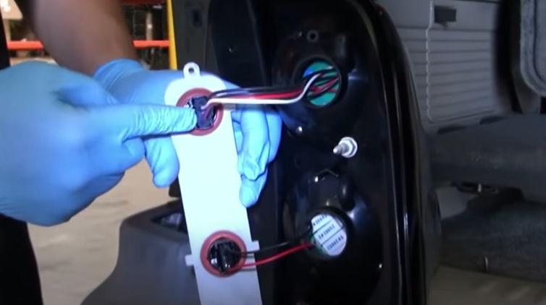
- Connect socket inserts to bulb socket bar making sure black side of wire is on the bottom.

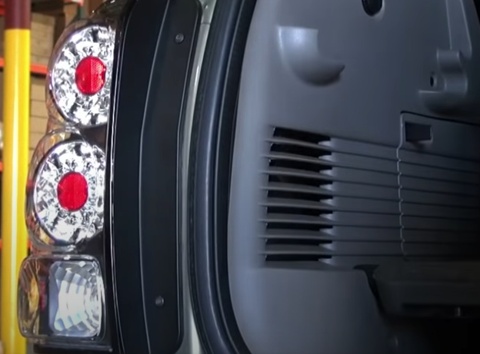
8. Seat Spyder tail light. Reinstall (2x) phillips screws securing tail light.
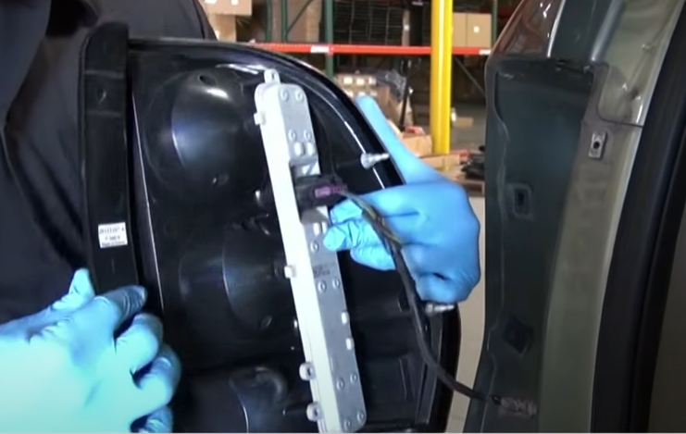
7. Reconnect wire harness.

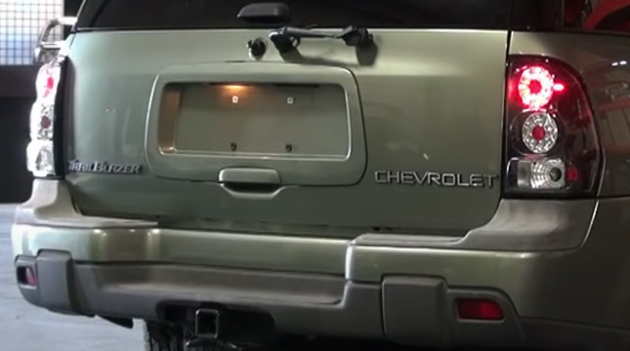
9. Turn on lights and confirm all functions are working properly. You have successfully completed the install of your new Spyder tail lights.

For further help with installation, please watch our installation video. Follow the direct link below to our YouTube channel for more information:
http://www.youtube.com/watch

DISCLAIMER
Spyder Auto Installation Guide is not liable for damages, injuries, and death while installing the product. This is intended to be an installation guide, to reduce installation time. We have no responsibility for improper installation. If you do not know how to install, please have a professional install it.

