

**Installation Guide:**

ALT-YD-CTA15-LE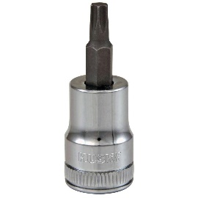D-(All)

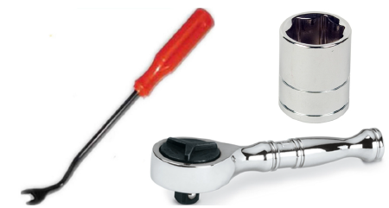

Tools Needed:

* ¼” ratchet
* Panel popper
* T15 Torx socket

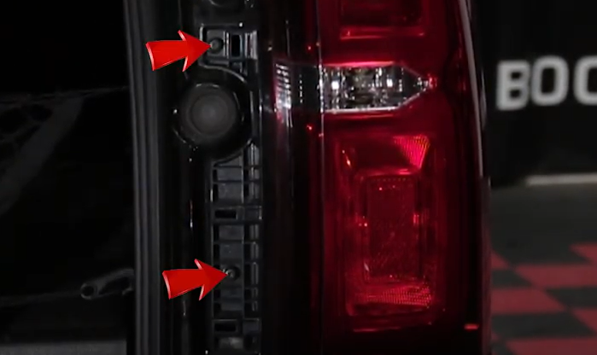

1. Remove (2x) T15 torx screws.

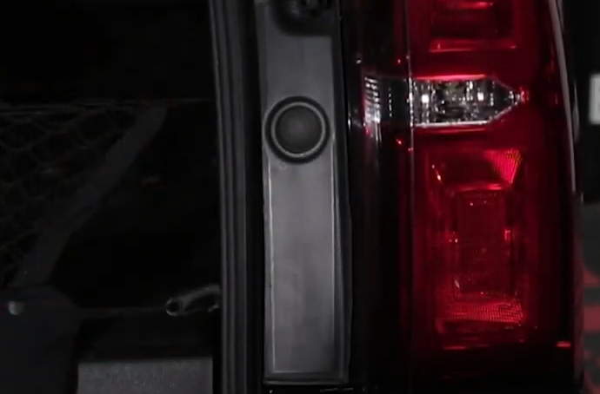

1. Remove tail light panel cover.

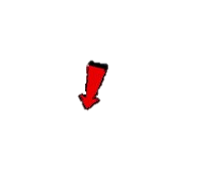

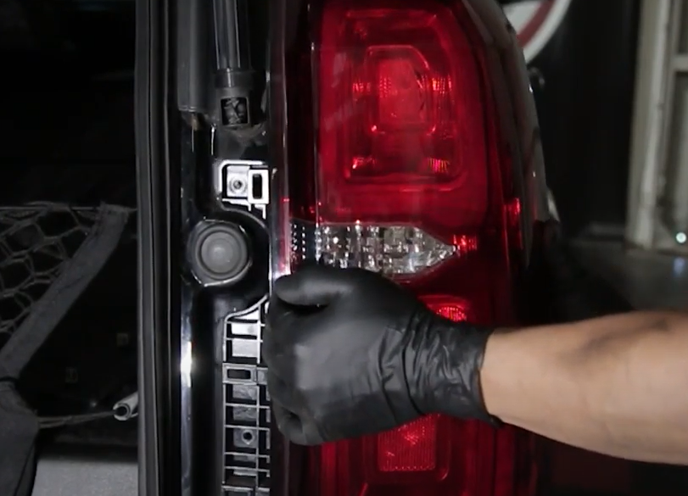

1. Unseat tail light and pull threw harness.

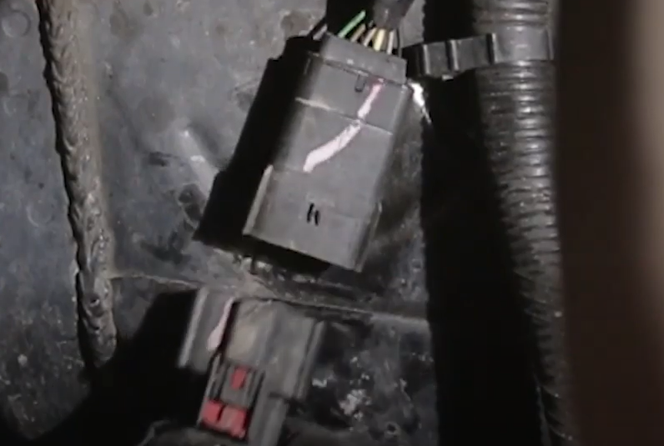

1. Disconnect tail light harness located behind the bumper.

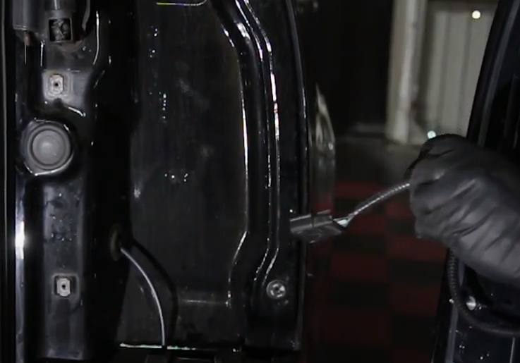

1. Guide threw Spyder tail light harness.

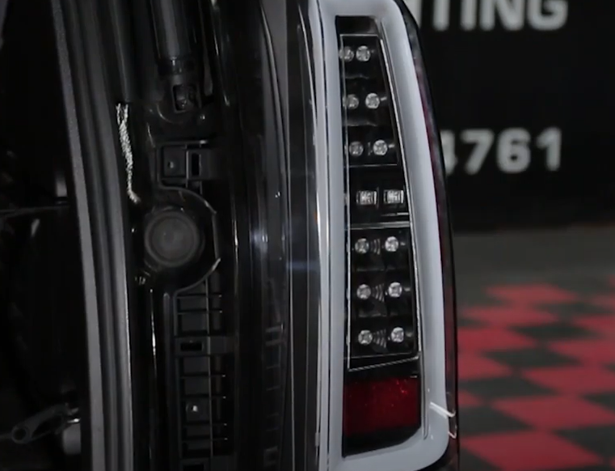

1. Seat Spyder tail light.

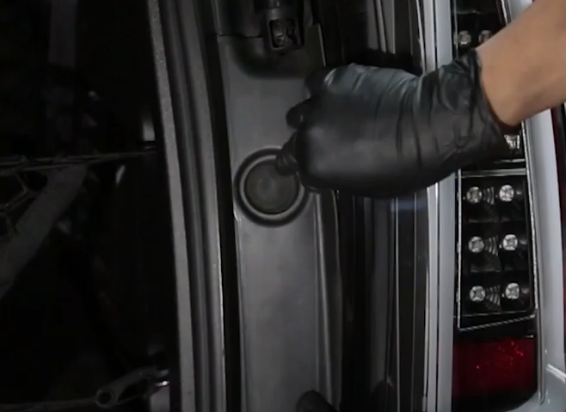

1. Reinstall tail light cover panel.

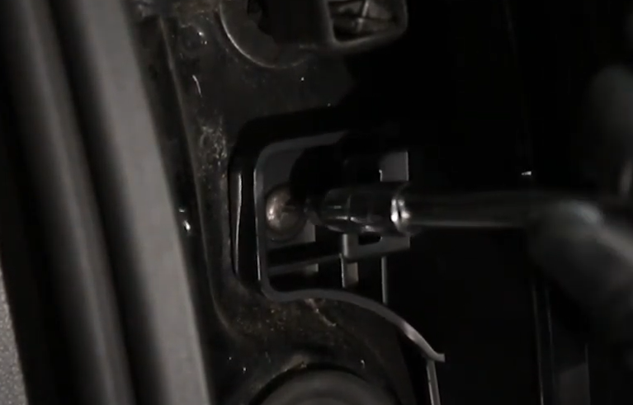

1. Reinstall (2x) T15 torx screws.

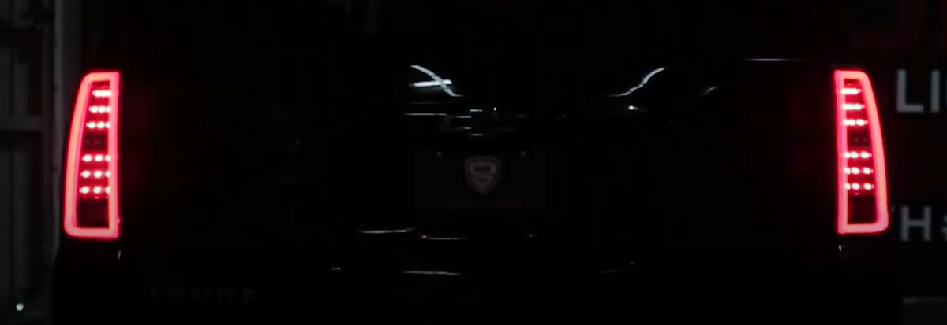

10. Turn on lights and confirm all functions are working properly. You have successfully completed the install of your new Spyder LED tail lights.

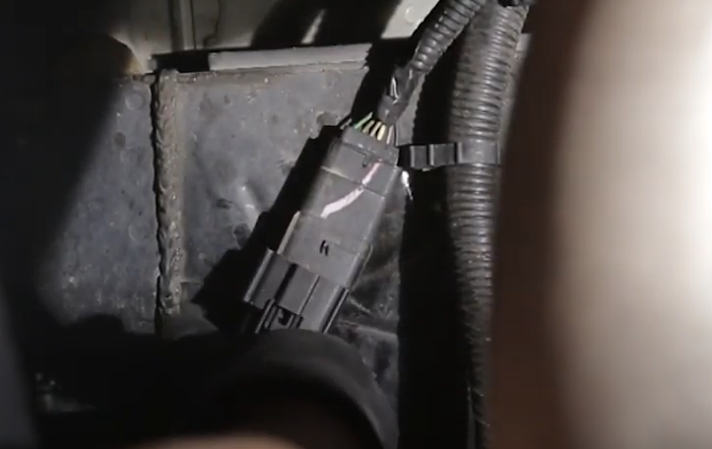

9. Connect Spyder tail light harness.



For further help with installation, please watch our installation video. Follow the direct link below to our YouTube channel for more information:

http://www.youtube.com/watch

**DISCLAIMER**

Spyder Auto Installation Guide is not liable for damages, injuries, and death while installing the product. This is intended to be an installation guide, to reduce installation time. We have no responsibility for improper installation. If you do not know how to install, please have a professional install it.