

**Installation Guide:**

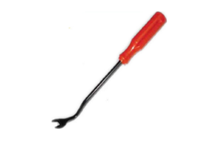ALT-YD-CSUB07V2-LED-(All)

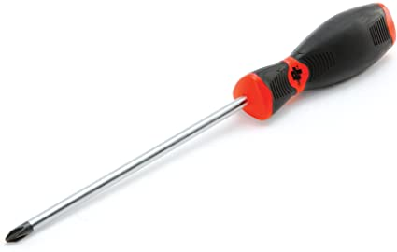Tools Needed:

* Phillips Screwdriver
* Panel Popper

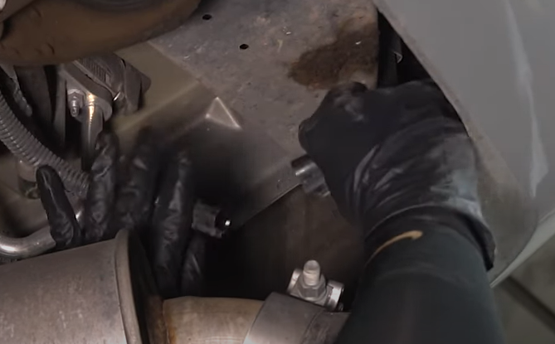

1. Disconnect tail light harness.

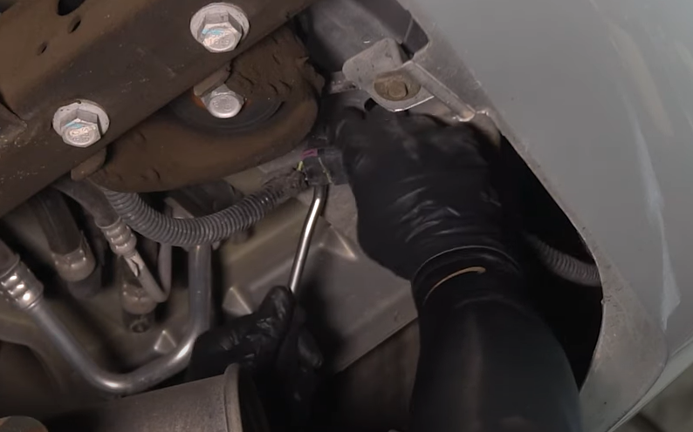

1. Under rear bumper using panel popper remove connector from body panel.

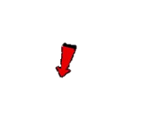

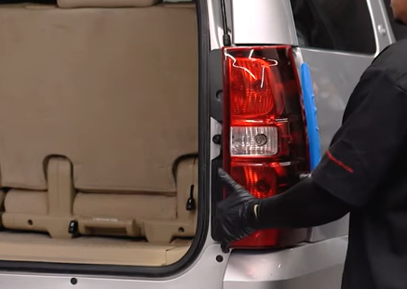

1. Unseat tail light and pull out harness.

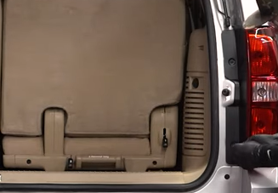

1. Remove (2x) phillips screws.





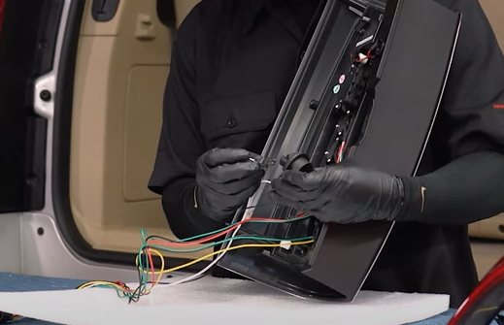

1. Install bulb in Spyder reverse tail light socket.

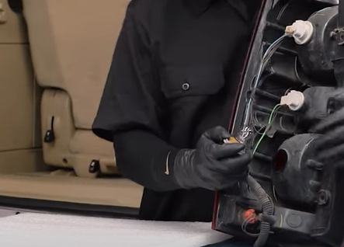

1. Remove parking bulb from tail light. (Never touch bulb with bare hands)





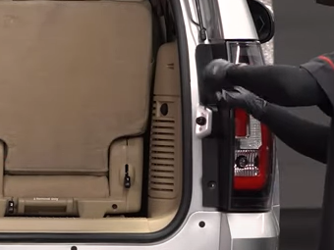

8. Reinstall (2x) phillips screws securing tail light.

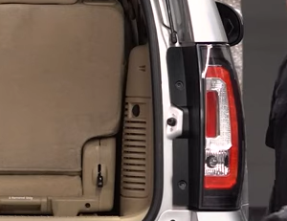

7. Route Spyder harness and seat tail light.

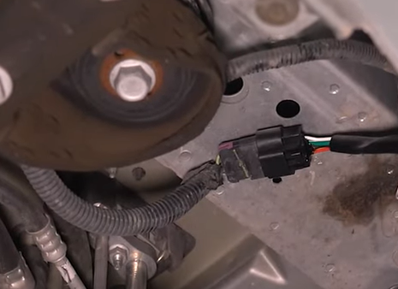

9. Connect Spyder tail light harness and clip to body panel.

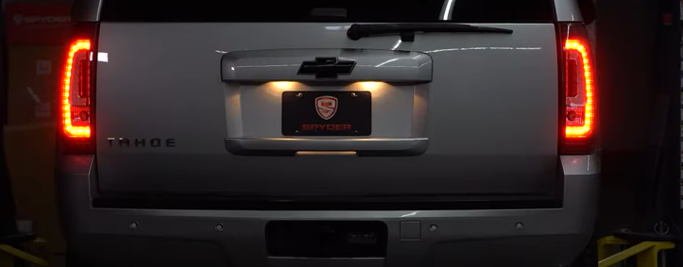

10. Turn on lights and confirm all functions are working properly. You have successfully completed the install of your new Spyder tail lights.



For further help with installation, please watch our installation video. Follow the direct link below to our YouTube channel for more information:

http://www.youtube.com/watch

**DISCLAIMER**

Spyder Auto Installation Guide is not liable for damages, injuries, and death while installing the product. This is intended to be an installation guide, to reduce installation time. We have no responsibility for improper installation. If you do not know how to install, please have a professional install it.