Installation Guide:
ALT-YD-CSUB07-LED-(All)
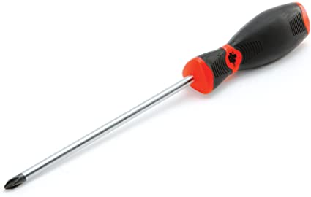
Tools Needed:
- Phillips Screwdriver

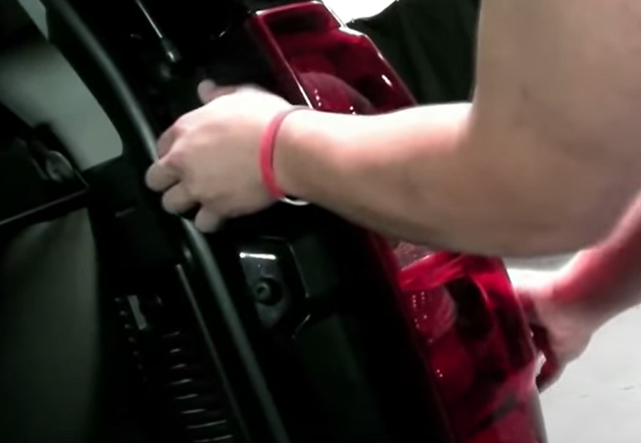
- Unseat tail light.
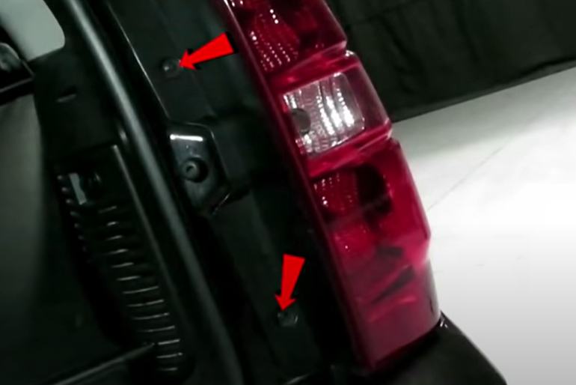
- Remove (2x) phillips screws.

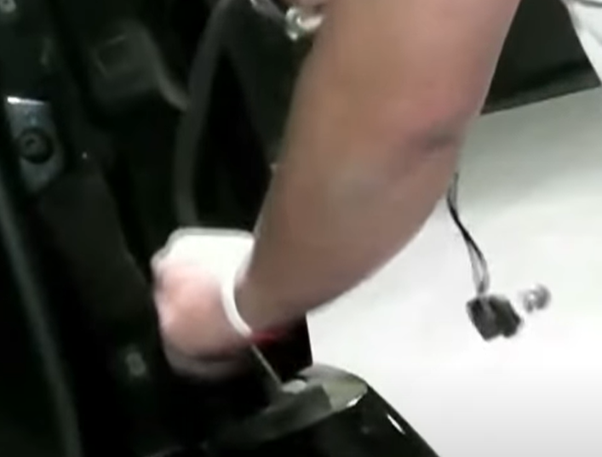
- Remove factory harness.
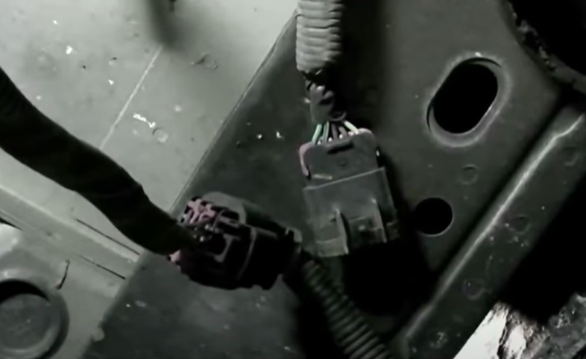
- Disconnect main tail light harness hidden in the bumper under the car.

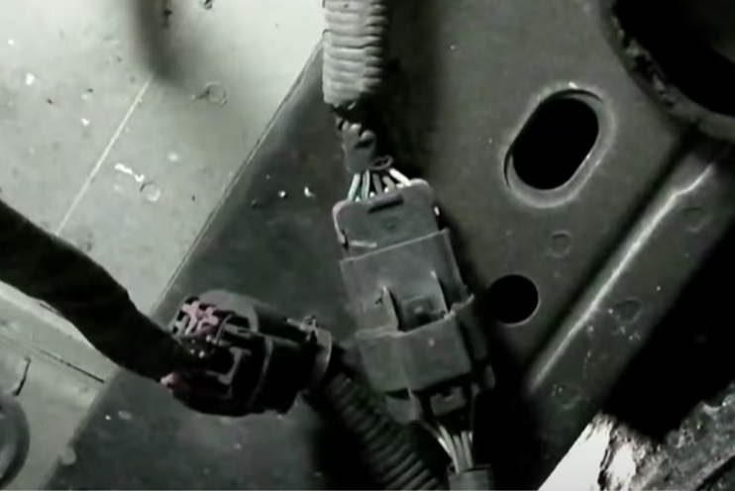
- Connect Spyder tail light harness.
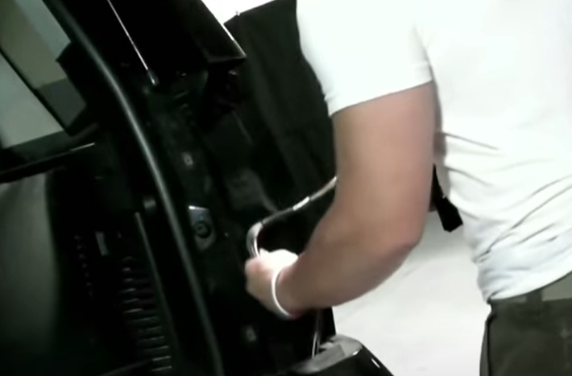
- Feed in Spyder tail light harness.

8. Reinstall (2x) phillips screws securing tail light.
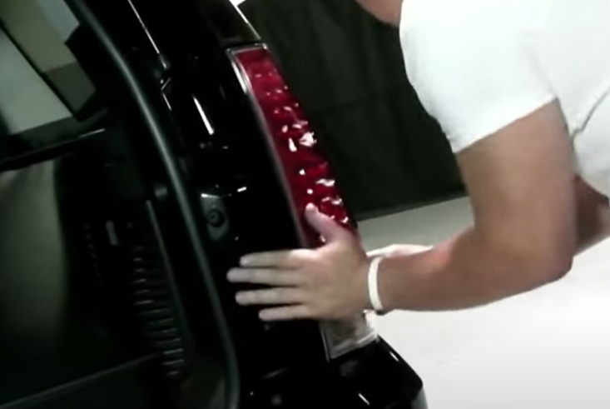
7. Seat Spyder tail light.

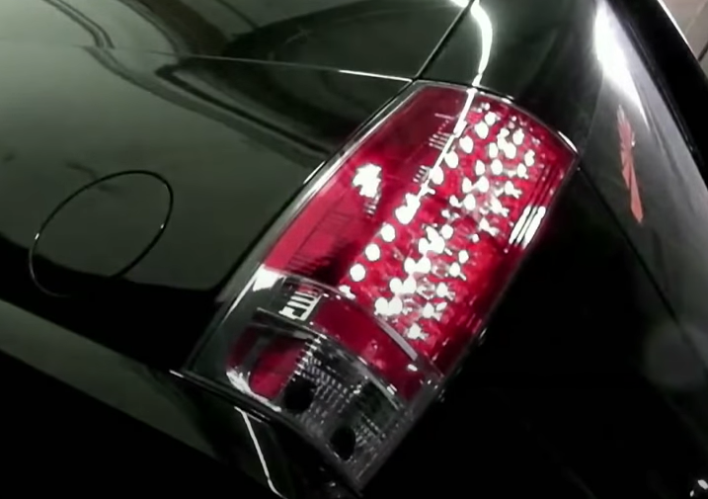
9. Turn on lights and confirm all functions are working properly. You have successfully completed the install of your new Spyder tail lights.

For further help with installation, please watch our installation video. Follow the direct link below to our YouTube channel for more information:
http://www.youtube.com/watch

DISCLAIMER
Spyder Auto Installation Guide is not liable for damages, injuries, and death while installing the product. This is intended to be an installation guide, to reduce installation time. We have no responsibility for improper installation. If you do not know how to install, please have a professional install it.

