Installation Guide:
ALT-YD-CS03-LED-(All)
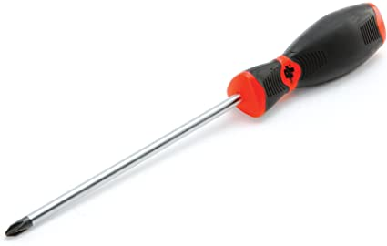
Tools Needed:
- Phillips Screwdriver

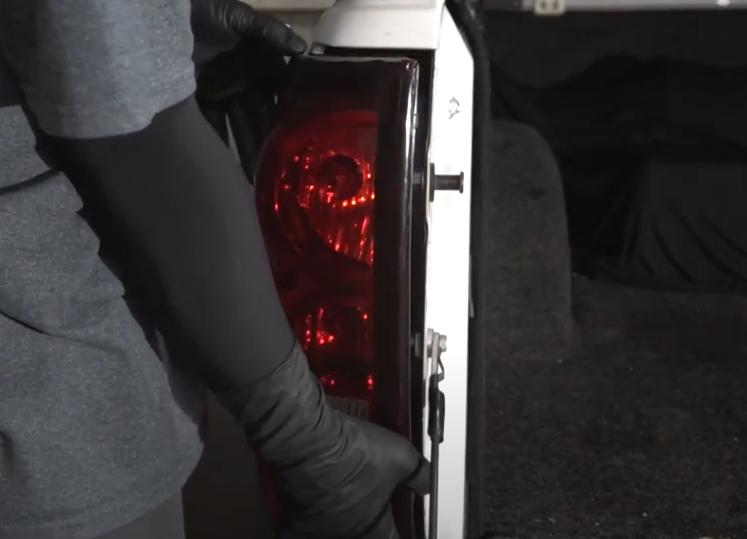
- Unseat tail light.
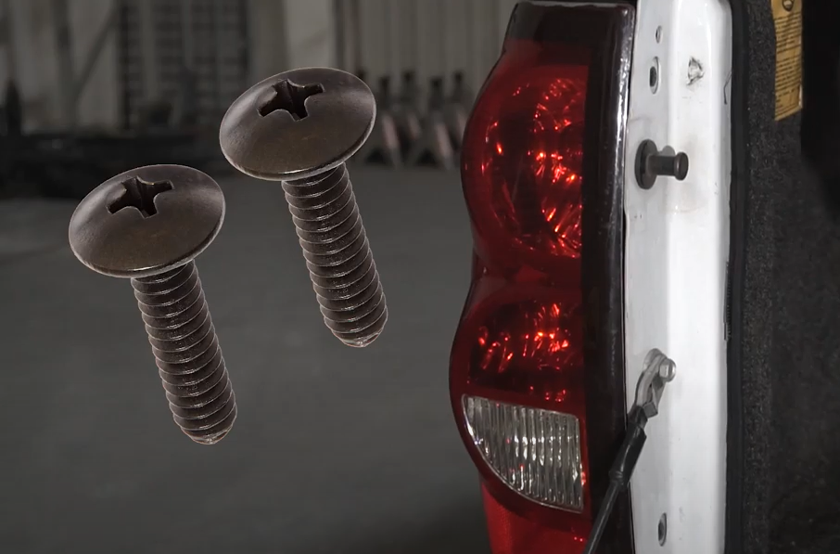
- Remove (2x) phillips screws.

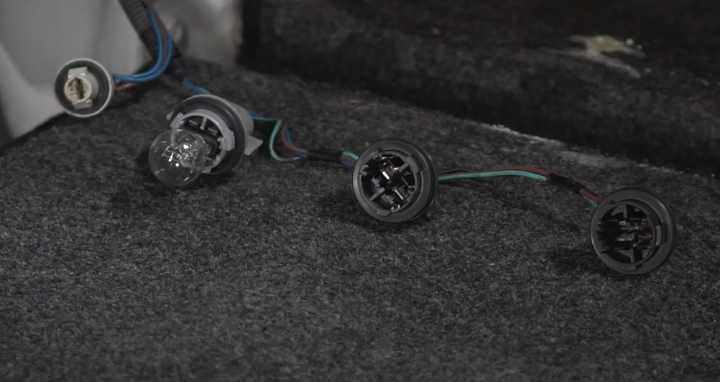
- Remove brake, turn signal and side marker bulb from sockets.
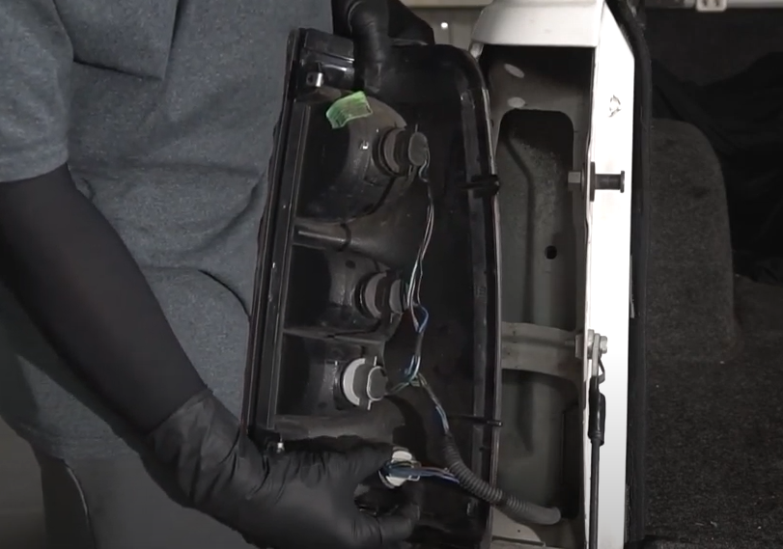
- Remove (3x) bulb sockets from tail light. (Never touch bulbs with bare hands)

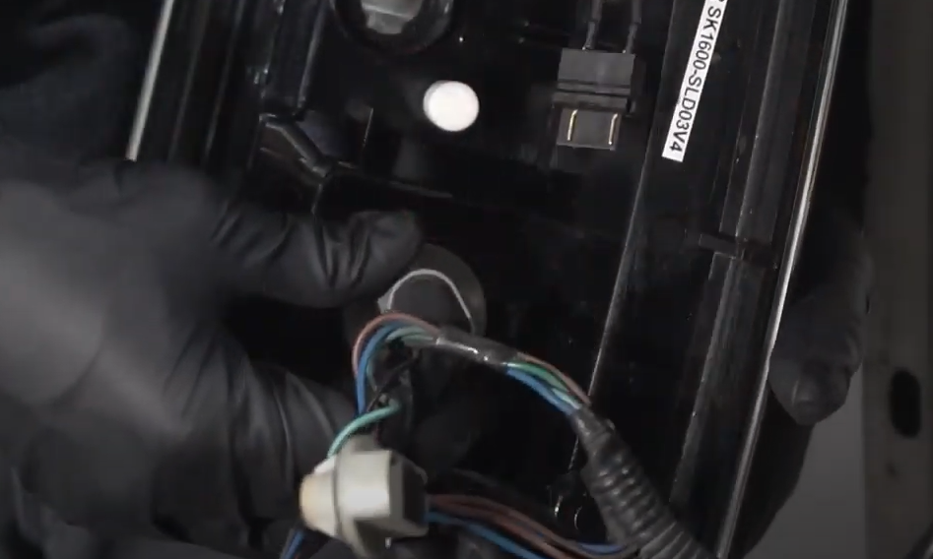
- Connect turn signal socket to Spyder tail light center socket plug. (Make sure socket plug black wire lines up with socket black wire)
- Seat reverse tail light socket into Spyder tail light.

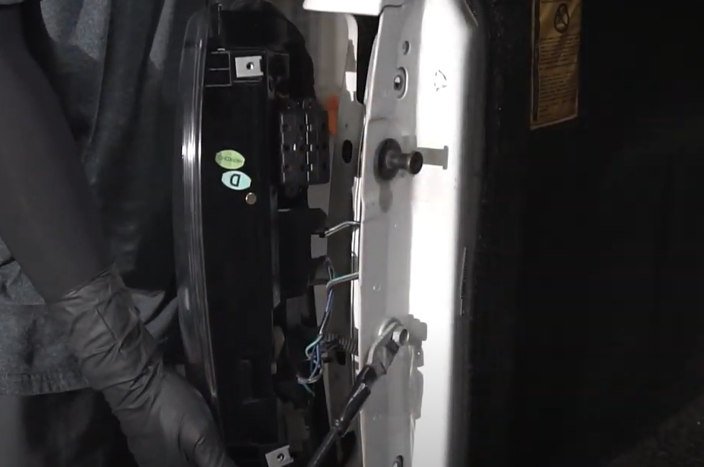
- Reinstall all sockets and seat Spyder tail light.
- Connect brake light socket to Spyder Upper tail light socket plug. (Make sure socket plug black wire lines up with socket black wire)

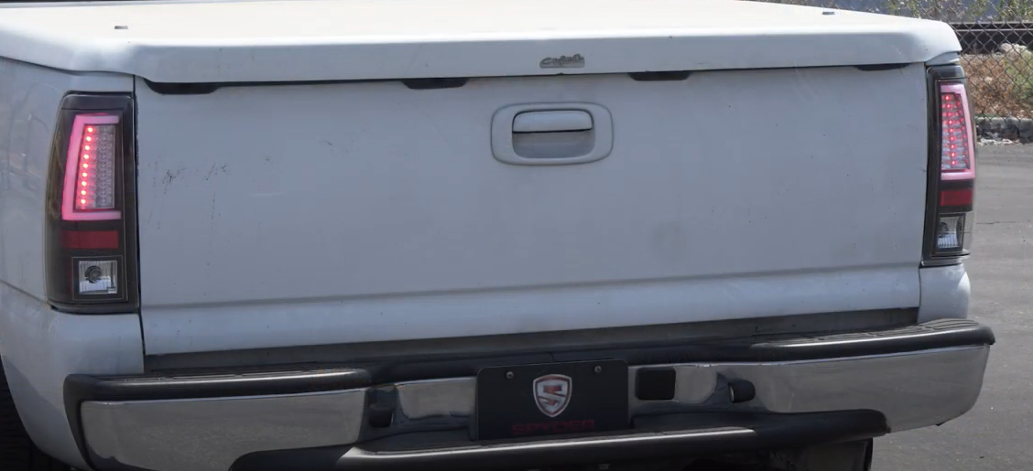
10. Turn on lights and confirm all functions are working properly. You have successfully completed the install of your new Spyder tail lights.
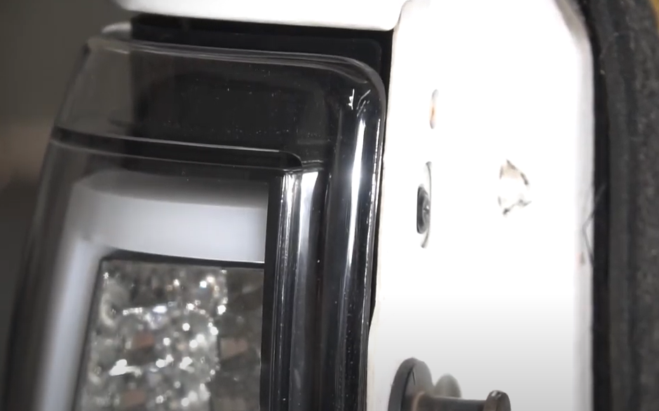
9. Reinstall (2x) phillips screw securing tail light.

For further help with installation, please watch our installation video. Follow the direct link below to our YouTube channel for more information:
http://www.youtube.com/watch

DISCLAIMER
Spyder Auto Installation Guide is not liable for damages, injuries, and death while installing the product. This is intended to be an installation guide, to reduce installation time. We have no responsibility for improper installation. If you do not know how to install, please have a professional install it.

